HEALTH CARE PROFESSIONAL’S WRITTEN OPINION
FOR HEPATITIS B VACCINATION

This form is to be used as needed-currently the health care provider which has an agreement with Germantown Municipal School District to provide the hepatitis B vaccine provides additional information to the employees about the vaccine. This includes a recommendation for a follow-up after the dosage requirement has been completed.

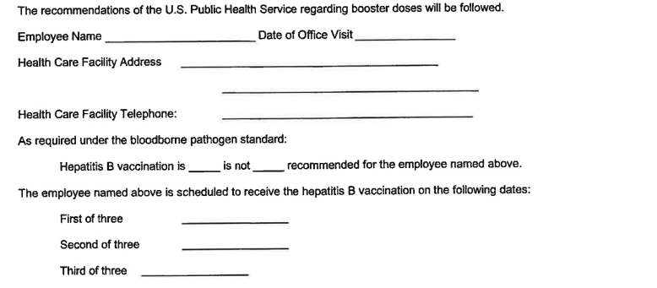
Again, the vaccine and the follow-up are furnished at no cost to employees of Germantown Municipal School District.

Employer: Germantown Municipal School District
Title: Coordinated School Health Supervisor
Address: 3350 S. Forest Hill Irene Rd
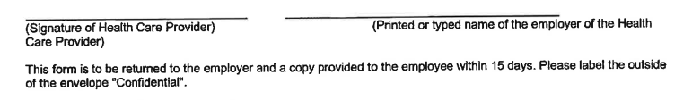
Germantown, TN 38138
