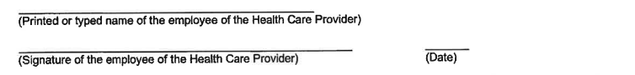
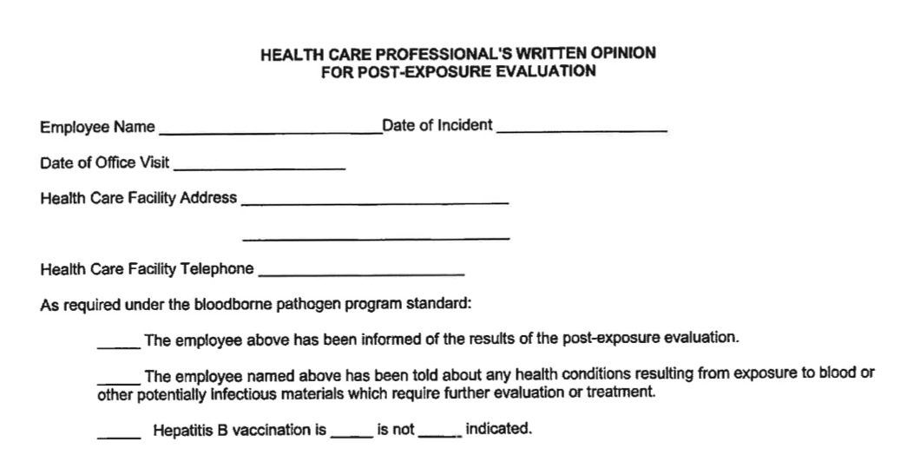

This form is to be returned to the employer (Germantown Municipal Schools) and a copy provided to the employee within fifteen (15) days. Please label the outside envelope “confidential”.

Employer: Germantown Municipal School District
Title: Coordinated School Health Supervisor
Address: 3350 S. Forest Hill Irene Rd
Germantown, TN 38138
