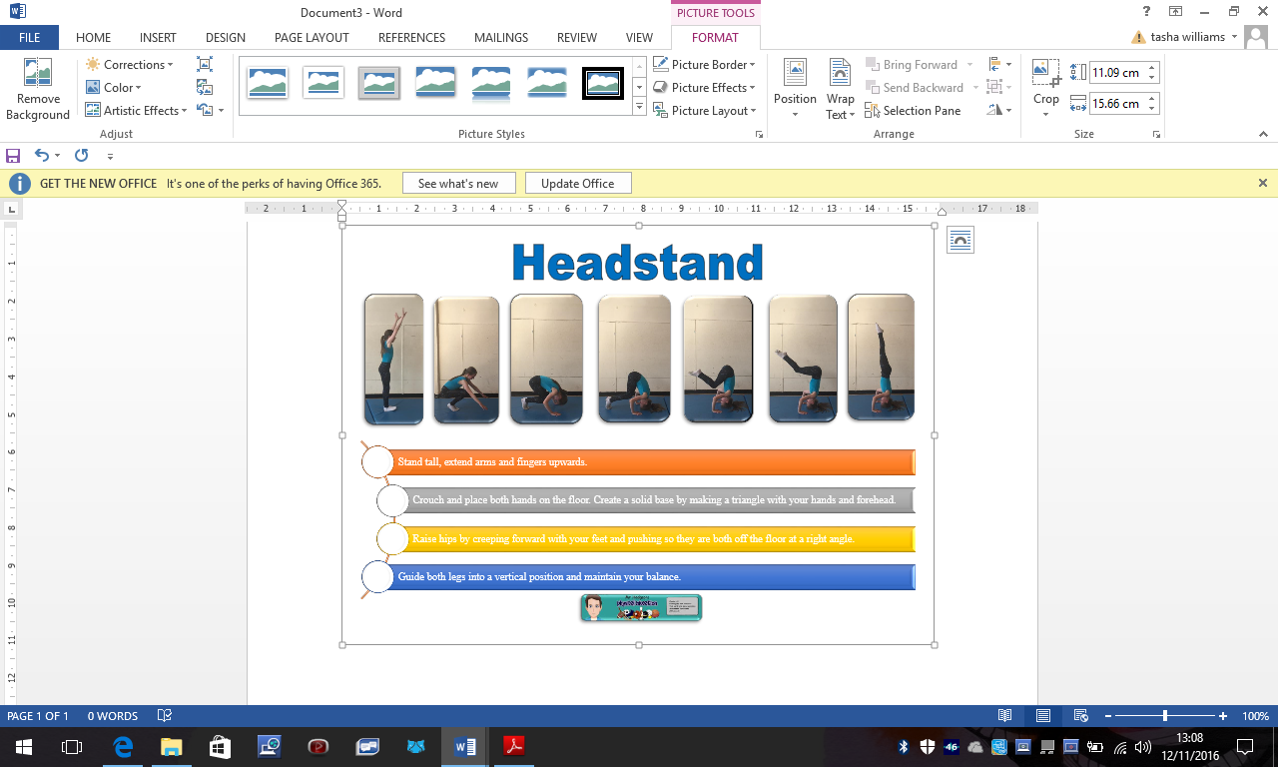

**Headstand**

* Stand up tall, extend arms and fingers upwards
* Crouch to the floor making a triangle with your head and hands
* The part of your head touching the floor should be where your hair line is
* Extend your legs with toes still on the floor
* Make sure you bum is high
* Walk on knee at a time into your chest – Take your time and tense your tummy
* Then one at a time straighten your legs towards the ceiling

Remember to tense your stomach muscles and point your toes

Head

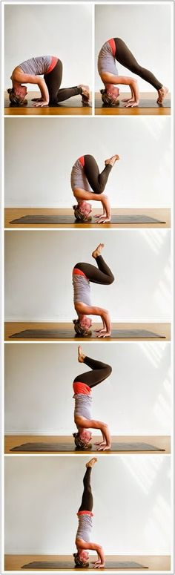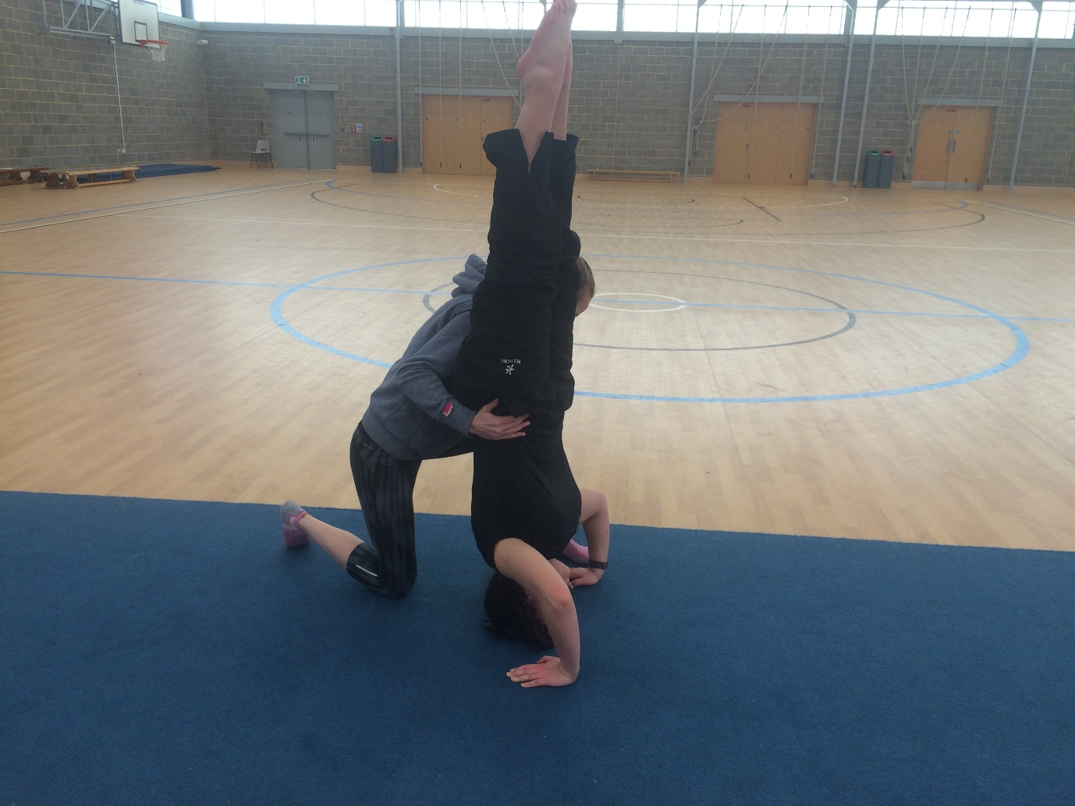

* Partners will have knees bent, one placed forward
* Your partners hands should be level with your foot
* You will support them at the hips
* Their legs should be touching your shoulder

Hands

Hands