

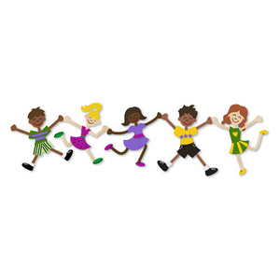

Date

P.E. Teacher

It gives me great pleasure to report to you that ____________________ has __________________________________________________________

__________________________________________________________

__________________________________________________________

The aim of physical education is to involve students in developmentally appropriate movement experiences that focus on learning to move and learning through movement. The knowledge of movement and personal fitness are skills that students achieve through the medium of movement.