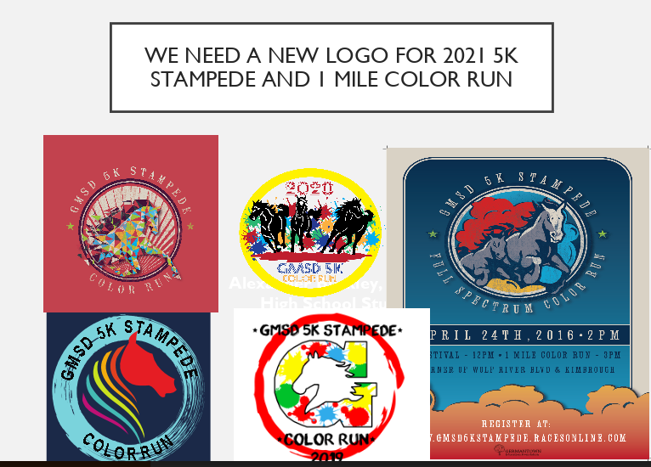
Guidelines for contest:
- Must include a horse somewhere in the design
- Must include the following phrases:
- GMSD 5K STAMPEDE
- COLOR RUN
- Must include the colors of ALL our schools:
- Red
- Yellow
- Blue
- Green
- Orange
- Must include the year 2021
- Must be enclosed in a circular design or outline (see below examples)
Art Work Submissions are due by February 12, 2021 by 5pm
We will vote on the submissions and the winning submission will receive a:

$50 Gift Card from Germantown Education Foundation

The teacher of the winning submission will receive a:

$50 Gift card from Coordinated School Health

