PE/Adapted PE Name:
Activity Log _______________________
Dates:____________________

It is important to be active everyday and try to get some fresh air. Today I……..?

Activity | Monday | Tuesday | Wednesday | Thursday | Friday
Morning
Afternoon/Evening

Activity ideas:
Students can cut and paste these into the chart above or write in their activities.

Walk or Run  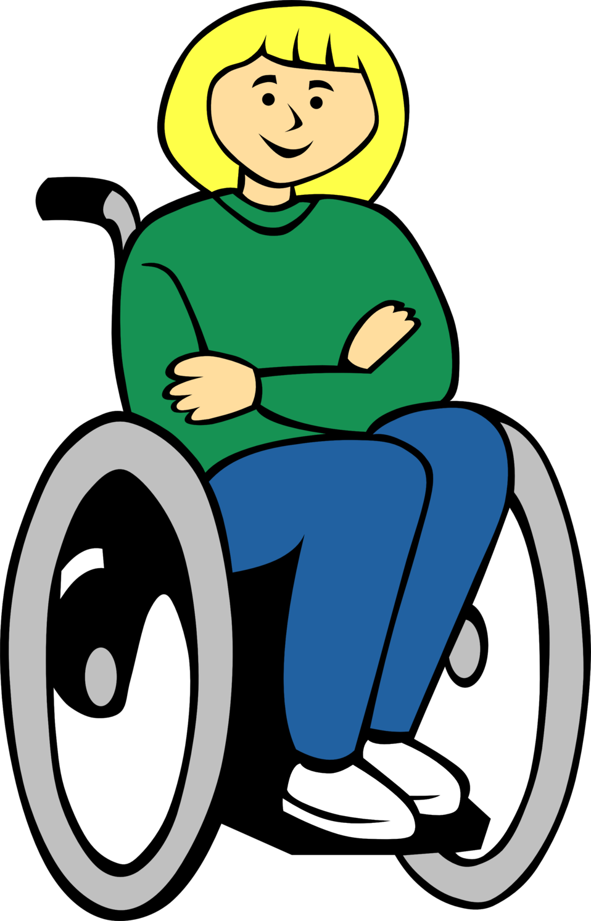 | Go Outside | Basketball Dribbling or  shooting. | Kicking a soccer ball. | Bike ride.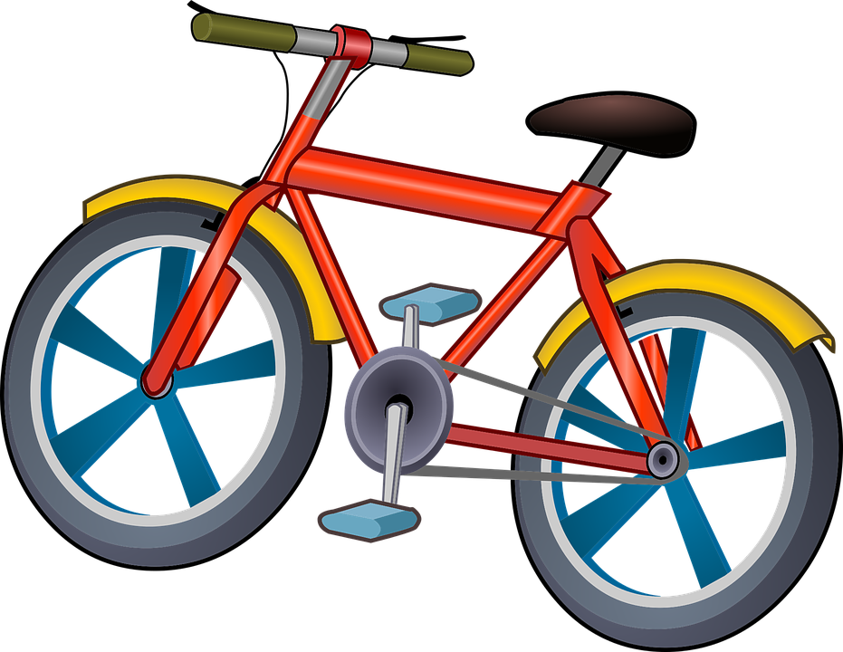 | Yoga
Beach Ball volleyball | Throwing and Catching  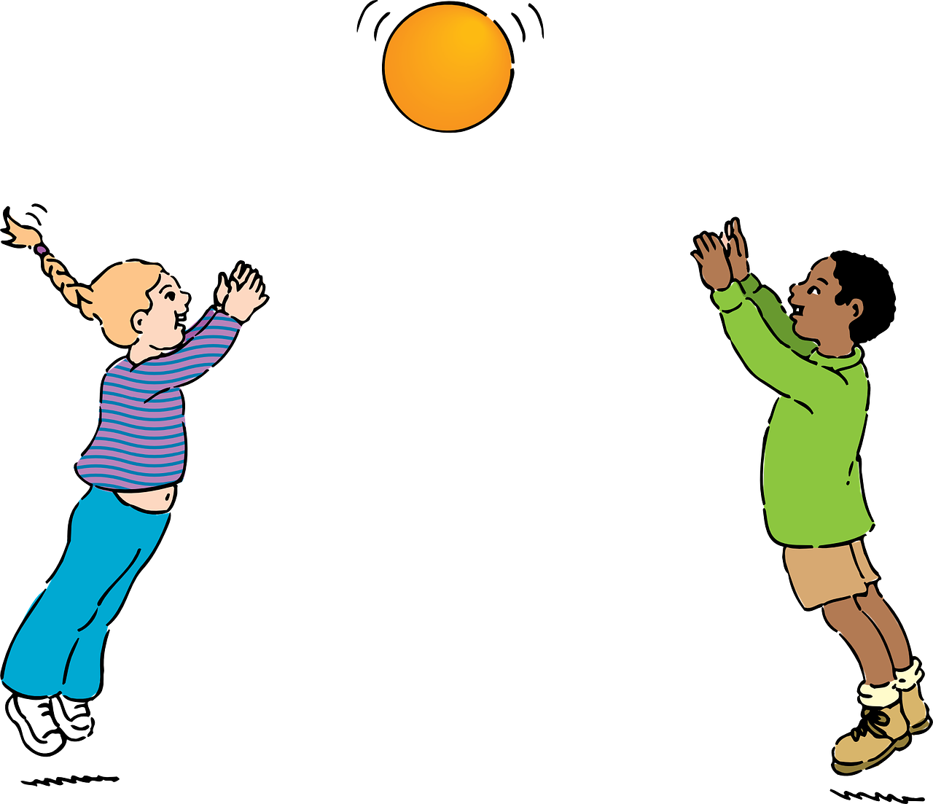 | 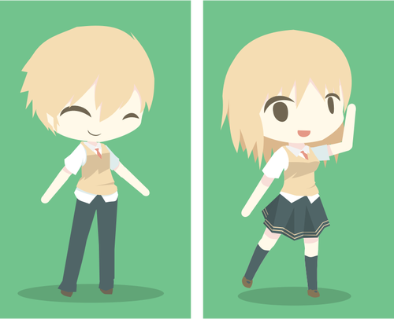  Just Dance | Go Noodle | Play Ball  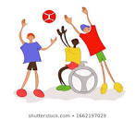 | Balloon volleyball/tennis
Fitness or fitness Video  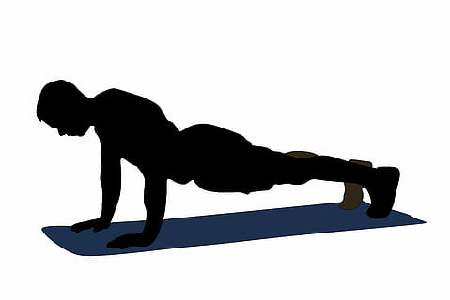 | Tennis or racket sports with a balloon or ball  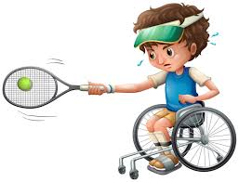 | Active video Games (wii, switch) 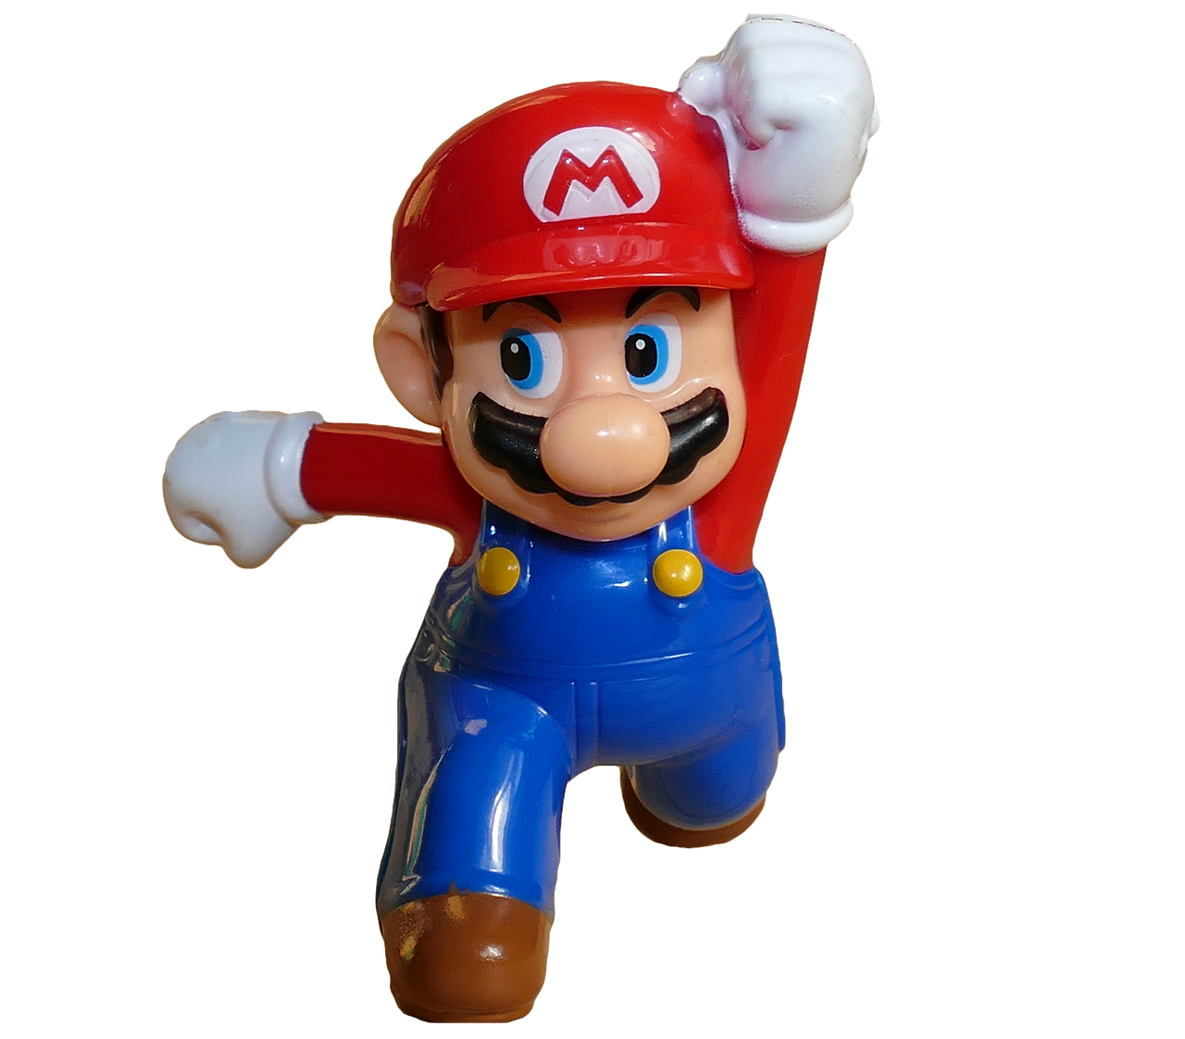 | Bowling  Use recycled bottles and a sock ball. | Build your own Obstacle Course | Roll a ball on the floor or a table.  