GMSD Medication Acceptance Form
20__ - 20__ School Year
Student: __________________________________________ Grade: _____________________
Medication: ________________________________________ Dose: ______________________
Initial Quantity: _________________ Expiration date: ___________________________
Purpose: ____________________________________________________________________________
Time Administered: ____________________________________________________________________
This certifies that I, the undersigned parent/ guardian, am aware of the terms of the above authorization and hereby request that they be carried out accordingly.
Parent Signature:____________________________ Contact Number:_________________________ Email:____________________________________________________________________________
*Acknowledgement Statement of Medication Disposal: I am aware that is my child’s medication is not picked up by dismissal on the last day of school, it will be disposed of following our TN School Health Clinic Guidelines.
Parent Name: ______________________________ Date: __________________
Parent Signature: ___________________________
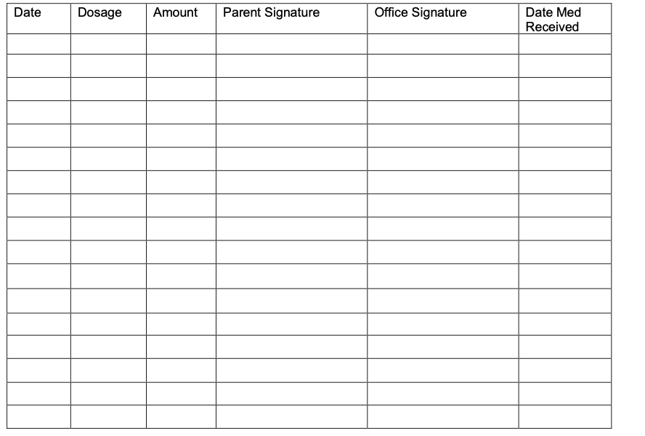
Nurse/ Medical Records Clerk Signature: ____________________________ Date:______________

