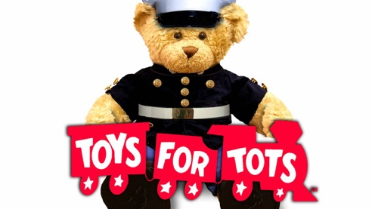
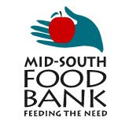
Germantown
Gives back
Mid-south food bank
&
Toys for tots

Germantown Municipal Schools,

The holidays present a time of celebration and excitement for many. However, there are those in our neighborhood and surrounding areas that are struggling due to the hardships of the COVID-19 pandemic. I’m asking that we band together to support two organizations that will help to give back to those that need it most: The Mid-South Food Bank and The Mid-South Toys for Tots.

If you’re able to donate to one of these great organizations, then use the links below to access the pages online that will grant you access. We would normally collect toys and canned food in our buildings, but the COVID-19 pandemic has changed how we’ll do that this year. Your online donation will go a long ways in making a difference in the lives of those that need it most this holiday season.

If you donate to either one of these organizations, then print off the “red train” on the second page of this document and send it to your child’s homeroom teacher. We will tour the buildings prior to Winter Break to see which classroom has the most “red trains” as a result of this challenge! There might be a prize involved for the class that’s most involved in each GMSD school building!

Mid-South Food Bank Donation:
https://midsouthfoodbank2020.sitewrench.com/ways-to-give-donate

Mid-South Toys for Tots Donation:
https://midsouth.toysfortots.org/local-coordinator-sites/lco-sites/default.aspx?nPageID=100&nPreviewInd=200&nRedirectInd=3

Thanks for your support in making GMSD the best place to be!!

Andrew Martin
School Health Supervisor
GMSD
Andrew.martin@gmsdk12.org
