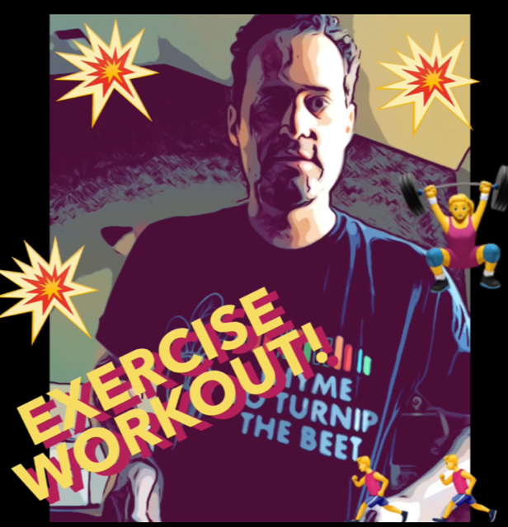

Click the links below or
Copy and Paste the links into your
Internet search bar!

Main Remote Learning Exercise
https://www.youtube.com/watch?v=PBGvV-bTU4I

Dance Exercise Workout Video
https://www.youtube.com/watch?v=EpsmWX2LlqA

Baseball Workout Video
https://www.youtube.com/watch?v=9zYwGg76jF8

Football Workout Video
https://www.youtube.com/watch?v=hoMIxuI5jAo

Basketball Workout Video
https://www.youtube.com/watch?v=vd2NjW4H-Pw

