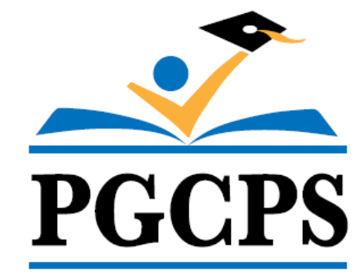 | Fourth Grade Physical Education  Course Syllabus
Physical Education | Prince George’s County Public Schools

Prerequisites: None

Course Description:
The physical education program is based on the Society of Health and Physical Education (SHAPE America) Standards and Grade Level Outcomes. SHAPE America’s five standards focus on developing physically literate individuals that have the knowledge, skills, and confidence to enjoy a lifetime of healthful physical activity. At the elementary level, the focus is on the foundational skills, knowledge and personal/social responsibility in a physical activity setting.

By the end of fourth grade, students will have learned to apply offensive and defensive strategies as they relate to manipulative skills. Students continue to learn fitness concepts, participate in a variety of fitness development exercises, and learn to assess their personal fitness. Working together as part of a group, students learn to give and accept feedback and demonstrate sportsmanship.

Note: Lesson activities depend on a number of factors that include but are not limited to time, space, and equipment.

GRADING:

Elementary School Physical Education
Overview: The goal of grading and reporting is to provide the students with feedback that reflects their progress towards the mastery of the indicators and objectives align to the Society of Health and Physical Educators (SHAPE) America Standards.

Factors | Brief Description | Grade Percentage  Per Quarter
Classwork | This includes all work completed in the classroom setting. This may include but is not limited to:  - Warm ups  - Worksheets  - Article Critiques  - Notebooks  - Whole/Small group work or discussions  - Vocabulary  - Skill Assessments/Performance Based Assessments  - Personal/Social/Emotional Development | 70%
Homework | This includes all work begun or completed outside the classroom/gymnasium. This may include, but is not limited to:  - Journals  - Written reports  - Projects  - Fitness Logs | 10%
Assessment | This category entails both traditional and alternative methods of assessing student learning. This may include:  - Skill Assessments  - Written Assessments  - Rubrics  - Task Cards  - Pre/Post Fitness Assessment  - Pair/Self Evaluation  An instructional rubric should be created to outline the criteria for success and scoring for each alternative assessment. | 20%

