Floorball Game Highlights: Finland vs Canada

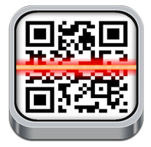
Step 1: find the app; QR code reader
Step 2; open it and scan the pictogram below:

Floorball Game Highlights: Finland vs Canada

Step 1: find the app; QR code reader
Step 2; open it and scan the pictogram below:

