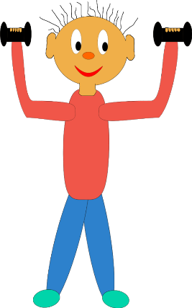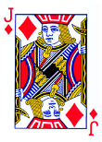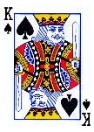

**@PE4Life_Spencer**

*Beats Queen*

*Beats*

Jack

*Beats*

*10*

*Highest Card*

*Beats*

*King*

**Instructions**

* Chose an exercise for each suit in the deck
* Split a deck of cards evenly between all players
* Players place playing cards face down in front of them
* Each player flips over only the top card in their pile
* The highest card wins and player rests
* All other players do the exercise listed on the right based on their card
* Cards with a number is their value
* If a player does not win and has a A K Q J they get to choose how many times they complete the exercise
* If there is a tie both players do an exercise
* Winning player of the round keeps played cards
* Game is complete when 1 player has all cards

**Choose Your Exercises**

**Hearts**  = ___________

**Clubs**   = ____________

**Spades**   = ___________

**Diamonds**  = __________

**Fitness War**