Fitness Test
Fall 2017

Name: ______________________________________________________________________
Grade: ______________________________________________________________________
Teacher: _____________________________________________________________________

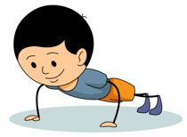
Test #1: Push-Ups
Attempt #1= ________
Attempt #2= ________
Attempt #3= ________

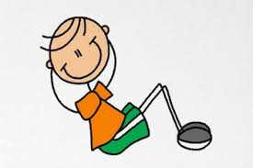
Test #2 Sit-Ups
Attempt #1= ________
Attempt #2= ________
Attempt #3= ________

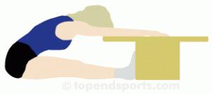
Test #3 Flexibility
Attempt #1= ________
Attempt #2= ________
Attempt #3= ________

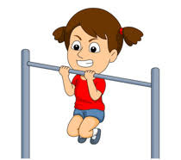
Test #4 Pull-Ups
Attempt #1= ________
Attempt #2= ________
Attempt #3= ________

Test # 5 Pacer
Attempt #1= ________

