THE MOUTH
- Takes in (breathes) Oxygen, which is the start of the Respiratory System
- Next: Oxygen will move through the trachea (airways) towards lungs

SCOOTER EXERCISE: PUSH-UP & TUCK
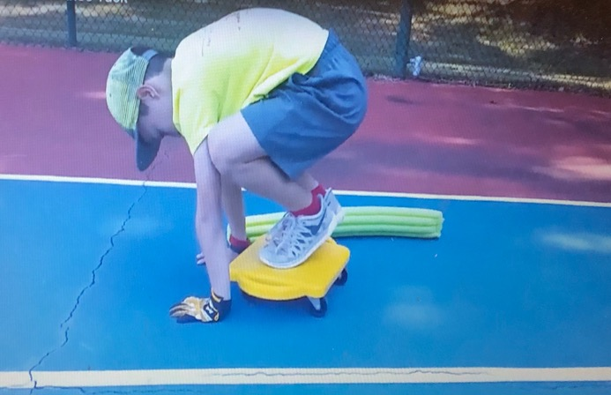
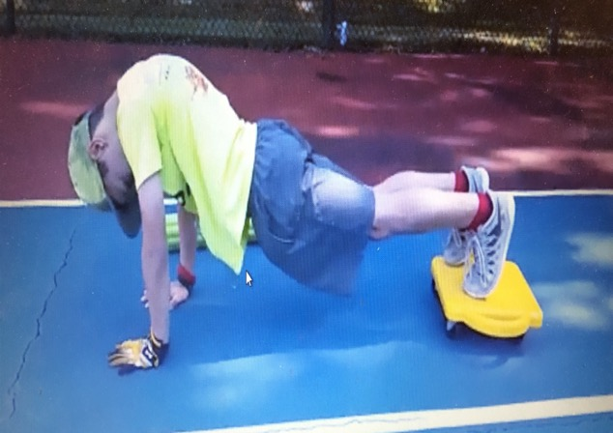

THE LUNGS
- Exchanges Oxygen and Carbon Dioxide.
- Next: After taking in Oxygen, the blood leaves the lungs and goes to the heart (carrying oxygen).

SCOOTER EXERCISE: PULL & PUSH
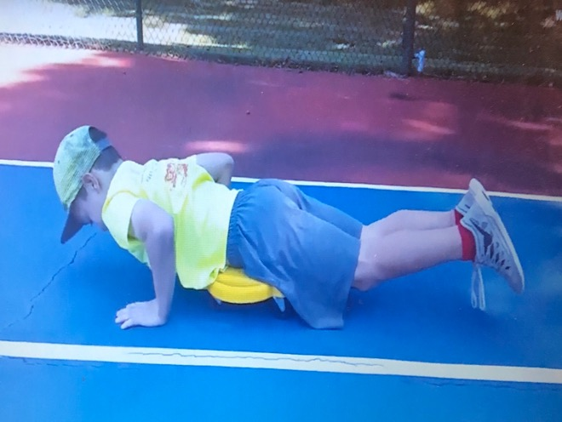
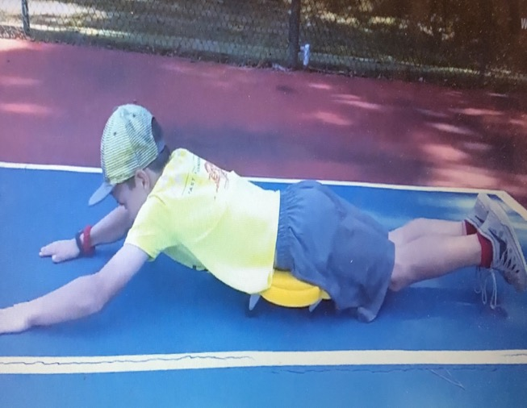

ALVEOLI
- Oxygen passes through here and enters the blood.
- Oxygen is carried around the body in blood vessels (after leaving lungs and heart).
- Carbon dioxide is released into the air.
- Next: Oxygen rich blood is passed through to the lungs.

EXERCISE: Diamond Push-Ups
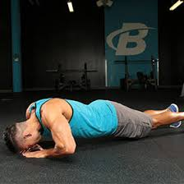
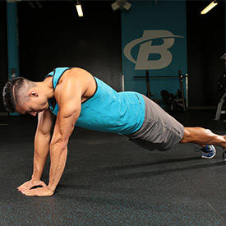

THE HEART
- Oxygen rich blood enters the heart on the left side, (left ventricle) which comes from the lungs
- Next: Oxygenated blood will leave the heart through Arteries to go to the body’s tissues.

SCOOTER EXERCISE: CRAB TUCK
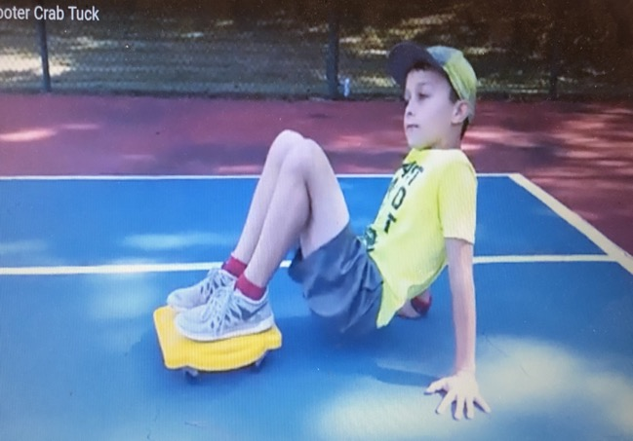
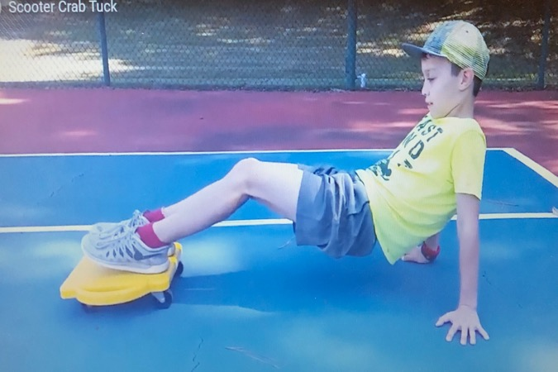

THE ARTERIES
- Arteries carry oxygen rich blood throughout the entire body during the circulatory system.
- Arteries are smaller in size than veins.
- Next: Arteries will carry blood to all the body’s tissues.

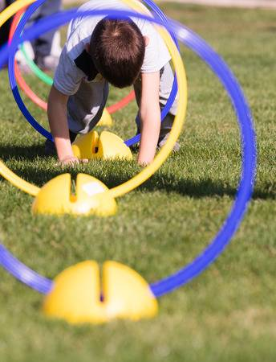
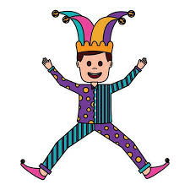
EXERCISE: JUMPING JACKS & HOOP CRAWL

THE VEINS
- Veins carry blood without oxygen back to the heart.
- Veins are bigger than arteries.
- Next: The body will prepare to exhale in order to release carbon dioxide from body.

SCOOTER EXERCISE: CRAB LEG CIRCLES
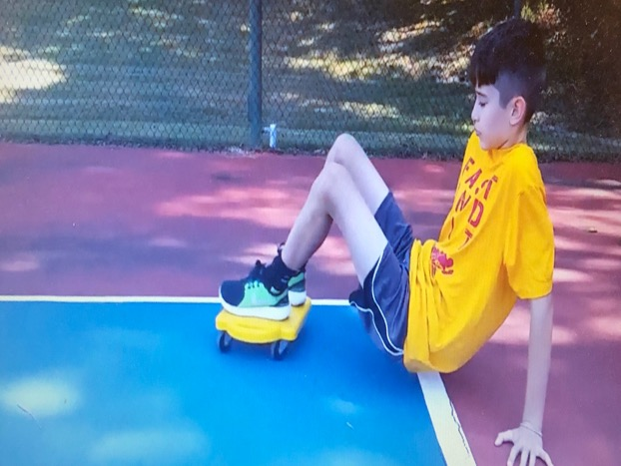
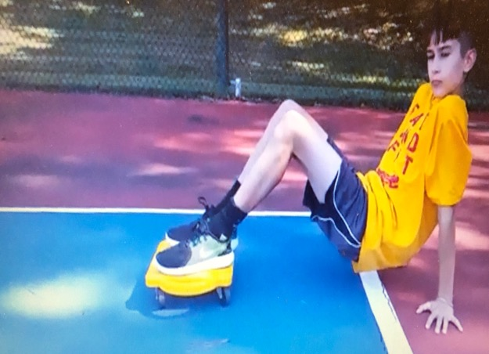

THE MOUTH
- Carbon Dioxide will exit the body through the mouth to complete the respiratory cycle.
- Next: The cycle starts over every time you take a new breath.

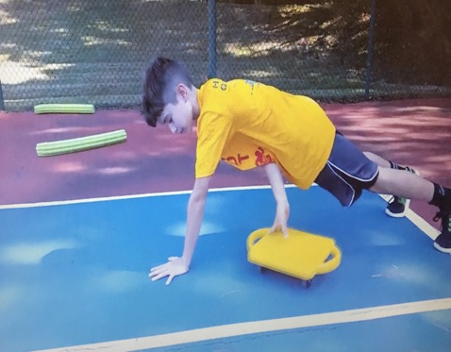
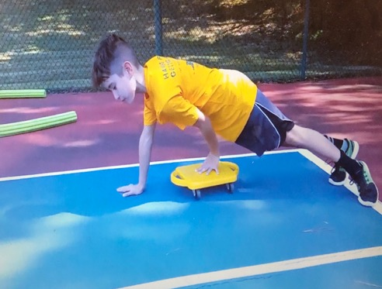
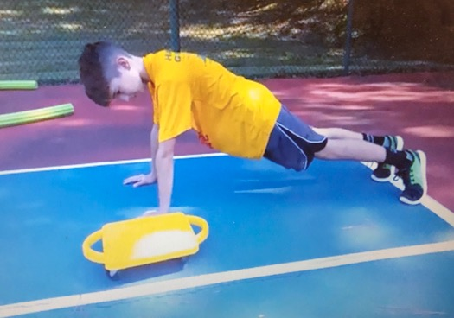
SCOOTER EXERCISE: PLANK EXCHANGE

