ATLANTIC AVENUE
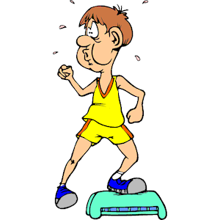
AEROBIC STEP UPS

INDIANA AVENUE
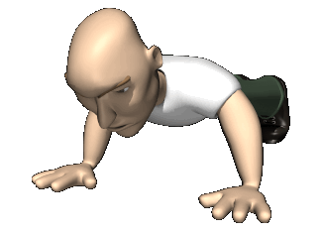

PUSH UPS

PACIFIC AVENUE
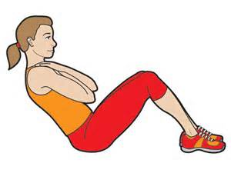

SIT UPS
GO TO JAIL
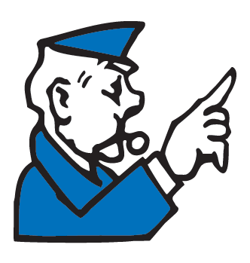

Miss a Turn!

NORTH CAROLINA AVENUE
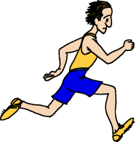
RUN IN PLACE

BOARDWALK

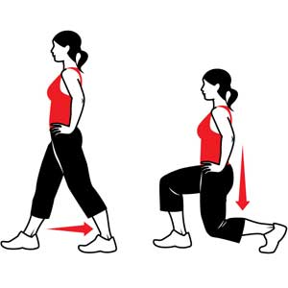
FORWARD LUNGES
COMMUNITY CHEST
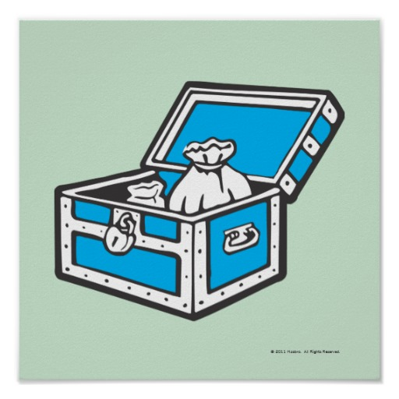
Resistance Bands

VERMONT AVENUE
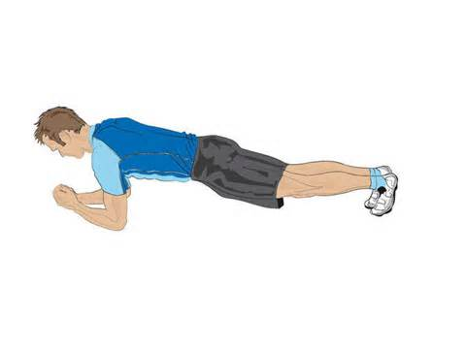

PLANKS

TENNESSEE AVENUE
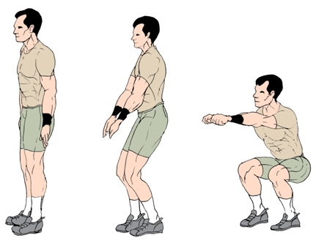

BODY SQUATS

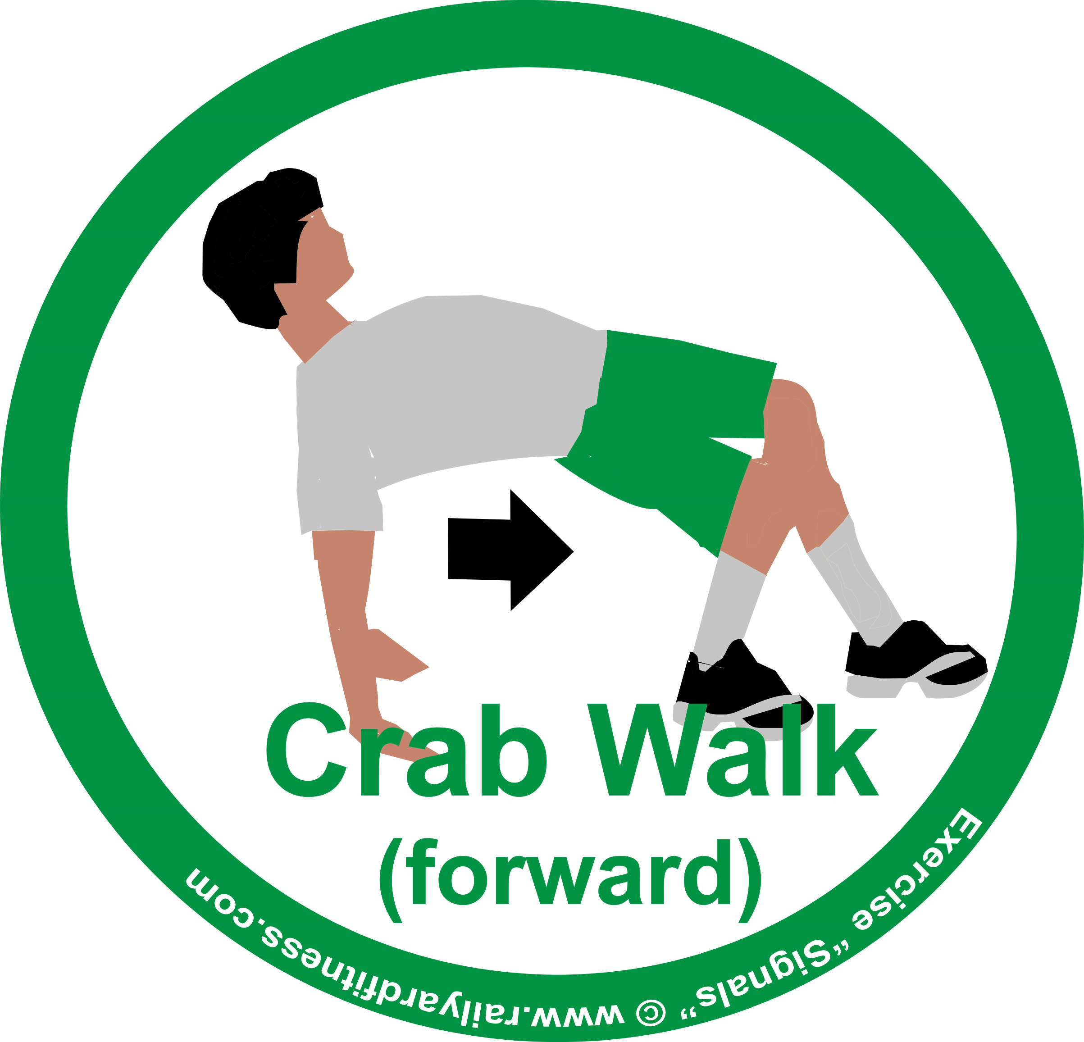
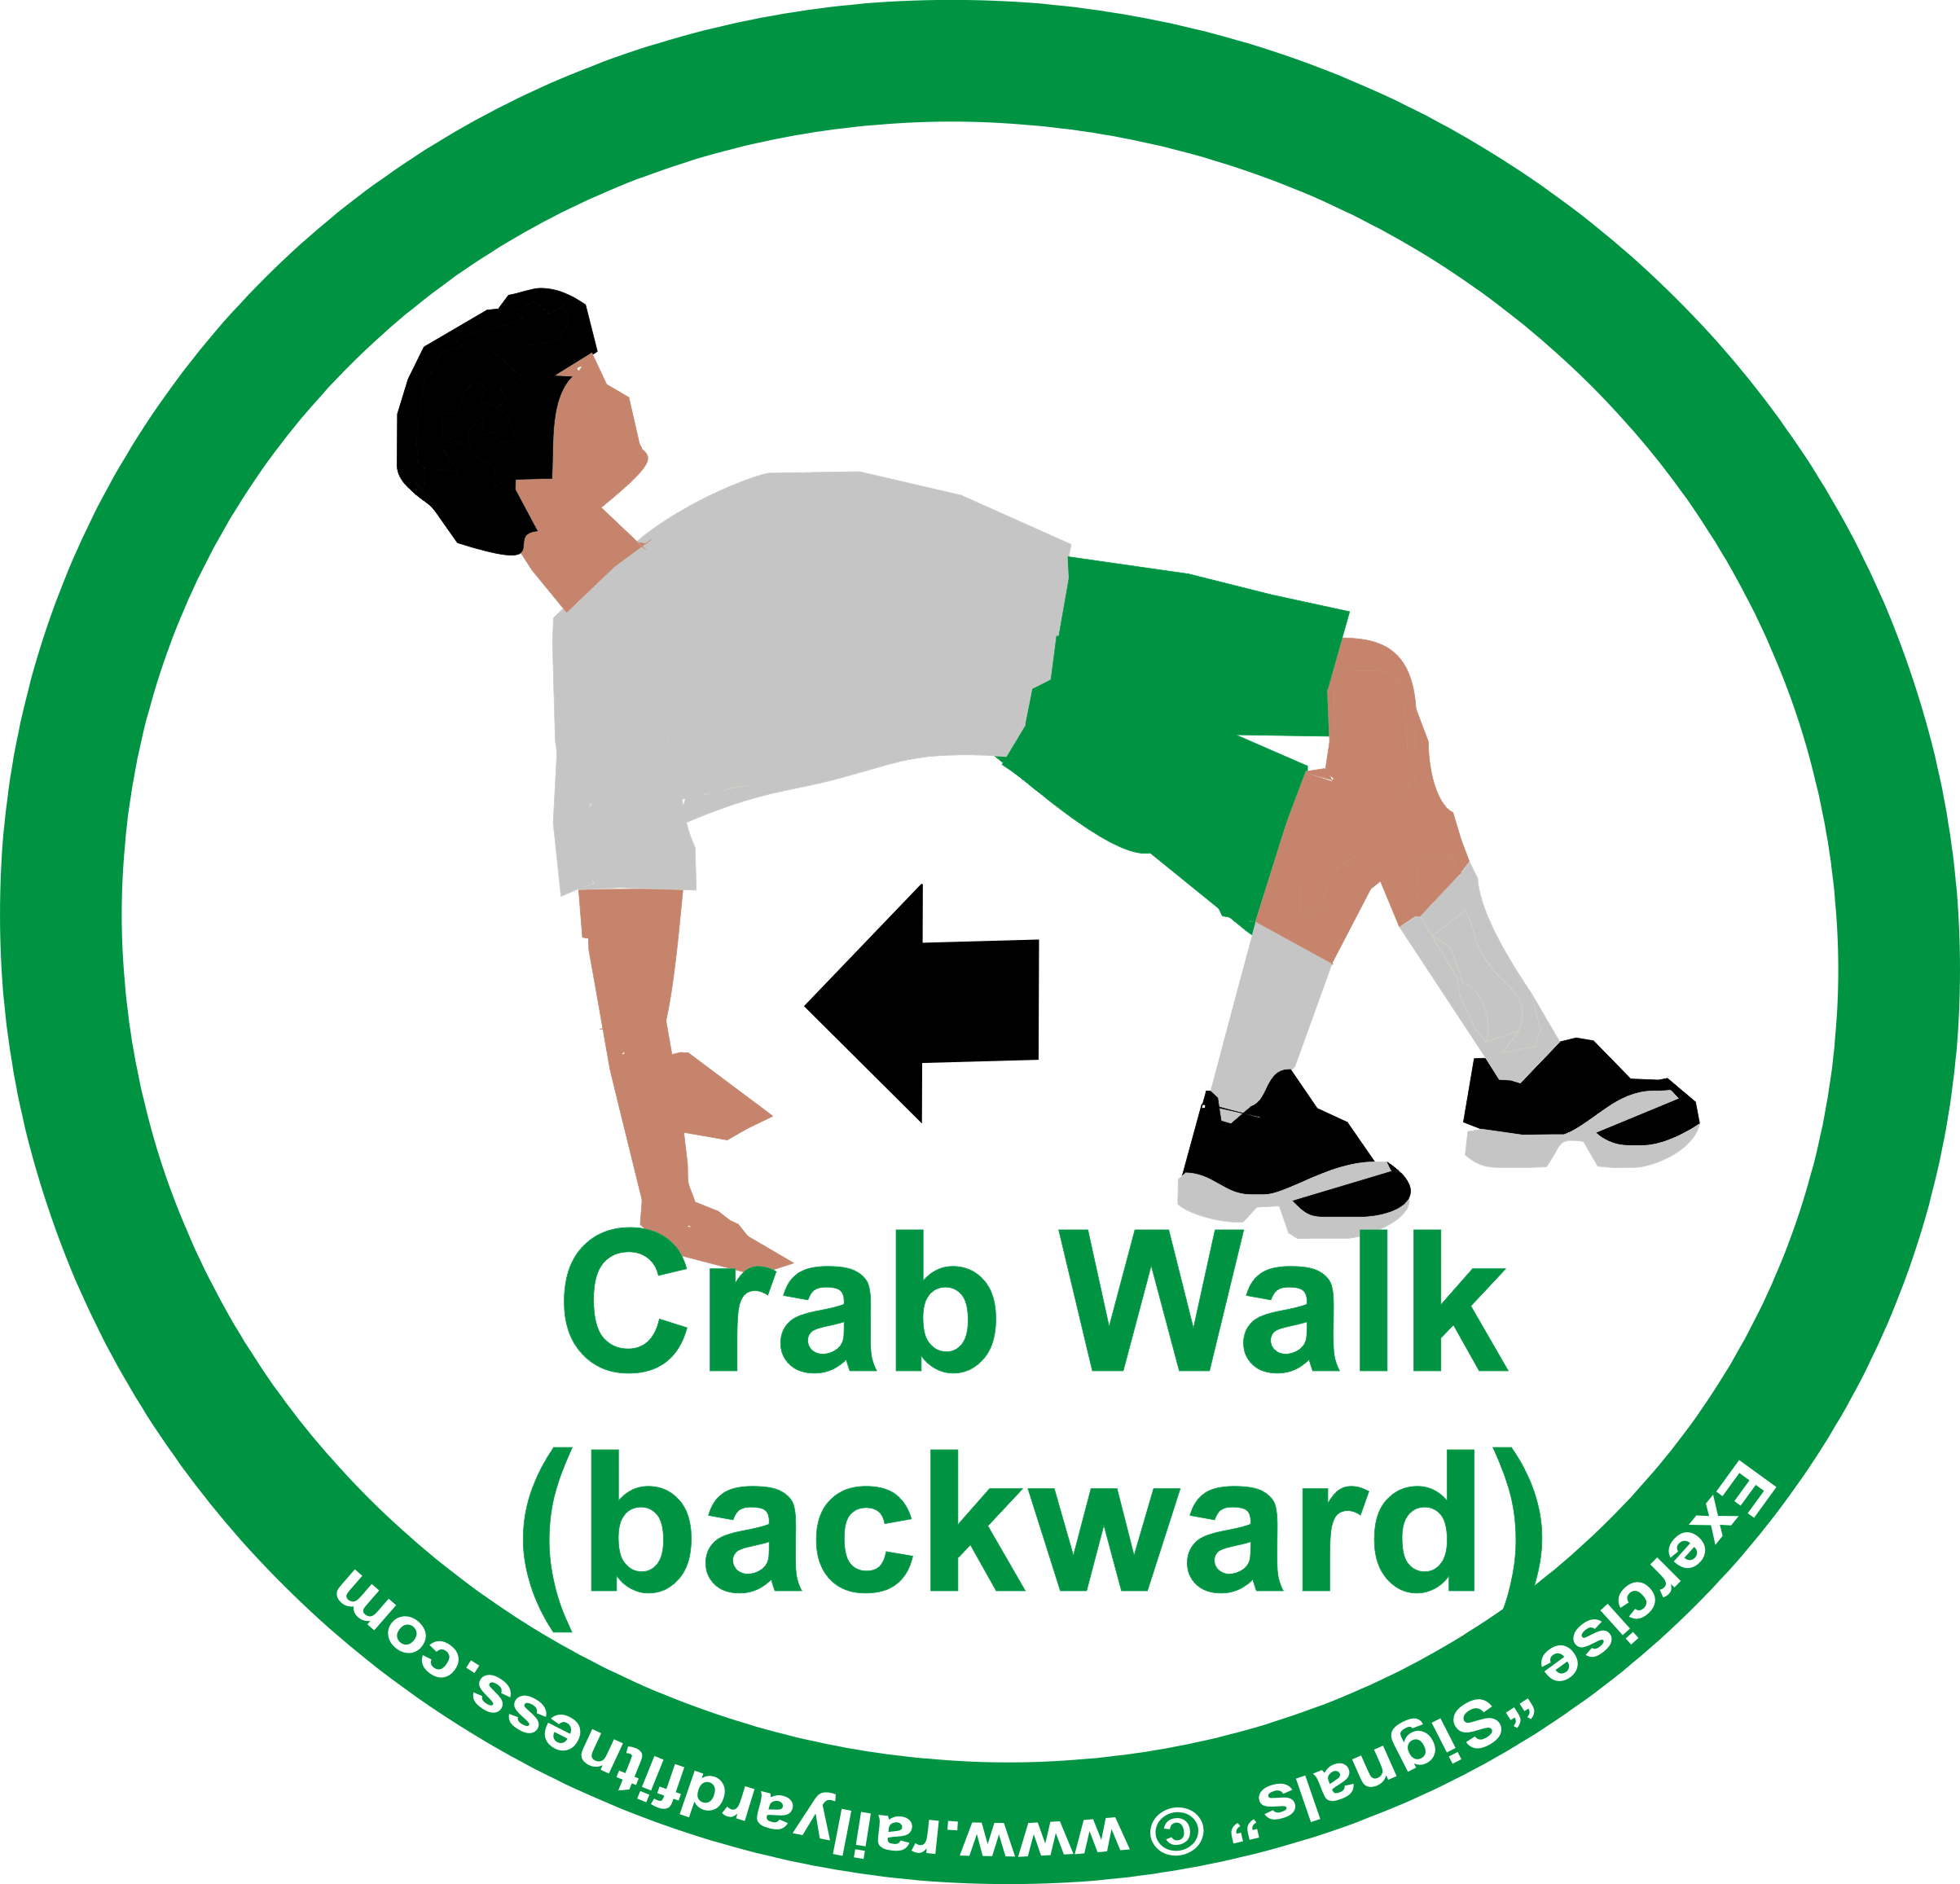
KENTUCKY AVENUE

CRAB WALK

ST. CHARLES PLACE

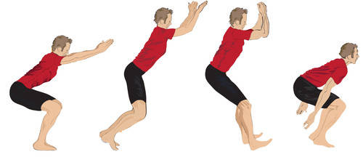

PLYO JUMPS

MARVIN GARDENS
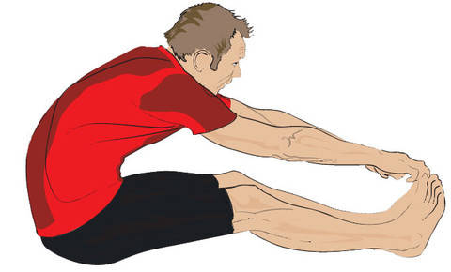

SIT AND REACH
CHANCE
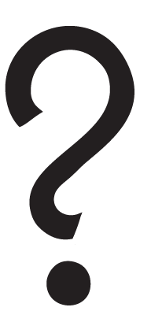
Ab Wheel Exercise
FREE PARKING
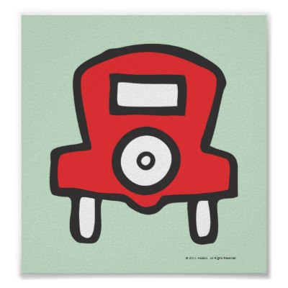
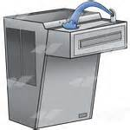

Take a Waterbreak!

ORIENTAL AVENUE
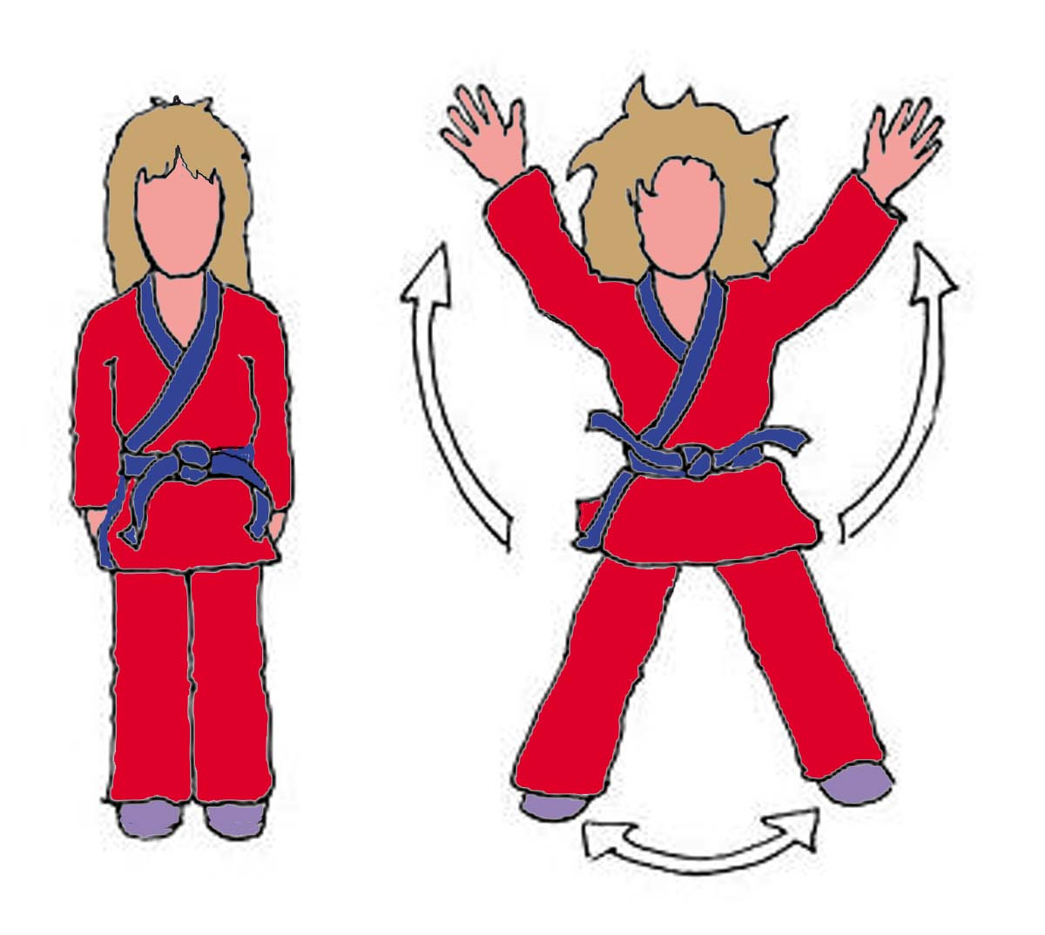
JUMPING JACKS

BALTIC AVENUE
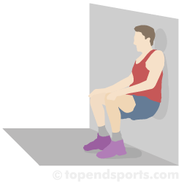
WALL SITS

NEW YORK AVENUE
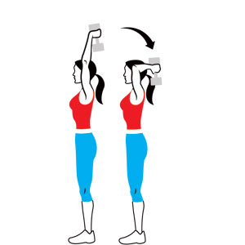
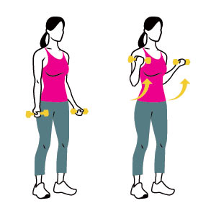
BICEP CURL & TRICEP EXTENSION

VENTNOR AVENUE
RUN IN PLACE

PENNSYLVANIA AVENUE
SIT AND REACH

ILLINOIS AVENUE
BODY SQUATS

INDIANA AVENUE

JUMPING JACKS

NEW YORK AVENUE
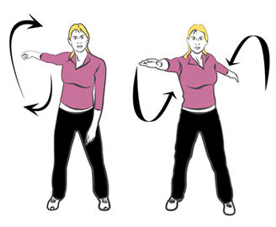

ARM CIRCLES

ST. JAMES PLACE

BICEPS CURLS & TRICEPS EXTENSIONS

VIRGINIA AVENUE

WALL SITS

STATES AVENUE

JUMPING JACKS

CONNECTICUT AVENUE

SIT AND REACH

MEDITERRANEAN AVENUE

PLYO JUMPS

PARK PLACE

CRAB WALK
PENNSYLVANIA RAILROAD
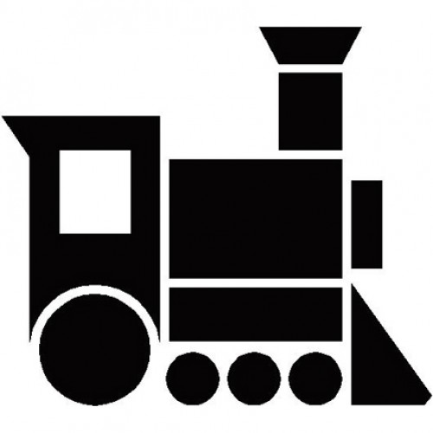
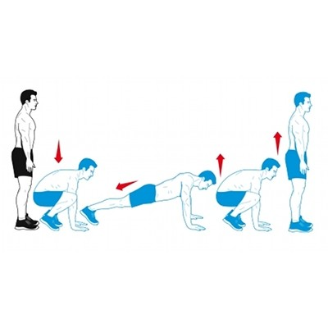
BURPEE
SHORT LINE
BURPEE
READING RAILROAD
BURPEE
B&O
RAILROAD
BURPEE
WATER WORKS
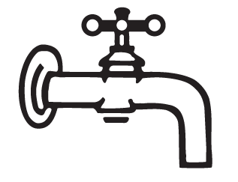
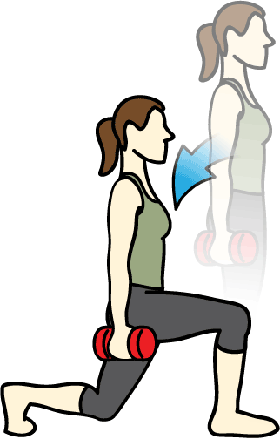
REVERSE LUNGES
LUXURY TAX
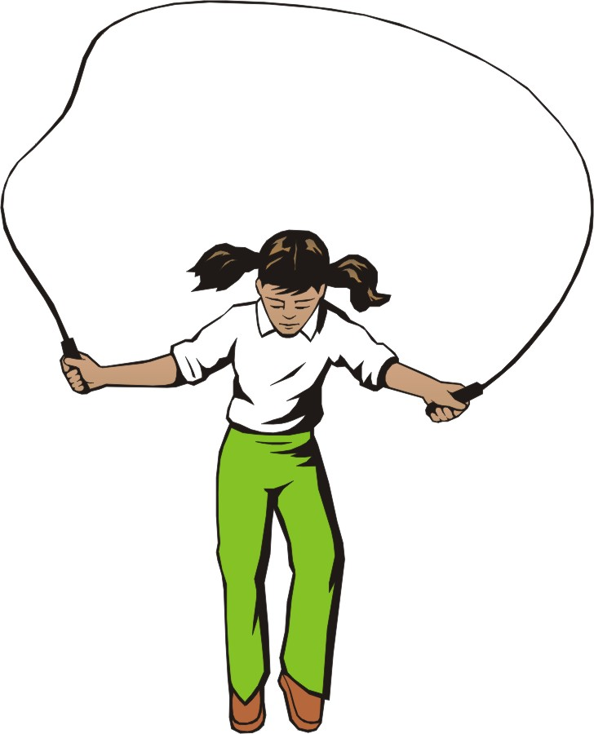
JUMP ROPE

INCOME TAX
JUMP ROPE

ELECTRIC COMPANY
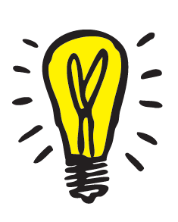
REVERSE LUNGES
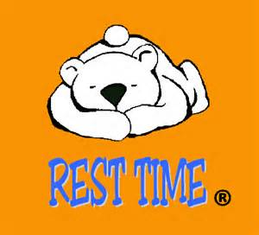
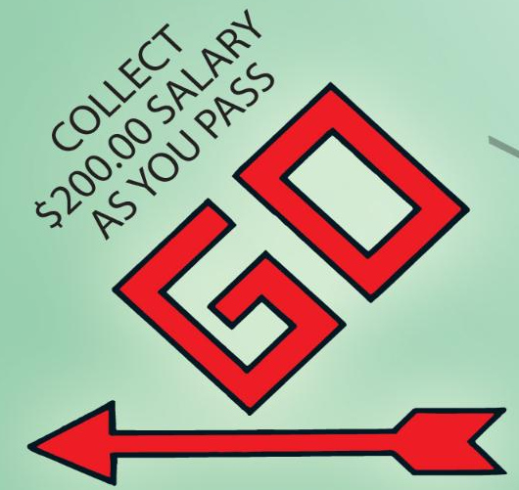

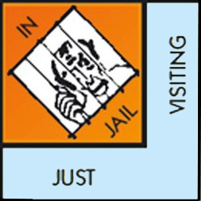

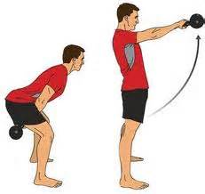
MEMPHIS AVENUE

BODY SQUATS

NASHVILLE AVENUE

PLANKS

BEALE STREET

FORWARD LUNGES

OHIO AVENUE

RUN IN PLACE

IOWA AVENUE

PUSH-UPS

KANSAS AVENUE
JUMP ROPE

CALIFORNIA AVENUE
AEROBIC STEP-UPS

OREGON AVENUE
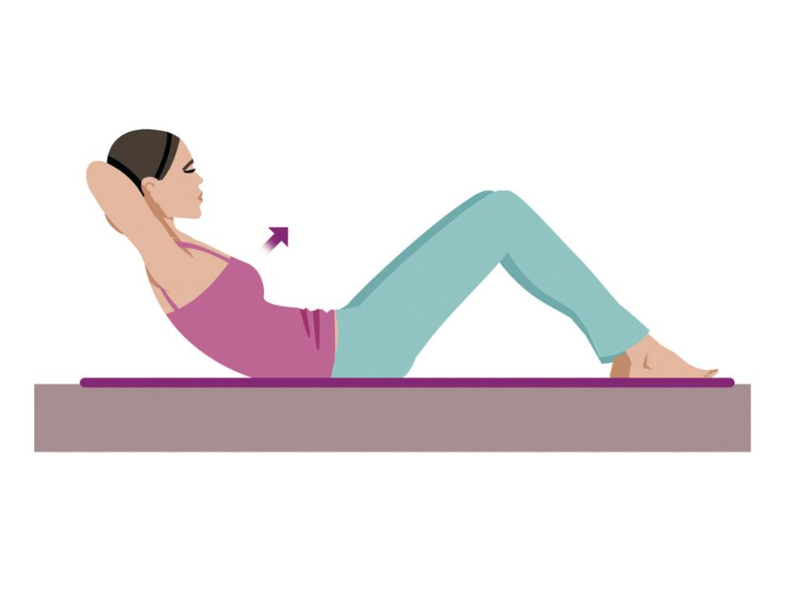
SIT-UPS

NEW ORLEANS AVENUE
JUMPING JACKS

MIAMI AVENUE

ARM CIRCLES

DALLAS AVENUE
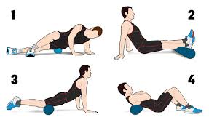

FOAM ROLLER

Belmont Avenue
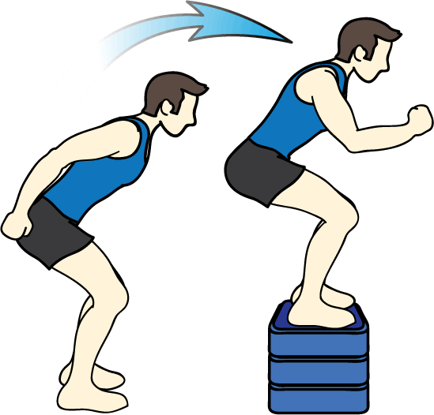
PLYOMETRIC BOX JUMPS

