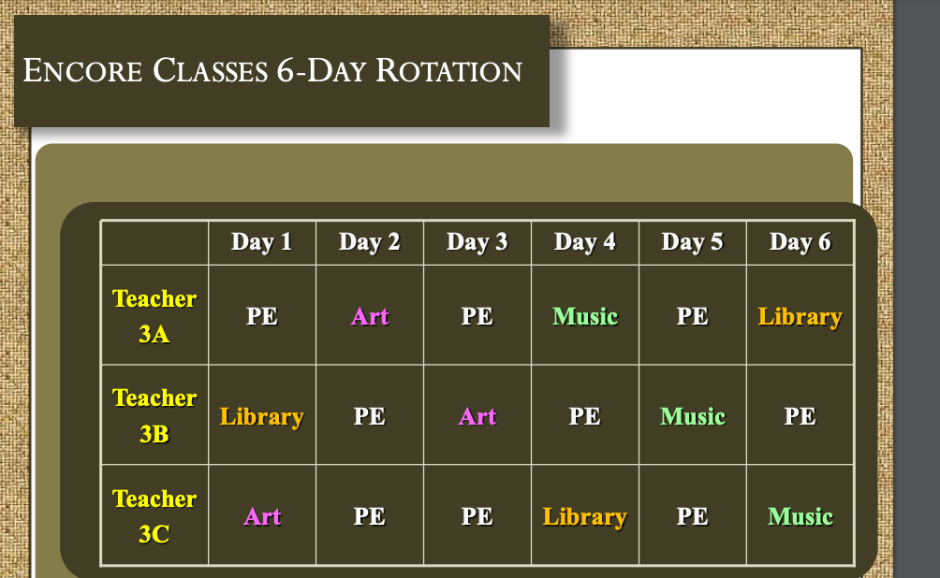

- School can have a 6-day rotation for Encore classes.

- Guidance would take the place of the 3rd PE class from above schedule

- Library/Keyboarding would alternate from week to week

- Students would receive the 2 PE classes per week with this layout and wouldn’t have to take away other Encore classes.

- Schedule would have to be made out on monthly calendar for teachers to view, since they wouldn’t necessarily have the same class on the same day each week.

Sample Schedule:
1st Grade FHES

Teacher | Day 1 | Day 2 | Day 3 | Day 4 | Day 5 | Day 6
Ayers | PE | Art | PE | Music | Library | Guidance
Berggren | Guidance | PE | Art | PE | Music | Library
Brooke | Library | Guidance | PE | Art | PE | Music
Browning | Music | Library | Guidance | PE | Art | PE
Dowdle | PE | Music | Library | Guidance | PE | Art
MacFeggan | Art | PE | Music | Library | Guidance | PE

