Tier 1 Goalkeepers | Tier 2 Goalkeepers | Tier 3 Goalkeepers
25 press ups | 15 press ups | 5 push ups
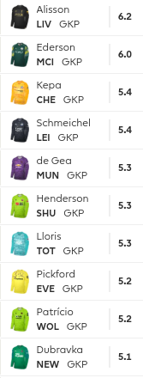 | 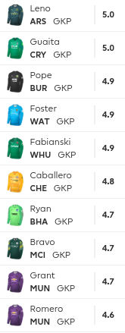 | 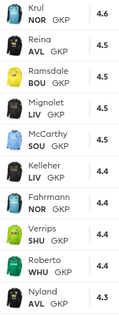

Tier 1 Defenders | Tier 2 Defenders | Tier 3 Defenders
25 sit ups (per defender) | 15 sit ups (per defender) | 10 sit ups (per defender)
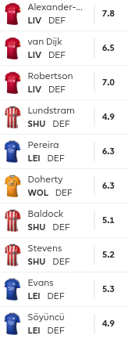 | 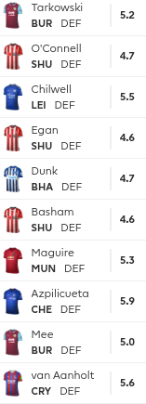 | 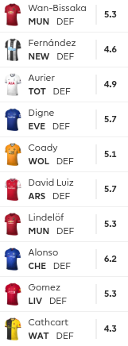

Tier 1 Midfielders | Tier 2 Midfielders | Tier 3 Midfielders
30 Burpees (per midfielder) | 20 Burpees (per midfielder) | 10 Burpees (per midfielder)
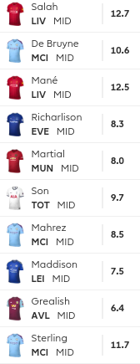 | 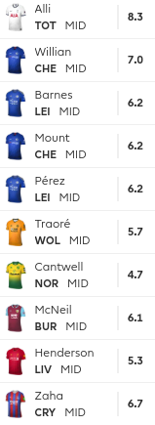 | 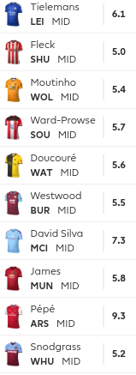

Tier 1 Strikers | Tier 2 Strikers | Tier 3 Strikers
40 Star Jumps (per striker) | 30 Star Jumps (per striker) | 20 Star Jumps (per striker)
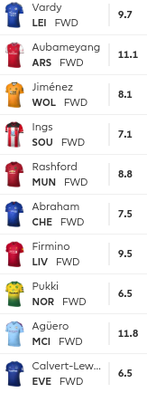 | 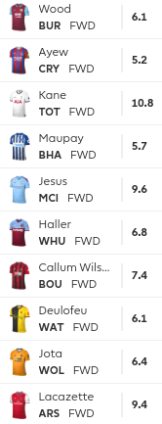 | 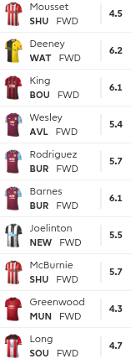

Sub Keeper | Sub Defender | Sub Midfielder | Sub Striker
1 minute plank for every sub you select (Max 4 subs)
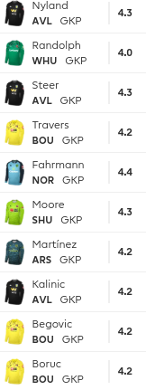 | 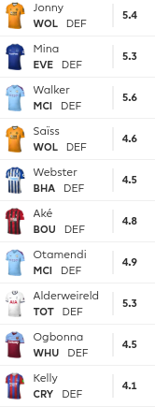 | 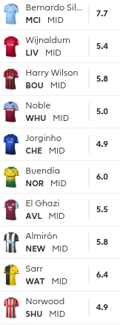 | 