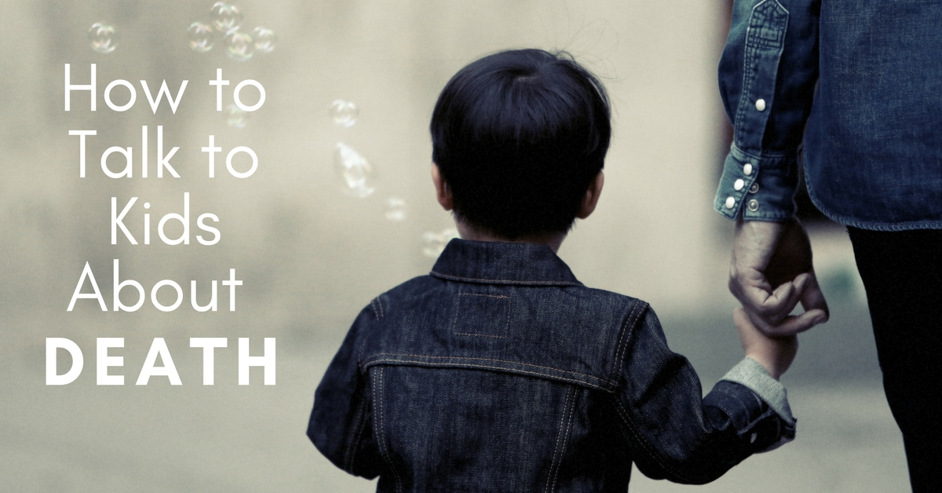
Discussing death with your kids can be a real concern and many tend to avoid it. Death is however an inevitable part of life and it is our responsibility to ensure our kids are aware of it and know it’s okay to discuss it.
If we allow children to talk to us about death, we can give them needed information, prepare them for a crisis, and help them when they are upset. We can encourage their communication by showing attention and respect for what they have to say. We can also make it easier for them to talk to us if we are open, honest, and at ease with our own feelings.
Death is very much a part of our lives on many different levels. We may be surprised at how aware children already are about death. They see dead insects, dead birds and animals on the road or a family pet may have died. Children read about death in their fairy tales, watch it in cartoons and even role-play death in school plays. Without realising it they already have some exposure to the concept.

Problems That Make Discussing Death Difficult
- We avoid talking about things that upset us. We bottle it up and hope that by saying nothing will help it go away. Children are sensitive barometers of emotion and are tremendous observers. They know something is wrong by simply watching us. Our body language, emotions on our faces, what we say and what we don’t say are all communicating a message to our kids.When we choose not to discuss an issue with our kids they too hesitate to ask questions. They automatically think “If Mummy and Daddy are so upset that they can’t talk about it, I had better not talk about it either……it must be bad!”. This causes our kids to stress and worry more as they don’t know how we are feeling.
- We feel uncomfortable when we don’t have all the answers. As a teacher and parent myself, kids will often expect us to know everything, even all about death. Take it as a compliment and know that they look up to us.It is okay to say to your child “I’m not sure myself about that” or “I just don’t know the answer to that”. Children respond to this honesty beautifully and feel connected in our openness towards them. It helps them feel better about not knowing everything also. In discussing death, we may find different answers at different stages in our life or grieving process.Share with children your beliefs. Expose them to the belief of others, for example some people believe in afterlife, others do not. Allow them to be comforted in knowing your beliefs and allow them to choose their own.
- Death is often a taboo subject– in some cultures death is an integral part of family life. People died in their home environment, surrounded by loved ones (adults and children alike). They comforted each other and mourned together.Unfortunately today death is much lonelier. Many people die in isolation and loved ones miss sharing their last moments. The living has in some ways become separated from the dying; consequently, death has taken on added mystery and, for some, added fear.
Help to diminish this trend and openly discuss death with your child when an appropriate time arises. Model appropriate behaviour regarding death, for example express your sympathy towards someone who has lost a loved one in front of your child. Show them that it is kind to acknowledge a loss and express care towards others.

Developmental Stages of Understanding – A General Guide
- Preschool children mostly see death as temporary, reversible and impersonal. In stories they read or watch characters will often suddenly rise up alive again after being totally destroyed. It’s not surprising they don’t understand, yet it is appropriate for their age level to think this way.
- Between the ages of five and nine, most children are beginning to see that all living things eventually die and that death is final. They tend to not relate it to themselves and consider the idea that they can escape it. They may associate images with death, such as a skeleton. Some children have nightmares about them.
- From nine through to adolescence, children to begin to understand fully that death is irreversible and that they too will die some day.
It is important to remember however that all children develop at different rates and that children experience life uniquely. They have their own personal ways of handling and expressing emotions.
It is not uncommon for a three year old to ask questions about death, for a child to be openly unconcerned about the death of a grandparent yet devastated over the death of a pet. Some children show their understanding of death through playing with their toys.
It is important to explain death in simple terms for young children. For example, when someone dies they don’t breathe, or eat, or feel hungry or cold and you won’t be able to see them again.
No matter how children cope with death or express their feelings, they need sensitive and nonjudgmental responses from adults. Careful listening and observing are important ways to learn how to respond appropriately to a child’s needs.

Talking About Death With Preschoolers or Young Children
Many people feel challenged when approaching the subject of death to preschoolers and young children. They in particular need brief and simple explanations. Using concrete and familiar examples may help. For example, death may be made more clear by explaining it in terms of the absence of familiar life functions – when people die they do not breathe, eat, talk, think, or feel any more; when dogs die they do not bark or run anymore; dead flowers do not grow or bloom any more.
Children learn through repetition so they may need to go over this quite a few times. A child may immediately ask more questions, others may be silent, then wish to revisit the subject again later. Children sometimes get confused with what they hear so it is important you check their understanding by revisiting the subject at appropriate times.
As time passes and children have new experiences, they will need further explanations and sharing of ideas and thoughts.
It may take time for a child to comprehend fully the ramifications of death and its emotional implications. A child who knows that Uncle Tom has died may still ask why Aunt Julie is crying. The child needs an answer. “Aunt Julie is crying because she is sad that Uncle Tom has died. She misses him very much. We all feel sad when someone we care about dies.”
There are also moments when we have trouble “understanding” what children are asking us. A question that may seem dreadfully thoughtless to an adult may be a child’s request for reassurance. For instance, a question such as, “When will you die?” needs to be heard with the realization that the young child perceives death as temporary.
While the permanency of death is not yet fully understood, a child may think that death means separation, and separation from parents and the loss of care involved are frightening.
Being cared for is a realistic and practical concern, and a child needs to be reassured. Possibly the best way to answer a question is by asking a clarifying question in return: “Are you worried that I won’t be here to take care of you?” If that is the case, the reassuring and appropriate answer would be something like, “I don’t expect to die for a long time. I expect to be here to take care of you as long as you need me, but if I did die, there are lots of people to take care of you. There’s Daddy, Aunt Laura and Uncle John or Nan.”
It is important to check which words you use when discussing death with your kids. Some children confuse death with sleep, particularly if they hear adults refer to death with one of the many euphemisms for sleep – “they died in their sleep”, “eternal rest”, “rest in peace.” Resulting from this confusion, a child may be afraid of going to bed, in case they don’t wake up either!
Similarly, if children are told that someone who died “went away”, brief separations may begin to worry them. Grandpa “went away” and hasn’t come back yet. Maybe Mummy won’t come back from the shops or from work. Therefore, it is important to avoid such words as “sleep”, “rest”, or “went away” when talking to a child about death.
To avoid confusion with preschoolers and very young children, it helps to explain that only very serious illness may cause death. When they hear that sickness was the cause of death, we don’t want them to assume that minor ailments are a cause for major concern.
When a child associates death only with old age, they can become very confused when they learn that young people can die too. It is important to explain that most people live a long time, but some don’t. However we do expect that we will live a very long time (always reassure them)!

Religious References
Religion is a real source of strength for many people in a time of grieving. If however religion has not played a part in your child’s life before dealing with death, it may be very confusing and worrying to hear religious references. For example, the explanation “Big sister is with God now” may comfort an adult, but frighten a child. They may fear that God will come and take them away as He did big sister. Ensure that your child has an affiliation for your terms so they feel familiar and can understand.
Other messages may confuse children, including statements such as “Tommy is happy in Heaven with the angels”. They may wonder why everyone is so unhappy when they say that Tommy is happy. They need to hear about the sadness being felt from losing Tommy, along with our expressions of religious faith.
It is important to help children understand the realities of death, being the loss and the grief. Trying to shelter children from these realities only denies them from the opportunity to express their feelings and be comforted. Sharing feelings between you and your child will benefit you both.

Other Opportunities To Talk About Death
Children tend to be extremely curious when they discover death, particularly dead flowers, birds, trees and insects. This may open windows of opportunity to discuss death further and answer all the detailed questions that may arise. Try to reinforce the concept that all living things eventually die, but it makes room for new things to join us on earth.
Other opportunities to discuss death with your kids arise when well-known persons die and their funeral receives a lot of media coverage. This is a natural time to clarify any misunderstandings they may have about death. If the death is violent or aggressive however, you need to reassure your child that they are safe and most people do not behave this way towards each other.
Attending Funerals
If your child is to attend a funeral, they need to be prepared beforehand for what they might see and hear before, during and after the service. Explain that it is a very sad occasion and that some people will be crying and others feeling very sad.
Seat your child next to you or someone they are familiar with who is able to cope with their questions and be prepared to offer explanations. If your child prefers to not attend the funeral, they must not be forced.
Mourning
We all need to mourn in order to heal our sorrows and move on in our lives. By being open with our emotions and showing our sorrow and tears, expresses to our children that it is okay that they also feel sad and cry. We should never associate tears and expressing feelings with weakness.
Children often feel guilty and angry when they lose a close family member. They need reassurance that they have been, and will continue to be, loved and cared for.

In Summary
A grieving child needs information that is clear and comprehensible for their development level. They need a lot of reassurance that they are safe and loved and be made feel that they can discuss their feelings openly. Children need to maintain their activities and interests as they desire and revisit questions regularly.
When preparing a child for an anticipated death, allow them to help care for the dying person if they desire, receive lots of affection and answer questions, be given information about the physical, emotional, and mental condition of the terminally ill person and be given a choice of visiting or remaining away.

