Cypress Naturals Joins Healthy & Active Germantown
GMSD
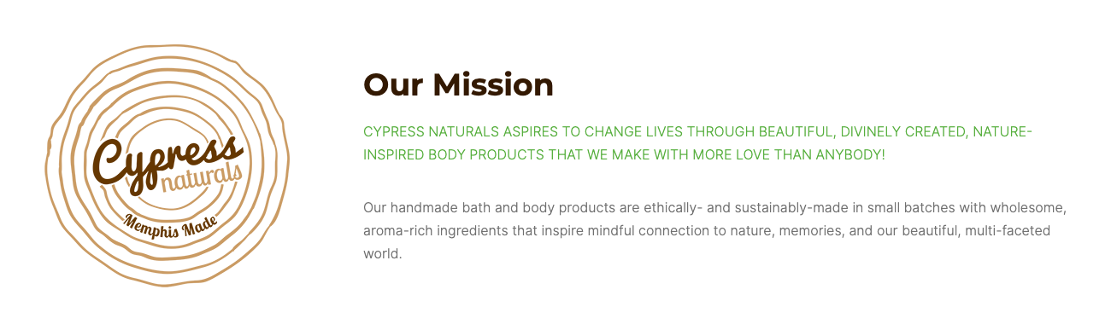

GMSD Employees will receive a 25% discount

Must be done in person at the Germantown Location

Discount Code: GMSD25

https://cypressnaturalsmemphis.com/

Owner: Diana Foster

Discount goes into effect: 09/04/2020

