Directions: Start with jogging in place, then follow the arrows after each choice you make to create your workout. Example included.

You may turn in a reflection (what exercises did you complete, how long did it take you, etc.), video clip of your workout, Screenshot the table and highlight the exercises you completed, or a sweaty selfie.

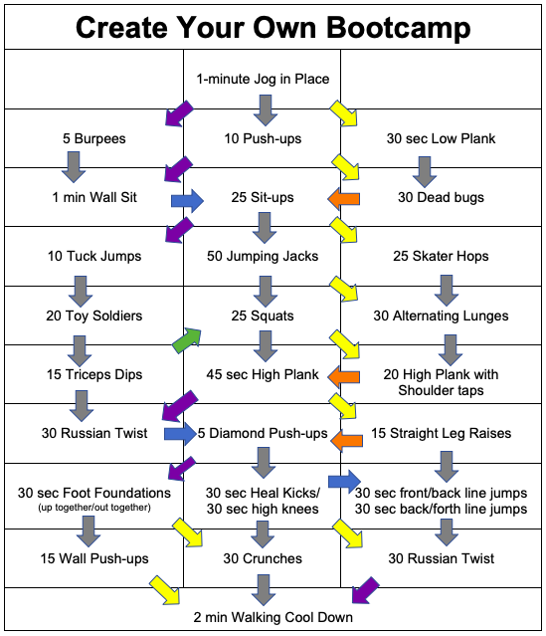
You can follow my example to help guide you through your own workout. The exercises in this workout are highlighted on orange and are numbered so you can see the order they were completed.