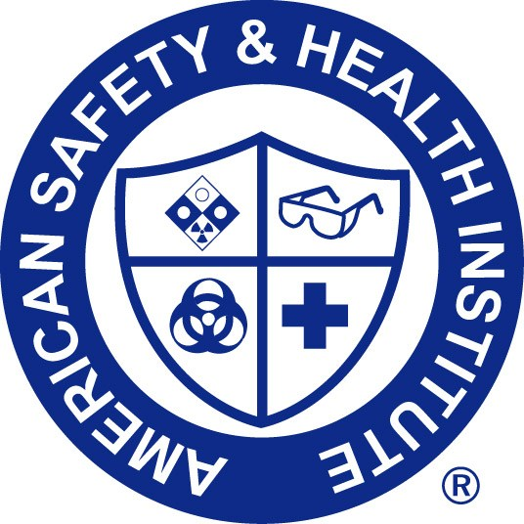

Emergency cpr & aed use
Adult, child & infant certified

has successfully completed the objectives and skills evaluations in accordance with the curriculum of the ASHI CPR and AED Programs.

Date Completed: _____________________ Valid Until: ________________________

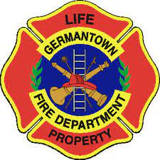

___________________
Training Center I.D.
____________________________
Registry No.

_______________________________
Authorized Instructor
Andrew Martin
________________________
Training Center Phone Number

