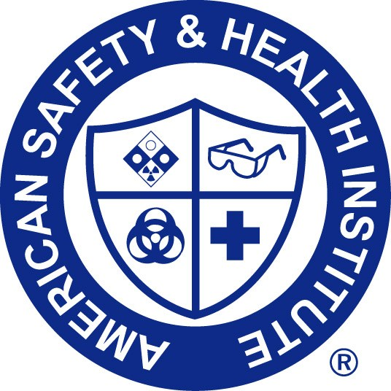

Emergency First-Aid & CPR/AED

has successfully completed the objectives and skills evaluations in accordance with the curriculum of the ASHI First-Aid, CPR, and AED Programs.

Date Completed: _____________________ Valid Until: ________________________

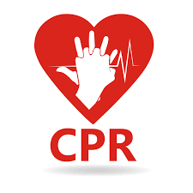

_______________________________

Andrew Martin
School Health Supervisor ____________________
ASHI Instructor Center Number

