Count to 10 in 10 Different Languages

Description: C:\Documents and Settings\wchamplin\Local Settings\Temporary Internet Files\Content.IE5\1RPHYFQK\MC900309844[1].wmf

 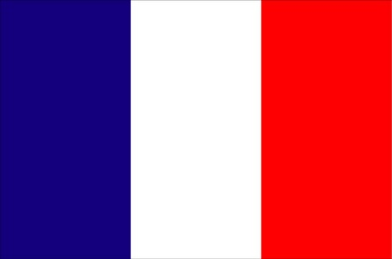 

  

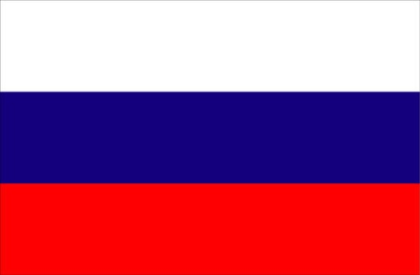  

English, Spanish, French, Italian, German, Chinese (Mandarin), Japanese, Hebrew, Russian, Greek, and Polish

|  |  |
| --- | --- |
| **English** | **Spanish** |
| 1. [one](http://webschool.wash.k12.ut.us/language/spanish/numbers/one.wav) (wuhn) | uno (oo-noh) |
| 2. [two](http://webschool.wash.k12.ut.us/language/spanish/numbers/two.wav) (too) | dos (dohs) |
| 3. [three](http://webschool.wash.k12.ut.us/language/spanish/numbers/three.wav) (three) | tres (trays) |
| 4. [four](http://webschool.wash.k12.ut.us/language/spanish/numbers/four.wav) (fawr) | quatro (kwah-troh) |
| 5. [five](http://webschool.wash.k12.ut.us/language/spanish/numbers/five.wav) (fahyv) | cinco (seen-koh) |
| 6. [six](http://webschool.wash.k12.ut.us/language/spanish/numbers/six.wav) (siks) | seis (says) |
| 7. [seven](http://webschool.wash.k12.ut.us/language/spanish/numbers/seven.wav) (sev-uhhttp://sp.dictionary.com/dictstatic/dictionary/graphics/luna/thinsp.pngn) | siete (syay-tay) |
| 8. [eight](http://webschool.wash.k12.ut.us/language/spanish/numbers/eight.wav) (eyt) | ocho (oh-choh) |
| 9. [nine](http://webschool.wash.k12.ut.us/language/spanish/numbers/nine.wav) (nahyn) | nueve (nway-vay) |
| 10. [ten](http://webschool.wash.k12.ut.us/language/spanish/numbers/ten.wav) (ten) | diez (dyays) |



|  |  |
| --- | --- |
| **English** | **French** |
| 1. [one](http://webschool.wash.k12.ut.us/language/spanish/numbers/one.wav) (wuhn) | un (uhn) |
| 2. [two](http://webschool.wash.k12.ut.us/language/spanish/numbers/two.wav) (too) | deux (deu) |
| 3. [three](http://webschool.wash.k12.ut.us/language/spanish/numbers/three.wav) (three) | trois (twa) |
| 4. [four](http://webschool.wash.k12.ut.us/language/spanish/numbers/four.wav) (fawr) | quatre (cat) |
| 5. [five](http://webschool.wash.k12.ut.us/language/spanish/numbers/five.wav) (fahyv) | cing (sank) |
| 6. [six](http://webschool.wash.k12.ut.us/language/spanish/numbers/six.wav) (siks) | six (sees) |
| 7. [seven](http://webschool.wash.k12.ut.us/language/spanish/numbers/seven.wav) (sev-uhhttp://sp.dictionary.com/dictstatic/dictionary/graphics/luna/thinsp.pngn) | sept (set) |
| 8. [eight](http://webschool.wash.k12.ut.us/language/spanish/numbers/eight.wav) (eyt) | huit (weet) |
| 9. [nine](http://webschool.wash.k12.ut.us/language/spanish/numbers/nine.wav) (nahyn) | neuf (noof) |
| 10. [ten](http://webschool.wash.k12.ut.us/language/spanish/numbers/ten.wav) (ten) | dix (dees) |



|  |  |
| --- | --- |
| **English** | Italian |
| 1. [one](http://webschool.wash.k12.ut.us/language/spanish/numbers/one.wav) (wuhn) | **uno** (OO-noh) |
| 2. [two](http://webschool.wash.k12.ut.us/language/spanish/numbers/two.wav) (too) | **due** (DOO-eh) |
| 3. [three](http://webschool.wash.k12.ut.us/language/spanish/numbers/three.wav) (three) | **tré** (treh) |
| 4. [four](http://webschool.wash.k12.ut.us/language/spanish/numbers/four.wav) (fawr) | **quattro** (KWAHT-troh) |
| 5. [five](http://webschool.wash.k12.ut.us/language/spanish/numbers/five.wav) (fahyv) | **cinque** (CHEEN-kweh) |
| 6. [six](http://webschool.wash.k12.ut.us/language/spanish/numbers/six.wav) (siks) | **sei** (say) |
| 7. [seven](http://webschool.wash.k12.ut.us/language/spanish/numbers/seven.wav) (sev-uhhttp://sp.dictionary.com/dictstatic/dictionary/graphics/luna/thinsp.pngn) | **sette** (SEHT-teh) |
| 8. [eight](http://webschool.wash.k12.ut.us/language/spanish/numbers/eight.wav) (eyt) | **otto** (OHT-toh) |
| 9. [nine](http://webschool.wash.k12.ut.us/language/spanish/numbers/nine.wav) (nahyn) | **nove** (NOH-veh) |
| 10. [ten](http://webschool.wash.k12.ut.us/language/spanish/numbers/ten.wav) (ten) | **dieci** (DYEH-chee) |



|  |  |
| --- | --- |
| **English** | German |
| 1. [one](http://webschool.wash.k12.ut.us/language/spanish/numbers/one.wav) (wuhn) | *eins* (Ighnss) |
| 2. [two](http://webschool.wash.k12.ut.us/language/spanish/numbers/two.wav) (too) | *zwei* (tsvigh) |
| 3. [three](http://webschool.wash.k12.ut.us/language/spanish/numbers/three.wav) (three) | *drei* (dry) |
| 4. [four](http://webschool.wash.k12.ut.us/language/spanish/numbers/four.wav) (fawr) | *vier* (fear) |
| 5. [five](http://webschool.wash.k12.ut.us/language/spanish/numbers/five.wav) (fahyv) | *fünf* (fuunf) |
| 6. [six](http://webschool.wash.k12.ut.us/language/spanish/numbers/six.wav) (siks) | *sechs* (zekhs) |
| 7. [seven](http://webschool.wash.k12.ut.us/language/spanish/numbers/seven.wav) (sev-uhhttp://sp.dictionary.com/dictstatic/dictionary/graphics/luna/thinsp.pngn) | *sieben* (zee-ben) |
| 8. [eight](http://webschool.wash.k12.ut.us/language/spanish/numbers/eight.wav) (eyt) | *acht* (ahkht) |
| 9. [nine](http://webschool.wash.k12.ut.us/language/spanish/numbers/nine.wav) (nahyn) | *neun* (noyn) |
| 10. [ten](http://webschool.wash.k12.ut.us/language/spanish/numbers/ten.wav) (ten) | *zehn* (tsayn) |



|  |  |
| --- | --- |
| **English** | Chinese (Mandarin) |
| 1. [one](http://webschool.wash.k12.ut.us/language/spanish/numbers/one.wav) (wuhn) | 一 Yi (yee) |
| 2. [two](http://webschool.wash.k12.ut.us/language/spanish/numbers/two.wav) (too) | 二 Er (uhr) |
| 3. [three](http://webschool.wash.k12.ut.us/language/spanish/numbers/three.wav) (three) | 三 San (sahn) |
| 4. [four](http://webschool.wash.k12.ut.us/language/spanish/numbers/four.wav) (fawr) | 四 Si (suh) |
| 5. [five](http://webschool.wash.k12.ut.us/language/spanish/numbers/five.wav) (fahyv) | 五Wu (woo) |
| 6. [six](http://webschool.wash.k12.ut.us/language/spanish/numbers/six.wav) (siks) | 六 Liu (lyo) |
| 7. [seven](http://webschool.wash.k12.ut.us/language/spanish/numbers/seven.wav) (sev-uhhttp://sp.dictionary.com/dictstatic/dictionary/graphics/luna/thinsp.pngn) | 七 Qui (chee) |
| 8. [eight](http://webschool.wash.k12.ut.us/language/spanish/numbers/eight.wav) (eyt) | 八 Ba (bah) |
| 9. [nine](http://webschool.wash.k12.ut.us/language/spanish/numbers/nine.wav) (nahyn) | 九 Ju (jyo) |
| 10. [ten](http://webschool.wash.k12.ut.us/language/spanish/numbers/ten.wav) (ten) | 十 Shi (shi) |



|  |  |
| --- | --- |
| **English** | Japanese |
| 1. [one](http://webschool.wash.k12.ut.us/language/spanish/numbers/one.wav) (wuhn) | 一 ichi (itchy) |
| 2. [two](http://webschool.wash.k12.ut.us/language/spanish/numbers/two.wav) (too) | 二 ni (knee) |
| 3. [three](http://webschool.wash.k12.ut.us/language/spanish/numbers/three.wav) (three) | 三 san (Sun) |
| 4. [four](http://webschool.wash.k12.ut.us/language/spanish/numbers/four.wav) (fawr) | 四 shi (she) |
| 5. [five](http://webschool.wash.k12.ut.us/language/spanish/numbers/five.wav) (fahyv) | 五 go (go) |
| 6. [six](http://webschool.wash.k12.ut.us/language/spanish/numbers/six.wav) (siks) | 六 roku (rowk) |
| 7. [seven](http://webschool.wash.k12.ut.us/language/spanish/numbers/seven.wav) (sev-uhhttp://sp.dictionary.com/dictstatic/dictionary/graphics/luna/thinsp.pngn) | 七 shichi (shi-chi) |
| 8. [eight](http://webschool.wash.k12.ut.us/language/spanish/numbers/eight.wav) (eyt) | 八 hachi (hat-chi) |
| 9. [nine](http://webschool.wash.k12.ut.us/language/spanish/numbers/nine.wav) (nahyn) | 九 kyu (coo) |
| 10. [ten](http://webschool.wash.k12.ut.us/language/spanish/numbers/ten.wav) (ten) | 十 ju (ju) |



|  |  |
| --- | --- |
| **English** | Russian |
| 1. [one](http://webschool.wash.k12.ut.us/language/spanish/numbers/one.wav) (wuhn) | Один (a-deen) |
| 2. [two](http://webschool.wash.k12.ut.us/language/spanish/numbers/two.wav) (too) | Два (dva) |
| 3. [three](http://webschool.wash.k12.ut.us/language/spanish/numbers/three.wav) (three) | Три (tree) |
| 4. [four](http://webschool.wash.k12.ut.us/language/spanish/numbers/four.wav) (fawr) | Четыре (chye-tir-ye) |
| 5. [five](http://webschool.wash.k12.ut.us/language/spanish/numbers/five.wav) (fahyv) | Пять (pyat) |
| 6. [six](http://webschool.wash.k12.ut.us/language/spanish/numbers/six.wav) (siks) | Шесть (shest) |
| 7. [seven](http://webschool.wash.k12.ut.us/language/spanish/numbers/seven.wav) (sev-uhhttp://sp.dictionary.com/dictstatic/dictionary/graphics/luna/thinsp.pngn) | Семь (syem) |
| 8. [eight](http://webschool.wash.k12.ut.us/language/spanish/numbers/eight.wav) (eyt) | Восемь (vo-syem) |
| 9. [nine](http://webschool.wash.k12.ut.us/language/spanish/numbers/nine.wav) (nahyn) | Девять (dyev-yat) |
| 10. [ten](http://webschool.wash.k12.ut.us/language/spanish/numbers/ten.wav) (ten) | Десять (dyes-yat) |

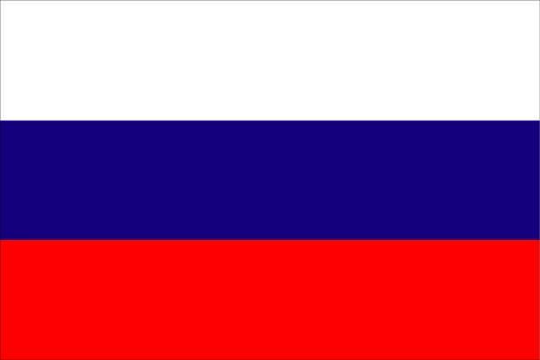

|  |  |
| --- | --- |
| **English** | Greek |
| 1. [one](http://webschool.wash.k12.ut.us/language/spanish/numbers/one.wav) (wuhn) | Ένα (aena) |
| 2. [two](http://webschool.wash.k12.ut.us/language/spanish/numbers/two.wav) (too) | Δύο (thee-o) |
| 3. [three](http://webschool.wash.k12.ut.us/language/spanish/numbers/three.wav) (three) | Τρία (tree-a) |
| 4. [four](http://webschool.wash.k12.ut.us/language/spanish/numbers/four.wav) (fawr) | Τέσσερα (taess-aer-a) |
| 5. [five](http://webschool.wash.k12.ut.us/language/spanish/numbers/five.wav) (fahyv) | Πέντε (paend-ae) |
| 6. [six](http://webschool.wash.k12.ut.us/language/spanish/numbers/six.wav) (siks) | Έξι (aeks-ee) |
| 7. [seven](http://webschool.wash.k12.ut.us/language/spanish/numbers/seven.wav) (sev-uhhttp://sp.dictionary.com/dictstatic/dictionary/graphics/luna/thinsp.pngn) | Εφτά (aefta) |
| 8. [eight](http://webschool.wash.k12.ut.us/language/spanish/numbers/eight.wav) (eyt) | Οχτώ (oct-o) |
| 9. [nine](http://webschool.wash.k12.ut.us/language/spanish/numbers/nine.wav) (nahyn) | Εννιά (en-ey-ya) |
| 10. [ten](http://webschool.wash.k12.ut.us/language/spanish/numbers/ten.wav) (ten) | Δέκα (thae-ca) |



|  |  |
| --- | --- |
| **English** | Polish |
| 1. [one](http://webschool.wash.k12.ut.us/language/spanish/numbers/one.wav) (wuhn) | Jeden (YEH-den) |
| 2. [two](http://webschool.wash.k12.ut.us/language/spanish/numbers/two.wav) (too) | dwa (dvah) |
| 3. [three](http://webschool.wash.k12.ut.us/language/spanish/numbers/three.wav) (three) | trzy (tzhih) |
| 4. [four](http://webschool.wash.k12.ut.us/language/spanish/numbers/four.wav) (fawr) | cztery (CHTEH-rih) |
| 5. [five](http://webschool.wash.k12.ut.us/language/spanish/numbers/five.wav) (fahyv) | piec (pyench) |
| 6. [six](http://webschool.wash.k12.ut.us/language/spanish/numbers/six.wav) (siks) | szesc (sheshch) |
| 7. [seven](http://webschool.wash.k12.ut.us/language/spanish/numbers/seven.wav) (sev-uhhttp://sp.dictionary.com/dictstatic/dictionary/graphics/luna/thinsp.pngn) | siedem (SHEH-dem) |
| 8. [eight](http://webschool.wash.k12.ut.us/language/spanish/numbers/eight.wav) (eyt) | osiem (OH-shem) |
| 9. [nine](http://webschool.wash.k12.ut.us/language/spanish/numbers/nine.wav) (nahyn) | dziewiec (JEV-yench) |
| 10. [ten](http://webschool.wash.k12.ut.us/language/spanish/numbers/ten.wav) (ten) | dziesiec (JESH-yench) |



English



1

[one](http://webschool.wash.k12.ut.us/language/spanish/numbers/one.wav)

(wuhn)

Description: C:\Documents and Settings\wchamplin\Local Settings\Temporary Internet Files\Content.IE5\1RPHYFQK\MC900309844[1].wmf2

[two](http://webschool.wash.k12.ut.us/language/spanish/numbers/two.wav)

(too)

Description: C:\Documents and Settings\wchamplin\Local Settings\Temporary Internet Files\Content.IE5\1RPHYFQK\MC900309844[1].wmf

3

[three](http://webschool.wash.k12.ut.us/language/spanish/numbers/three.wav)

(three)

Description: C:\Documents and Settings\wchamplin\Local Settings\Temporary Internet Files\Content.IE5\1RPHYFQK\MC900309844[1].wmf

4

[four](http://webschool.wash.k12.ut.us/language/spanish/numbers/four.wav)

(fawr)

Description: C:\Documents and Settings\wchamplin\Local Settings\Temporary Internet Files\Content.IE5\1RPHYFQK\MC900309844[1].wmf

5

[five](http://webschool.wash.k12.ut.us/language/spanish/numbers/five.wav)

(fahyv)

Description: C:\Documents and Settings\wchamplin\Local Settings\Temporary Internet Files\Content.IE5\1RPHYFQK\MC900309844[1].wmf

6

[six](http://webschool.wash.k12.ut.us/language/spanish/numbers/six.wav)

(siks)

Description: C:\Documents and Settings\wchamplin\Local Settings\Temporary Internet Files\Content.IE5\1RPHYFQK\MC900309844[1].wmf

7

[seven](http://webschool.wash.k12.ut.us/language/spanish/numbers/seven.wav)

(sev-uhhttp://sp.dictionary.com/dictstatic/dictionary/graphics/luna/thinsp.pngn)

Description: C:\Documents and Settings\wchamplin\Local Settings\Temporary Internet Files\Content.IE5\1RPHYFQK\MC900309844[1].wmf

8

[eight](http://webschool.wash.k12.ut.us/language/spanish/numbers/eight.wav)

(eyt)

Description: C:\Documents and Settings\wchamplin\Local Settings\Temporary Internet Files\Content.IE5\1RPHYFQK\MC900309844[1].wmf

9

[nine](http://webschool.wash.k12.ut.us/language/spanish/numbers/nine.wav)

(nahyn)

Description: C:\Documents and Settings\wchamplin\Local Settings\Temporary Internet Files\Content.IE5\1RPHYFQK\MC900309844[1].wmf

10

[ten](http://webschool.wash.k12.ut.us/language/spanish/numbers/ten.wav)

(ten)

Description: C:\Documents and Settings\wchamplin\Local Settings\Temporary Internet Files\Content.IE5\1RPHYFQK\MC900309844[1].wmf

Spanish

1

uno

(oo-noh)



2

dos

(dohs)



3

tres

(trays)



4

quatro

(kwah-troh)



5

cinco

(seen-koh)



6

seis

(says)



7

siete

(syay-tay)



8

ocho

(oh-choh)



9

nueve

(nway-vay)



10

diez

(dyays)



French



1

un

(uhn)



2

deux

(deu)



3

trois

(twa)



4

quatre

(cat)



5

cing

(sank)



6

six

(sees)



7

sept

(set)



8

huit

(weet)



9

neuf

(noof)



10

dix

(dees)



Italian



1

uno

(OO-noh)



2

due

(DOO-eh)



3

tré

(treh)



4

quattro

(KWAHT-troh)



5

cinque

(CHEEN-kweh)



6

sei

(say)



7

sette

(SEHT-teh)



8

otto

(OHT-toh)



9

nove

(NOH-veh)



10

dieci

(DYEH-chee)



German



1

eins (Ighnss)



2

zwei (tsvigh)



3

drei

(dry)



4

vier

(fear)



5

fünf

(fuunf)



6

sechs (zekhs)



7

sieben (zee-ben)



8

acht

(ahkht)



9

neun

(noyn)



10

zehn (tsayn)



Chinese

aka

Mandarin



1一

Yi

(yee)



2二

Er

(uhr)



3三

San

(sahn)



4四

Si

(suh)



5五

Wu

(woo)



6六

Liu

(lyo)



7七

Qui

(chee)



8八

Ba

(bah)



9九

Ju

(jyo)



10十

Shi

(shi)



Japanese



1一

ichi

(itchy)

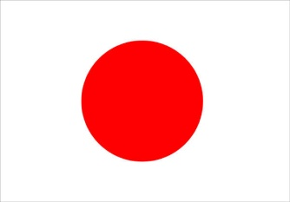

2二

ni

(knee)



3三

san

(Sun)



4四

shi

(she)



5五

go

(go)



6六

roku

(rock)



7七

shichi

(shi-chi)



8八

hachi

(hat-chi)



9九

kyu

(coo)



10十

ju

(ju)



Russian



1

Один

(a-deen)

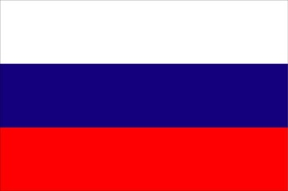

2

Два

(dva)



3

Три

(tree)



4

Четыре

(chye-tir-ye)



5

Пять

(pyat)



6

Шесть (shest)



7

Семь

(syem)



8

Восемь

(vo-syem)



9

Девять (dyev-yat)



10

Десять (dyes-yat)



Greek



1

Ένα

(aena)



2

Δύο

(thee-o)



3

Τρία

(tree-a)



4

Τέσσερα (taess-aer-a)



5

Πέντε (paend-ae)



6

Έξι

(aeks-ee)



7

Εφτά

(aefta)



8

Οχτώ

(oct-o)



9

Εννιά

(en-ey-ya)



10

Δέκα

(thae-ca)



Polish



1

Jeden

(YEH-den)



2

dwa

(dvah)



3

trzy

(tzhih)



4

cztery

(CHTEH-rih)



5

piec (pyench)



6

szesc (sheshch)



7

siedem (SHEH-dem)



8

osiem

(OH-shem)



9

dziewiec (JEV-yench)



10

dziesiec (JESH-yench)



Hebrew

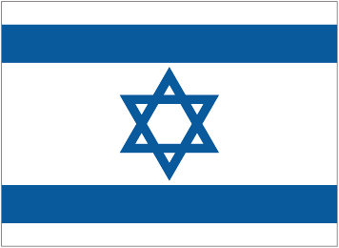

1

Ehad

(EH-ahd)



2

Shtayim

(Shtym)



3

Shalosh

(Shah-losh)



4

Arba

(Ar-bah)



5

Hamesh

(Hah-mesh)



6

Shesh

(Sesh)



7

Sheva

(Sheh-vah)



8

Shmoneh

(Shmoh-neh)



9

Tesha

(Tey-shah)



10

Eser

(Es-air)

