Mario Kart Battle - Station #1

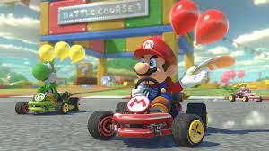

DESCRIPTION OF ACTIVITY:
Objective: To have the most coins in their base when time expires

- Split the class into two equal teams
  - Four students from each team get a scooter (scooters have a character, medium cone, and a foam tennis ball on top of the cone
  - Students without a scooter will pick a leftover character and stand on either side of the play area
    - These students will have a dodgeball and can try to pop “balloons” of players from the opposite team
  - Have the students on the side rotate in with someone from their team when a balloon gets popped
    - For example, if I am on Bronder’s team and her balloon gets popped, she drives the scooter back to base and we trade places, but keep our character

- On “GO,” students move their scooters to the middle to try and get up to five foam coins at a time

- When a balloon gets popped (falls off the cone), student goes back to base and start over
  - If they were holding coins, must drop the coins on the ground where the balloon was popped

- Teams can “hide” in the square of cones of their team color to be safe
  - Red = Villains
  - Blue = Good guys
  - Green = both teams can hide in but only one team or the other

- Team with the most coins at the end of time, wins

Angry Birds - Station #2

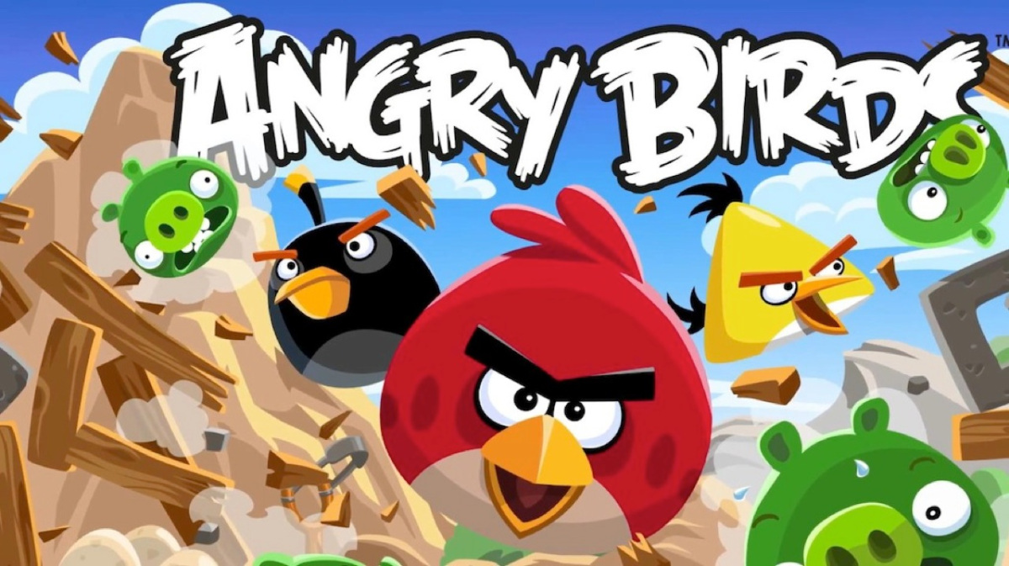

DESCRIPTION OF ACTIVITY:
Objective: Eliminate as many pigs as possible, by destroying piggie towers.

- Depending on class size, create 2-4 teams
  - Teams of 3-4 students = “Pigs” - creating the towers
    - Can have more than one tower, let the teams utilize their own strategies
    - Give “Pigs” 30 seconds to build towers before Angry Birds start throwing
  - Teams of 3-4 students= “Angry Birds” - attempting to knock towers down

- Once tower(s) are built, Angry Birds attempt to knock the towers down by throwing their ball (dodgeball or tennis ball) at the towers
  - Each team has their own dodgeball that matches the color of their team cone
  - Relay race style, “Angry Bird” take turns
  - Run to a designated cone and throw
  - Must go and retrieve their ball and run it back to the next student in line

- “Pigs” - May pick 2 to guard their towers by standing in front and trying to knock the balls away
  - May continue building until all towers are destroyed

Variations
- Time trial - See how quickly teams can build/knock over towers
- Save the eggs - Don’t knock over the buckets with the eggs
  - Only hit buckets with Pigs on them
- Only use tennis balls to hit the buckets

Pokémon Go Relay Race - Station #3

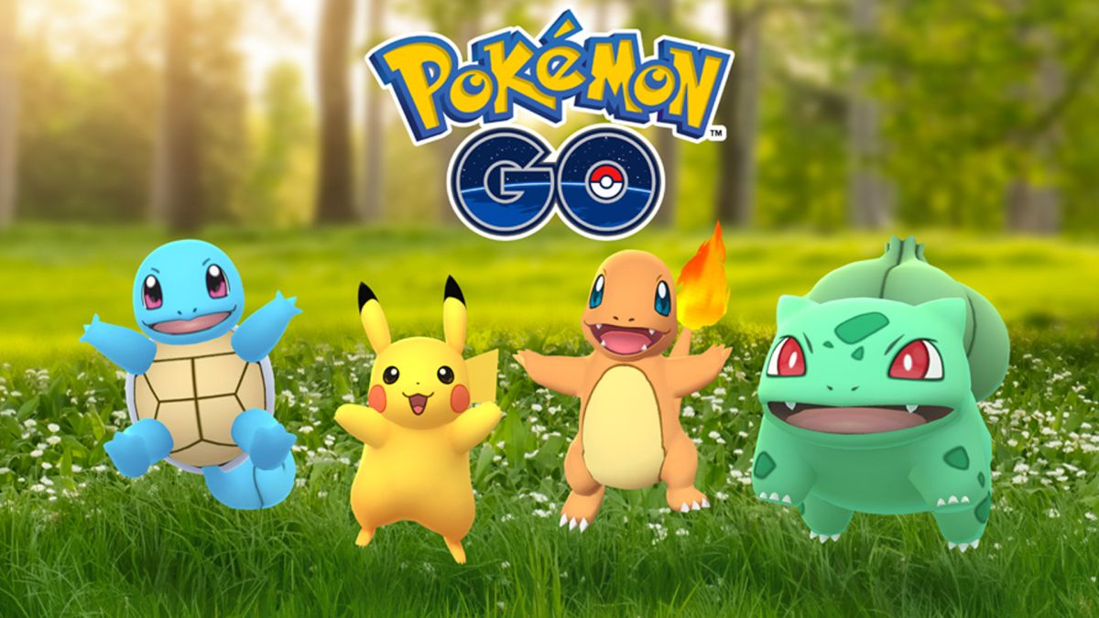

DESCRIPTION OF ACTIVITY:
Objective: To be the team with the most Pokémon characters at the end of a time limit

- Time limits: Go for about 2-4 minutes. Have the teams count their characters to see who wins. Set the characters up and go again.

- Split the class into 4 teams, each with their own colored bucket of Pokémon balls
  - Line up behind their specified color cone

- On “Go,” first student in line grabs one Pokémon ball from their bucket, runs to their cone at the opposite end, and rolls the ball, trying to hit a character
  - Students pick up any character(s), and their ball, that were hit and run back to the start
  - Once back, next student in line can go

Space Invaders - Station #4

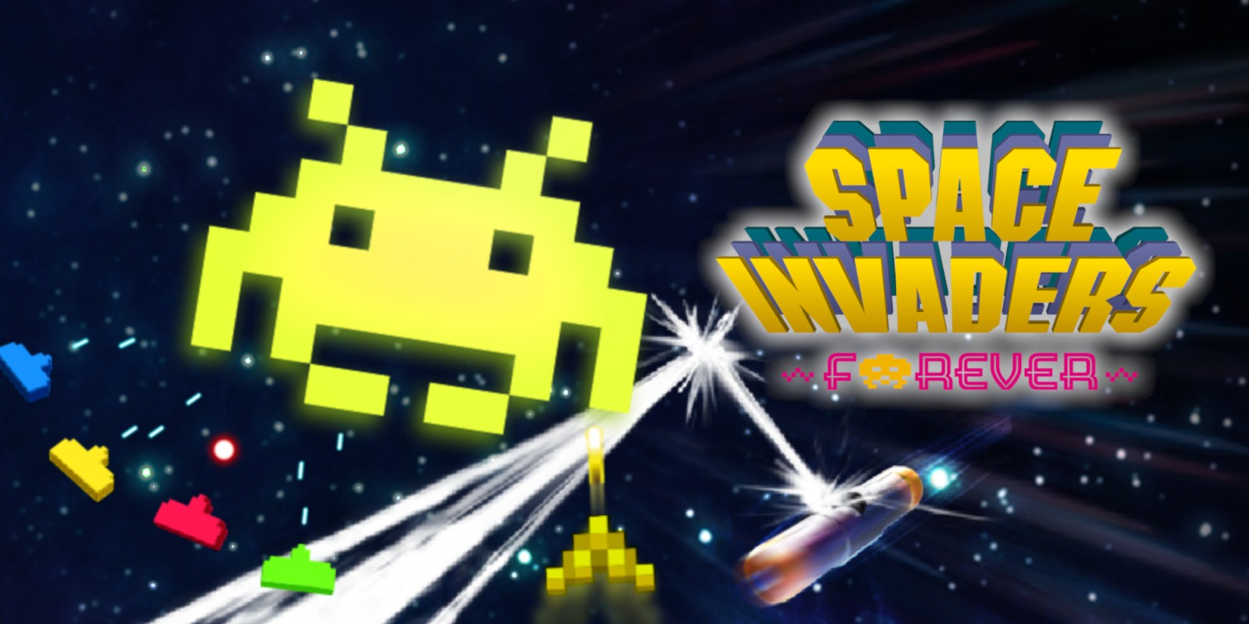

DESCRIPTION OF ACTIVITY:
Objective: To be the team that knocks down all of another team’s bowling pins, then MotherShip

- Split the class into 2-4 teams (can begin with 2 large teams first, then split to 4)
  - Each team has their own set of colored cones indicating their home bases where the MotherShip and bowling pins go
  - 5 bowling pins each team
  - Dodgeballs for each student
  - 6 hula hoops for each team to be built like this
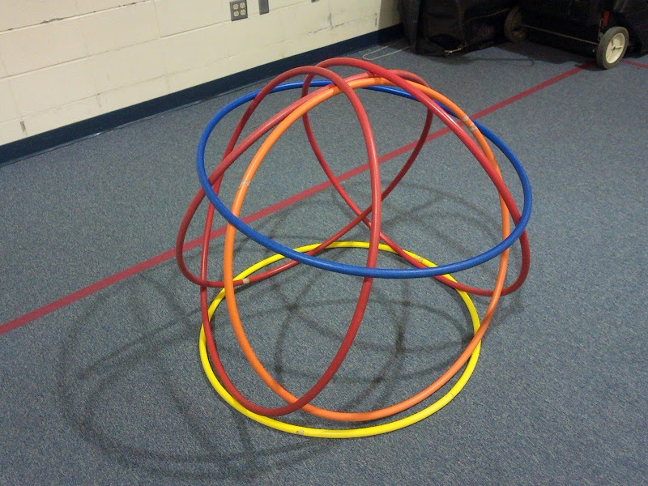

- Begin the game once the MotherShip is built
- All bowling pins must be knocked down before the MotherShip can be knocked down
  - Attacking team loses if the MotherShip is knocked down before all the bowling pins are knocked down
- Put everything back up and begin again

Minecraft Battle Relay Race - Station #5

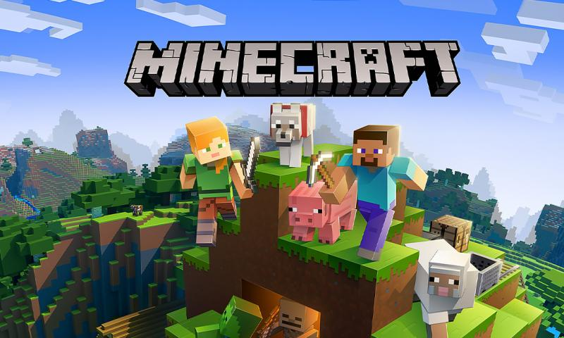

DESCRIPTION OF ACTIVITY:
Objectives: Relay race collecting “supplies” to build a tower with a specific number of cups for the base (4, 5, 6, etc.)

- Split the class into teams of 3-4 players
  - Builders- Building the tower
  - Retriever(s)- make their way through the cones to get cups
  - Creeper- Throws their dodgeball at the other team(s) tower to try and knock them down
- Each team has their specific colored small cone to serve as start and home base
- Teacher/Leader - Begin with a base of 4, then increase it to 5 and up
- Students take turns from each team to get one cup from the middle, and race to place their piece back in their home base area
- Must zigzag through the cones (wolves, zombies, etc) to collect each item and take it to their home base

PK-2: Team vs Team, see who can get their tower built the quickest
- Time limit - 60 seconds

3-6: Team vs Team, after 60 seconds, 1 person from each team (creepers) can throw a team colored dodgeball to try and knock over other buildings
- Creepers only get one ball and must chase that ball wherever it goes
- Retrievers can pick up cups that get knocked over by the Creepers, but cannot build
- Builders continue working together to be the first team to build their tower
  - Builders can try and protect their building

Power Up Station - #6

DESCRIPTION OF ACTIVITY:

Students will sit and have snacks. Classroom teachers, or students, may read a book out loud. There will be alternative snacks for those students who need them.

Draw Something - #7

DESCRIPTION OF ACTIVITY:
Objective: Draw, as good as possible, a given word (out of 3 choices) to get your partner to guess the word

- Partner up (2nd-6th) -
  - Have the class get into groups of 2-3
  - Decide who draws first, Mrs. Clark gives the word options, then starts the timer
  - Drawer decides which word they would like to draw first
  - 60 seconds to draw and guess the word
    - If first word is answered correctly, may go on to another word of the 3 choices
    - Keep going until 60 seconds is up
  - Change who draws and Mrs. Clark gives a new group of words

- Speed draw (2nd-6th) - Draw, and guess, as many words as possible in 60 seconds
  - Change up who draws

- Entire class guesses (Pk-6th) - Mrs. Clark draws and the class guesses

- PK-1st: Free draw

Rock Band - #8

DESCRIPTION OF ACTIVITY:

Play a wide variety of songs. Students will take turns playing the various “air instruments,” creating a Rock Band, while listening to the songs.

After everyone has had an opportunity, Ms. Brooks will create “teams” and they will have a “rock battle.”

Ms. Brooks will be the final judge on the winners. Winning teams will receive prizes.
Frogger - #9

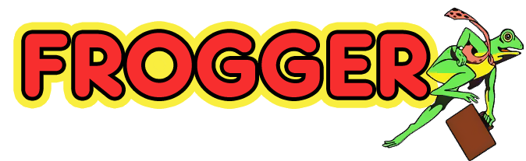

DESCRIPTION OF ACTIVITY:
Objective: For the “humans” to get through the course without being tagged by a “critter,” grab a bean bag at the opposite end, and return it to home base

- Critters at each level
  - Balance beams (snakes) = 3

  - Scooters (crocodiles) = 3

  - Hula hoops (frogs) = 2-3

  - Mats (lizards) = 3 with pool noodles

- Only 1-3 humans go at any time

- Critters attempt to tag humans while they go through the course
  - If a human is tagged, they go back to the beginning and perform a fitness activity of teacher’s choosing before they can go again

- When a human gets a bean bag, they get a safe return to “home” by going outside the playing area

- Switch up who are critters and humans
  - 3 “humans” to snakes, snakes to crocodiles, crocs to frogs, frogs to lizards, lizards to humans

Extensions:
- No safe returns, must go back through the course without being tagged
- Time trials, who can make it through the course the fastest, write their name(s) on the board
Among Us - #10

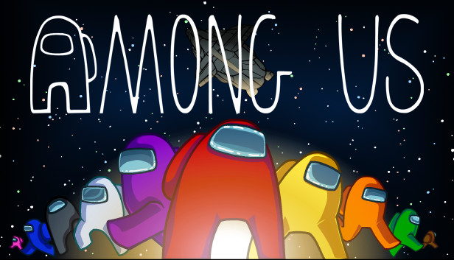
DESCRIPTION OF ACTIVITY:
Objective: (2nd-6th) To not get “knocked out” by an imposter while performing different tasks around the basement.

(PK-6th) Memory & Skeleton puzzle
- Must find the pieces throughout the cages and put them together in the hallway
- Memory-Put pieces back if they are not a match

Upon entry, each student receives a card that says either “Imposter” or “Crew Mate” KEEP IT SECRET!!!

- Crew Mates - Work independently to complete different tasks
  - Can move around to different tasks
    - Cages, and memory game (see rules)
  - When “knocked out” by an imposter - lay on the ground and wait for another Crew Mate to find them
  - Meeting immediately called when “knocked out” Crew Mate is found

- Imposters - Pretend to be completing tasks, but are really sabotaging the tasks by doing something different
  - Can “knock out” Crew Mates by secretly double tapping them on the back
  - Can “knock out” as many Crew Mates as possible without getting caught

- Each task area has a picture and description on what to do
  - Can have multiple Crew Mates working on the same task at the same time

Game is over when; 1) all Crew Mates are knocked out, 2) when all Imposters have been figured out

