18 Minute Fat Burner Workout
Student Instructions:

- Watch the video to complete the workout. Mirror the moves in the video.
  - Video Hyperlink: https://youtu.be/ge55KlczwHc
  - Follow the channel for more at home workouts by clicking here.
  - Upload this Google Doc to ManageBac in the Dropbox.

- After completing the video, complete the assessment sheet below.
  - Place your initials in each box to verify that you have completed the exercise.
  - Enter your Heart Rate at the end of the assessment sheet.
    - Find your pulse, and count your heart beats for 6o seconds.

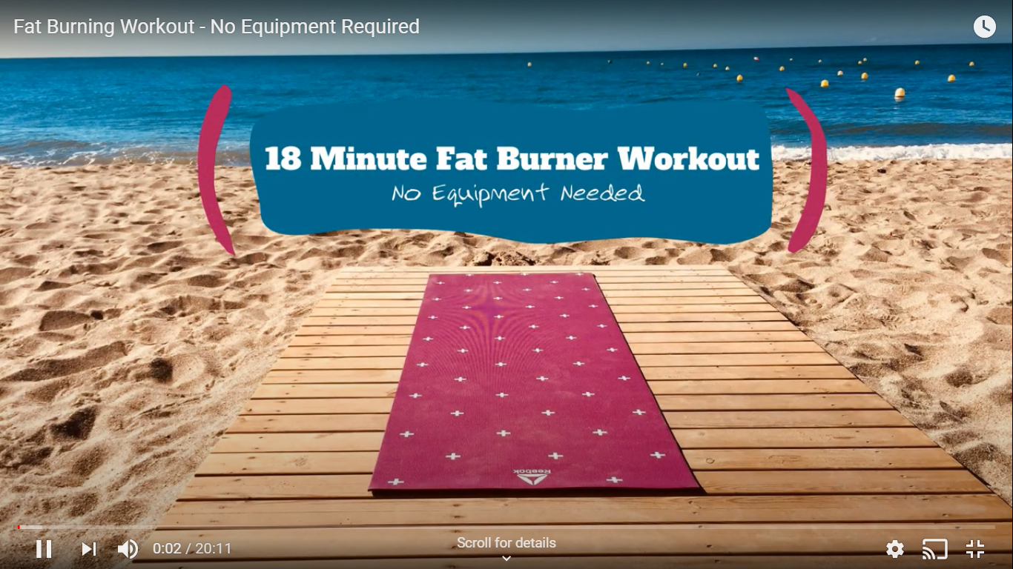

Students, please place your initials in each box below to verify that you have completed the exercise for each set
Exercise | Set 1 | Set 2 | Set 3 | Set 4
1️⃣Touchdown Squat Jacks
Modification: Touchdown Squat w/low impact jumping jack.
2️⃣Rowboat Crunches
Modification: Rowboat Crunches w/hands on ground for stabilization
3️⃣Forward Lunge to Glute Kick  Modification: Lunge Hold w/Glute Kick | Set 1 - Left | Set 1 - Right | Set 2 - Left | Set 2 - Right
4️⃣Long Arm Plank w/Glute Kick  Modification: Standard Prone Glute Kick | Set 1 - Left & Right | Set 2 - Left & Right | Set 3 - Left & Right | Set 4 - Left & Right
5️⃣Wide Stance Squat w/Elbow to High Knee Reach
Modification: Standing Elbow to High Knee Reach
6️⃣Bear Jacks
Modification: Bear Hold w/Lateral Toe Tap

- Immediately after completing the 10 exercises above, please calculate your Heart Rate. Use a timer for 60 seconds to count your beats per minute.

Heart Rate: | Student Signature (just type your name): | Parent/Guardian Signature (just type your name):

