TASK: Complete the following workout according to your full name. (First & Last Name)

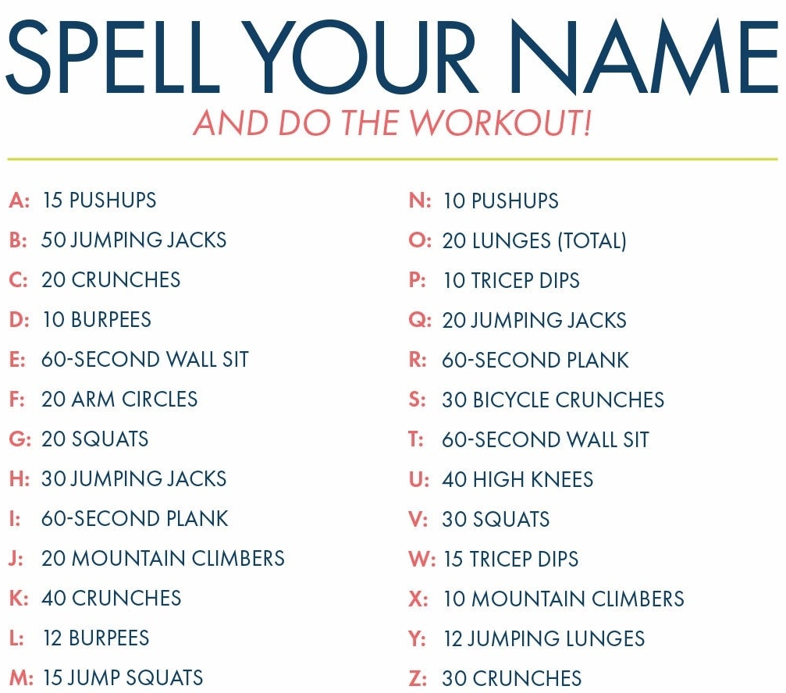

QUESTIONS:
- What was your full workout?

- What was your favorite exercise?

- What was your least favorite exercise?

- Would you do this again? What would you change, if you would change anything? (Answer BOTH PARTS of this question)
How will your teacher know you are completing the task?
- Record yourself using your chromebook/tablet/ phone etc. (You can timelapse the video- pictures will not count)
- Answer the questions in a doc and submit

