Fitness Circuit
Scan each qR code and follow the video or instructions within the activity. Please keep yourself and your ipad safe.

Learning Goal 1: Demonstrate peer & self respect
Learning Goal 2: demonstrate personal MVPA level

1 | 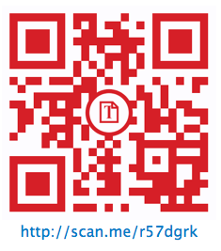 | 2 | 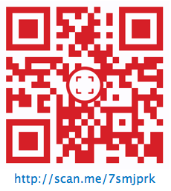
3 | 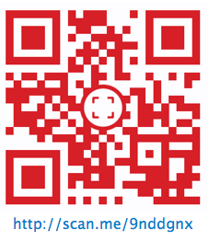 | 4 | 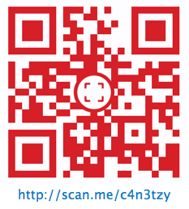
5 | 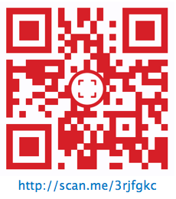 | 6 | 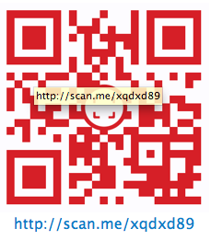
7 | 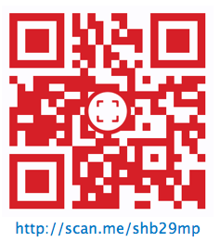 | 8 | 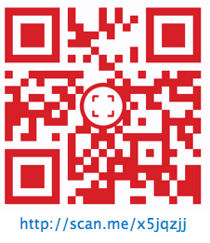

Please be sure to complete code 7. prior to the end of class. It will take about 3-5 minutes. Return and plug your ipad back into the cart. Have a great day!!!

