Ninja: _________________ Dojo: ________

Jump Rope Ninja Challenge
A different peer observer signs off for each completed level.
3 attempts for any given observer - after 3 mistakes, go back to your base to practice before your next attempt.
Level 1 - White Belt Ninja  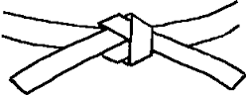  5 Consecutive Jumps  Observer: _______________ | Level 2 - Yellow Belt Ninja  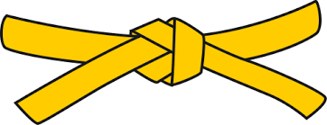  3 Different Jump Rope Skills  5 Consecutive Jumps Each  Observer: _______________ | Level 3 - Orange Belt Ninja  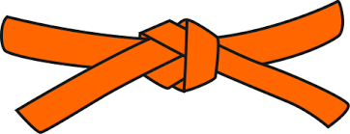  4 Different Jump Rope Skills  5 Consecutive Jumps Each  Observer: _______________
Level 4 - Green Belt Ninja  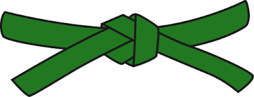  10 Consecutive Jumps  3 Different Jump Rope Skills  Observer: _______________ | Level 5 - Blue Belt Ninja  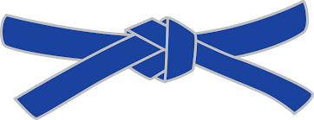  5 Different Jump Rope Skills  5 Consecutive Jumps Each  TEACHER CHECK-IN: ____________ | Level 6 - Purple Belt Ninja  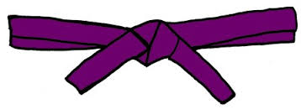  7 Different Jump Rope Skills  5 Consecutive Jumps Each  Observer: _______________
Level 7 - Brown Belt Ninja  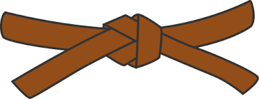  10 Consecutive Jumps  5 Different Jump Rope Skills  Observer: _______________ | Level 8 - Red Belt Ninja  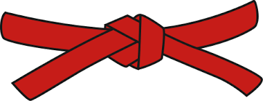  10 Different Jump Rope Skills  10 Consecutive Jumps Each  Observer: _______________ | Level 9 - Black Belt Ninja  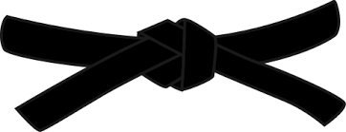  15 Different Jump Rope Skills  10 Consecutive Jumps Each  Teach Others Who Need Help  TEACHER CHECK-IN: ____________
Black Belt Ninjas: Wear a vest and work as a Sensei to assist others working toward their belts.

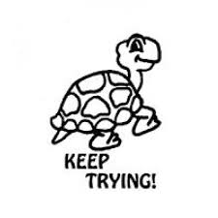
How do you feel about your performance today?

