Feed the Monster
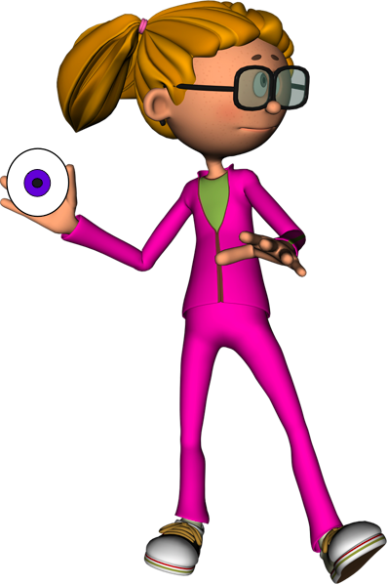 /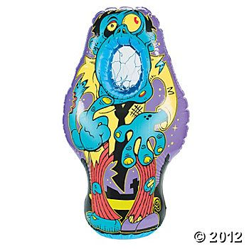
- Stand behind the line and throw an eyeball in the monster’s mouth.

- Retrieve the eyeball and give it to the next person in line.

- Return to the end of the line and wait your turn again☺

Zombie Walk
- Put your feet on top of the zombie feet.
- Hold the strings with your hand.
- Take a step and pull the string up at the same time.
- Walk up to the line and back.
- Give the zombie feet to your partner.
- Go to the end of the line and wait your turn again.

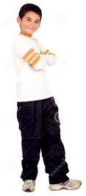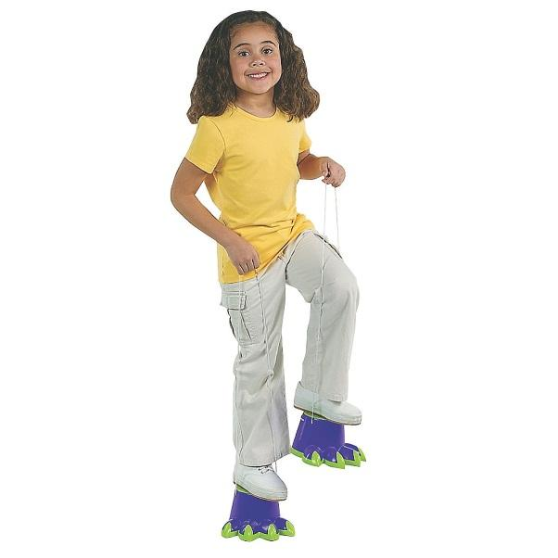

Muscle Puzzle
- Look at the muscle picture.
- Try to assemble the muscle puzzle.
- When the music stops, scramble up the puzzle pieces your group put together.
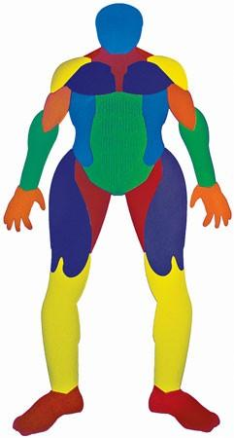
Ghost Darts
- Take two orange and black balls and stand behind the line.
- Throw two orange and black balls at the ghost target.
- Retrieve and return the orange and black balls to the next person in line.
- Go to the end of the line and wait your turn again.

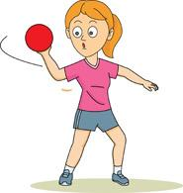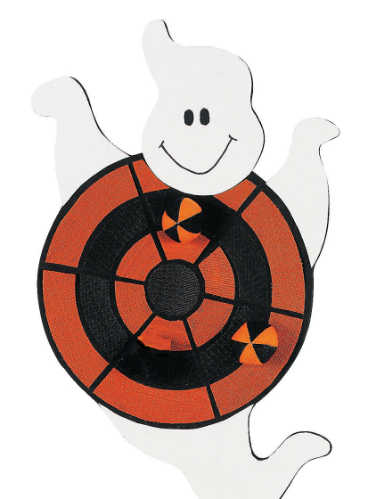

Jump Rope

- Look at the Calorie balance sheet.
- Find a candy that you have eaten.
- Try to burn off that candy’s calories today by jumping rope on your spot.
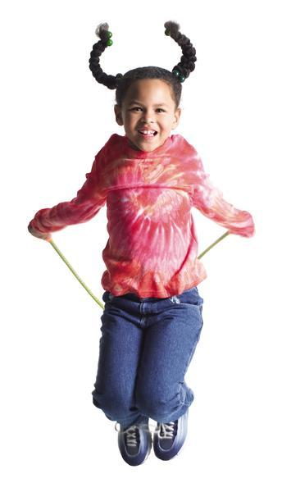
Bat Attack
- Take two stuffed animals and stand behind the line.
- Throw the stuffed animals one at a time at the bats.
- Retrieve the stuffed animals and give them to the next person in line.
- Return to the end of the line and wait your turn again.

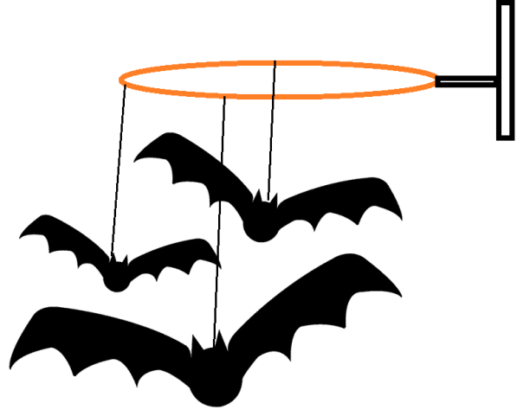
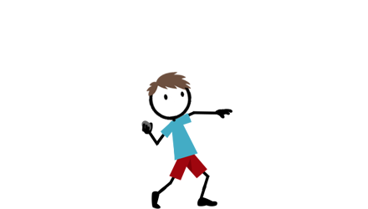

Spider Catch
- Take two spiders and stand behind your line.
- Underhand toss the two spiders in their web.
- Repeat.
- How many can you make?

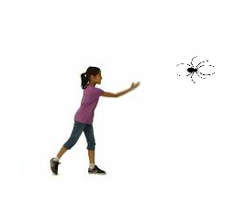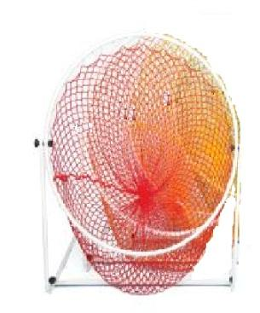

Pumpkin Patch
- Divide your group into two teams.
- One team will be Builders and the other Bulldozers in your group.
- When you are ready, start building and bulldozing using your feet.

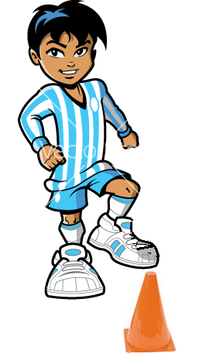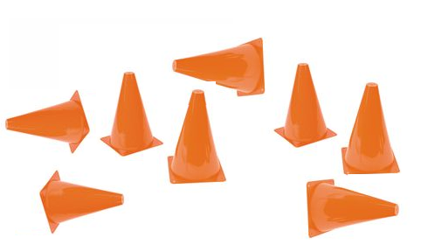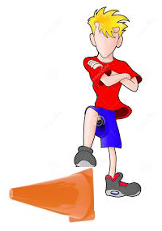

Monster Bowling
- Get a stuffed animal and stand behind the line.
- Underhand roll the stuffed animal towards the 6 monster pins.
- Restack the pins on the stickers
- Retrieve the ball and hand it to your partner.
- Go to the end of the line and wait your turn.
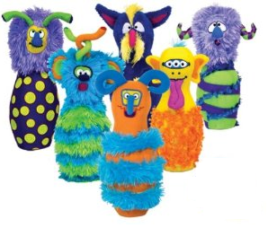
Parachute Launch
- Everyone grab the edge of the parachute.
- Place the stuffed animal in the middle of the parachute.
- On the count of three, everyone lift the parachute up.
- Try to aim the stuffed animal in the basketball hoop.
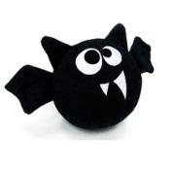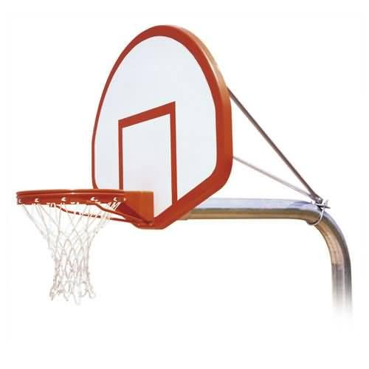
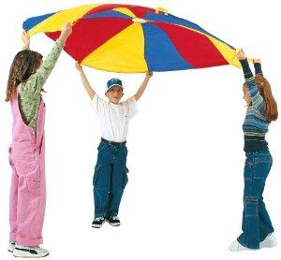
Skeleton Puzzle
- Look at the skeleton picture.
- Try to assemble the skeleton puzzle.
- When the music stops, scramble up the puzzle pieces your group put together
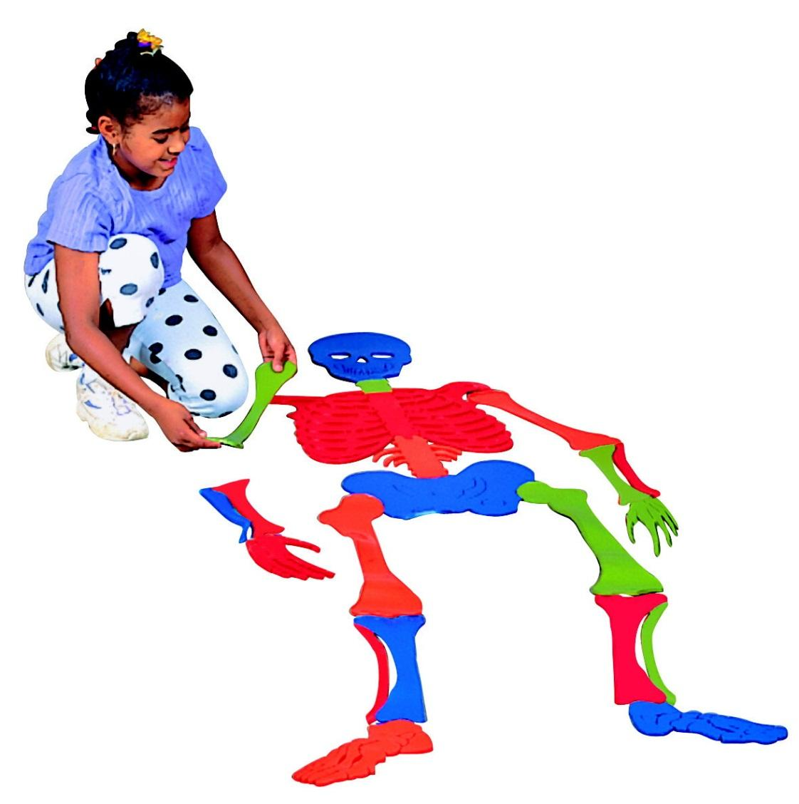

Eyeball Catch Paddles
- Pick up your paddle and stand on your spot.
- Try to get the eye ball into the monster’s eye socket.
- How many times can you do this?

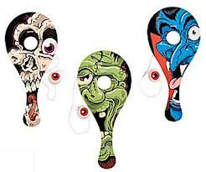

Infested Pumpkins
- Pick up to mice and stand behind the line.
- Underhand toss the mice one at a time into the pumpkin.
- How many can you make in?

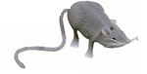
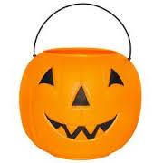

Wizards Brew
- Sit down and take a rubber cup.
- Flip it inside out and place it on the ground.
- Wait a couple of seconds and watch it pop.
- For bonus points, after it pops, can you catch it in the wizard’s pot?
- Repeat.
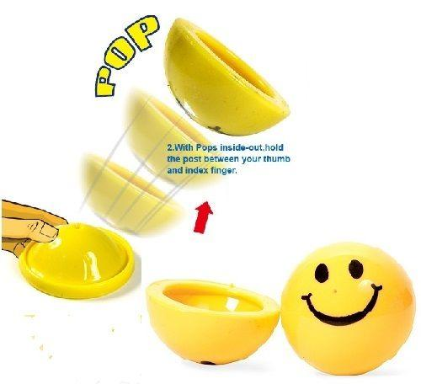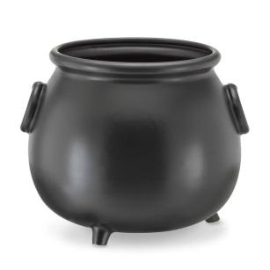

Jumping Spiders
- Sit down on your spot and grab a spider.
- Push down on the back of your spider and make him/her jump.
- How far can the spider jump?
- How high can the spider jump?

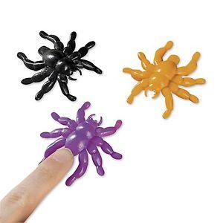

Witches Locomotors
- Stand behind the line and pick up a locomotor card.
- Read the locomotor skill.
- Perform the locomotor up and back.
- Go to the end of the line and wait your turn to go again.
- Repeat picking a different card.
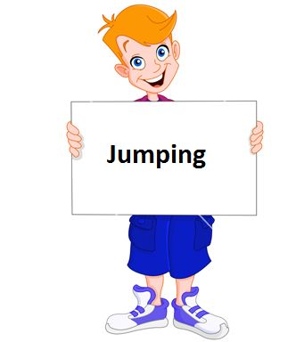

Hula Hoop
- Look at the Calorie balance sheet.
- Find a candy that you have eaten.
- Try to burn off that candy’s calories today by hula hooping on your spot.

Creepy Catch

- Stand on the tape line.

- Toss the creepy animal to your partner.

- Repeat.

