Fitness
Jenga
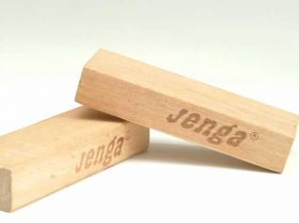
Materials: 1 Jenga set (each block labeled with an exercise)
Game Play:
- Divide students into 2 teams (i.e. A team/B team)
- Decide on which team draws first
- One student from A team draws a block
- That student can read the block aloud
  - or QR code - link to video, project onto screen for everyone can see?
- Players on B team must complete exercise
  - A team can count for B team (ie. 15 sec plank or 10 jumping jacks)
- One student from B team draws a block
- Continue until Jenga tower topples
Rules:
- May only use one hand at a time to pull a block
- May only pull one block at a time
- May not pull block from very top
- May not interfere with a player who is drawing a block
Toppling the Tower
- Team that topples the tower has to jog in place until teacher rebuilds tower
  - Speed of rebuild depends on effort of students

