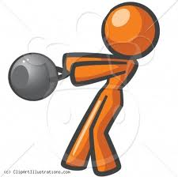
Fitness Test Results Reflection

Name: _______________________________________________ Period _______ Graduation Year ________

After receiving your Fitnessgram scores, answer the following questions.

Fitnessgram Healthy Fitness Zone chart
http://www.cde.ca.gov/ta/tg/pf/healthfitzones.asp
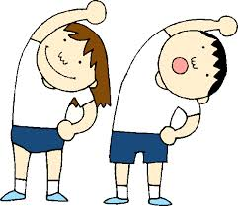
FITNESS GRAM RESULTS:

1. You completed five fitness tests. List which component of health related physical fitness each test assesses and if your results were in the healthy fitness zone for your age/gender.
The Five Components of Health Related Physical Fitness: Cardio-respiratory endurance, Muscular strength, Muscular endurance, Body composition, Flexibility.
Test | Component of Health Related Physical Fitness | Were you in the Healthy Fitness Zone?
Pacer
Sit and Reach
Body Fat Percentage
Curl-ups
Push-ups
2. Were any of these numbers a surprise to you?

3. What are your biggest strengths?

4. What are your biggest weaknesses?

5. What activities do you currently participate in that can help you improve/maintain your fitness results? If none, what activities can you do to help improve your results and reach your fitness goals?

SMART Goal:
Set one fitnessgram goal you wish to accomplish by the end of the semester! A SMART goal is one that is:
- Specific: Your goal should be well-defined and focused.
  - Choose one Fitnessgram test to improve. Example: Increasing your curl-ups
- Measurable: Put concrete numbers on your goals to know if you are on track.
  - How many, not just to improve but an actual concrete number.
- Achievable: Make sure that your goals are realistic and reachable, but not too easy.
  - If you got 10 push-ups it is not realistic to get 50 by the end of the semester. At the same time, a goal of 11 would be too easy.
- Relevant: Believe that the goal you are setting is important.
- Time-Based: All goals must have a deadline to encourage your commitment.
  - By the end of the semester…

6. Goal:

7. What are you going to do to accomplish this goal?? Write down 2-4 action steps that you are going to do in order to accomplish this goal.

