t Collect and Conquer

Directions: There are 12 cards placed under cones. The cones can be anywhere throughout the gym, locker rooms, laundry room, pool, wrestling room, weight room, and hallways in between. Your team is competing against the other groups to be the first to match the cards with the questions on this page. When you write down the answer, don’t forget to write the symbol that is attached to each answer!! Your team must stay together at all times. When you have all twelve answers and symbols, jog to find me and I will check your answers.

Team members:

1. _________________ is a mental benefit of physical activity.
Symbol:

2.__________________ is the amount of movement possible at a joint.
Symbol:

3. Making new friends, being part of a team, and learning cooperation skills are all benefits of physical activity that fall under the _________________ category.
Symbol:

4. The heart and lungs work together to keep the muscles supplied with ___________________.
Symbol:

5. Losing/maintaining weight is a ___________________ benefit of physical activity.
Symbol:

6. There are _________________ health related fitness components.
Symbol:

7. You can be a physically fit athlete without being ____________________.
Symbol:

8.___________________ is the ability to exercise your whole body for a long time.
Symbol:

9. Flexibility improves efficiency in sports like swimming and hurdling, so _______________ is used.
Symbol:

10. _________________ are used in all physical activities.
Symbol:

11. Your health is also dependent on other factors such as a __________________, your level of self-esteem, and developing positive relationships with other people.
Symbol:

12. ___________________ is an example of an activity that would require cardiovascular fitness.
Symbol:

Physical | Increased Self Esteem
Social | Five
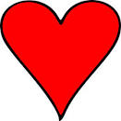  Healthy | Cardiovascular  Fitness
Oxygen | Less Energy  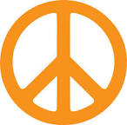
Flexibility  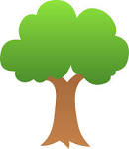 | Balanced Diet  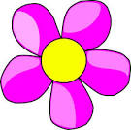
Soccer | Muscles  