Coffee and Tea

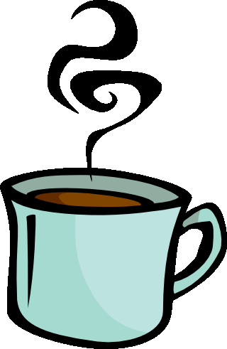

I like coffee,
I like tea,
I'd like ___ to jump with me!
(fill in blank with friends name)

