Task: Are you drinking enough water throughout the day? Keep track of your water intake for 1 day.

How will your teacher know you completed the task?
- Screen capture app used to track water intake
- (if you do not have a device for an app) Fill out this chart on a separate document and submit.
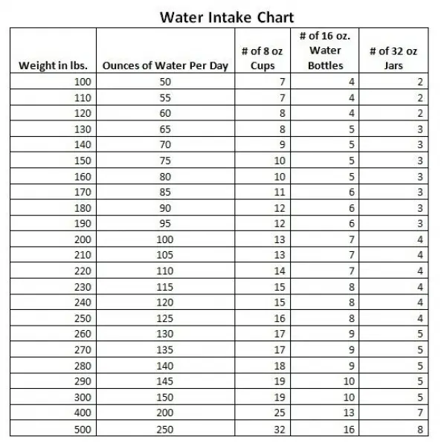
Amount of water recommended for you: ___________
Amount of water | TIme of day

App Recommendations: (Not required to use)
- Hyriollo
- Plant Nanny
- Water Time Drink Tracker & Reminder

