Coordinated School Health
Finance Flow-Chart

I want to make a purchase with CSH funds
YES
NO

Does the purchase fall in-line with 1 of the 8 components?

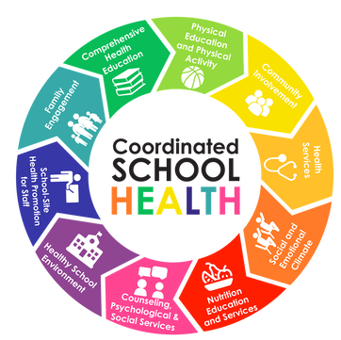
IMPORTANT INFO:
- Funds can NOT be used for AED/CPR supplies.
- Funds can NOT be used for guest speakers (assemblies)
- Funds can NOT be used for office furniture.
- Funds can NOT be used for t-shirts (i.e., race)
- Funds can NOT be used for sports equipment for one individual or group (i.e., sports team)
- Funds can NOT be used for in-state flights.
- Funds can NOT be used for cafeteria equipment.
- Funds can NOT be used for race registration fees.
- Funds can NOT be used for rental cares.
- Funds can NOT be used for large quantities of food.
- Funds can NOT be used on gift cards.
- Funds can NOT be used on presenters, without prior approval.

Make the purchase
If approval from OCSH is granted, move forward with purchase. If denied, purchase cannot be made!
Seek approval from OCSH (Shayla Sanderson)
YES
Is purchase of a single item costing more than $1,000?
If approval from OCSH is granted, move forward with purchase. If denied, purchase cannot be made!
NO
Seek approval from OCSH (Shayla Sanderson)

