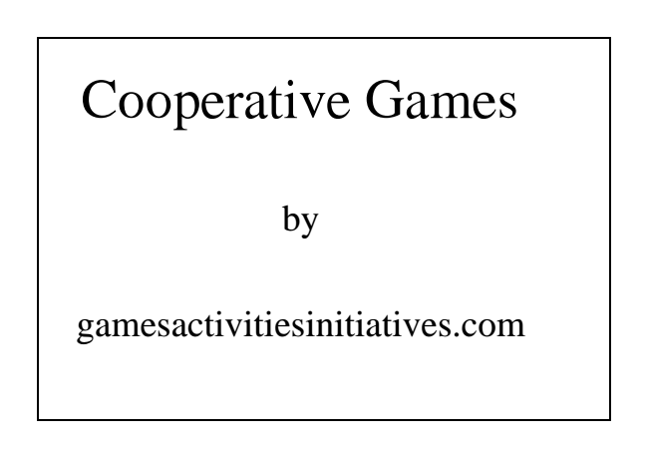
Cooperative Games
by
gamesactivitiesinitiatives.com
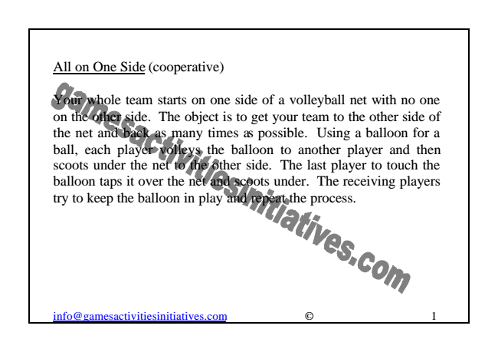
All on One Side (cooperative)
Your whole team starts on one side of a volleyball net with no one on the other side. The object is to get your team to the other side of the net and back as many times as possible. Using a balloon for a ball, each player volleys the balloon to another player and then scoots under the net to the other side. The last player to touch the balloon taps it over the net and scoots under. The receiving players try to keep the balloon in play and repeat the process.
info@gamesactivitiesinitiatives.com © 1
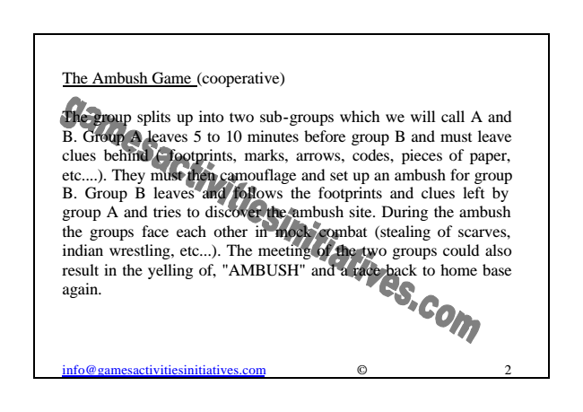
The Ambush Game (cooperative)
The group splits up into two sub-groups which we will call A and B. Group A leaves 5 to 10 minutes before group B and must leave clues behind ( footprints, marks, arrows, codes, pieces of paper, etc....). They must then camouflage and set up an ambush for group B. Group B leaves and follows the footprints and clues left by group A and tries to discover the ambush site. During the ambush the groups face each other in mock combat (stealing of scarves, indian wrestling, etc...). The meeting of the two groups could also result in the yelling of, "AMBUSH" and a race back to home base again.
info@gamesactivitiesinitiatives.com © 2
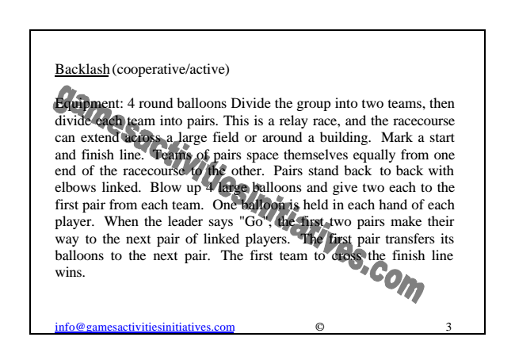
Backlash (cooperative/active)
Equipment: 4 round balloons Divide the group into two teams, then divide each team into pairs. This is a relay race, and the racecourse can extend across a large field or around a building. Mark a start and finish line. Teams of pairs space themselves equally from one end of the racecourse to the other. Pairs stand back to back with elbows linked. Blow up 4 large balloons and give two each to the first pair from each team. One balloon is held in each hand of each player. When the leader says "Go", the first two pairs make their way to the next pair of linked players. The first pair transfers its balloons to the next pair. The first team to cross the finish line wins.
info@gamesactivitiesinitiatives.com © 3
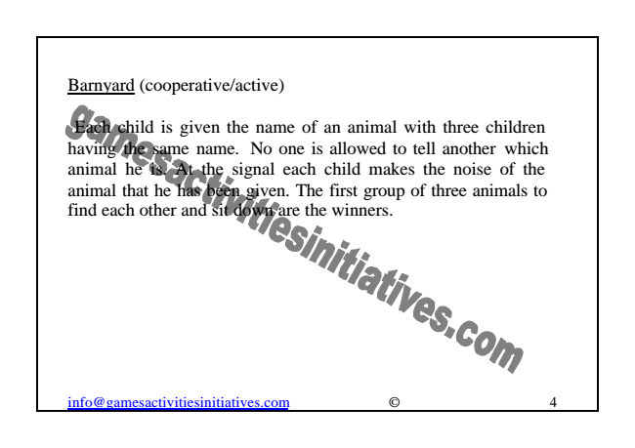
Barnyard (cooperative/active)
Each child is given the name of an animal with three children having the same name. No one is allowed to tell another which animal he is. At the signal each child makes the noise of the animal that he has been given. The first group of three animals to find each other and sit down are the winners.
info@gamesactivitiesinitiatives.com © 4
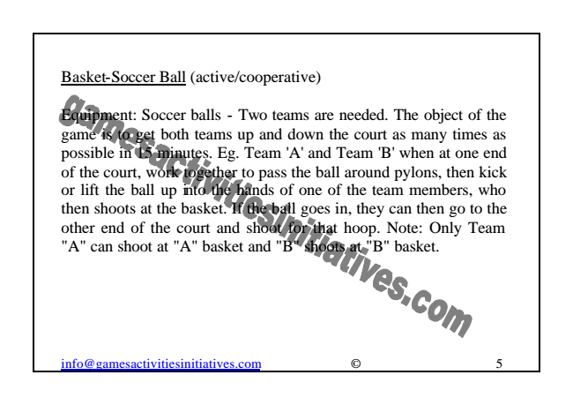
Basket-Soccer Ball (active/cooperative)
Equipment: Soccer balls - Two teams are needed. The object of the game is to get both teams up and down the court as many times as possible in 15 minutes. Eg. Team 'A' and Team 'B' when at one end of the court, work together to pass the ball around pylons, then kick or lift the ball up into the hands of one of the team members, who then shoots at the basket. If the ball goes in, they can then go to the other end of the court and shoot for that hoop. Note: Only Team "A" can shoot at "A" basket and "B" shoots at "B" basket.
info@gamesactivitiesinitiatives.com © 5
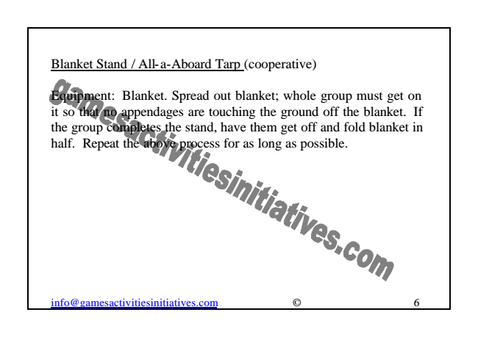
Blanket Stand / All-a-Aboard Tarp (cooperative)
Equipment: Blanket. Spread out blanket; whole group must get on it so that no appendages are touching the ground off the blanket. If the group completes the stand, have them get off and fold blanket in half. Repeat the above process for as long as possible.
info@gamesactivitiesinitiatives.com © 6
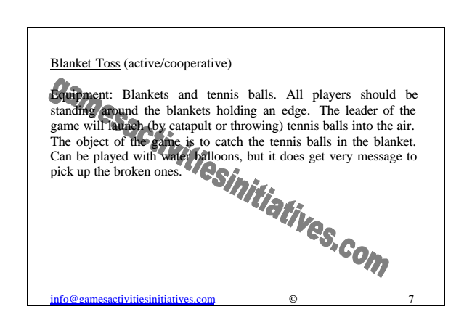
Blanket Toss (active/cooperative)
Equipment: Blankets and tennis balls. All players should be standing around the blankets holding an edge. The leader of the game will launch (by catapult or throwing) tennis balls into the air. The object of the game is to catch the tennis balls in the blanket. Can be played with water balloons, but it does get very message to pick up the broken ones.
info@gamesactivitiesinitiatives.com © 7
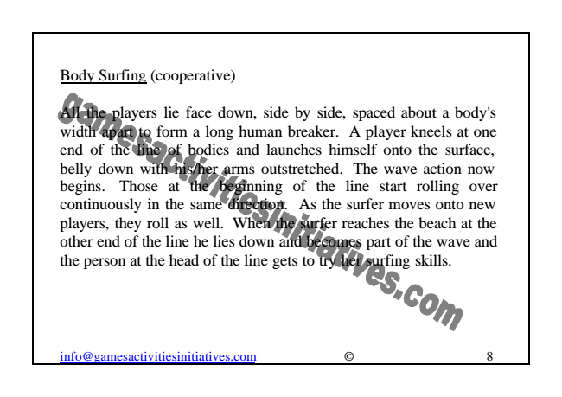
Body Surfing (cooperative)
All the players lie face down, side by side, spaced about a body's width apart to form a long human breaker. A player kneels at one end of the line of bodies and launches himself onto the surface, belly down with his/her arms outstretched. The wave action now begins. Those at the beginning of the line start rolling over continuously in the same direction. As the surfer moves onto new players, they roll as well. When the surfer reaches the beach at the other end of the line he lies down and becomes part of the wave and the person at the head of the line gets to try her surfing skills.
info@gamesactivitiesinitiatives.com © 8
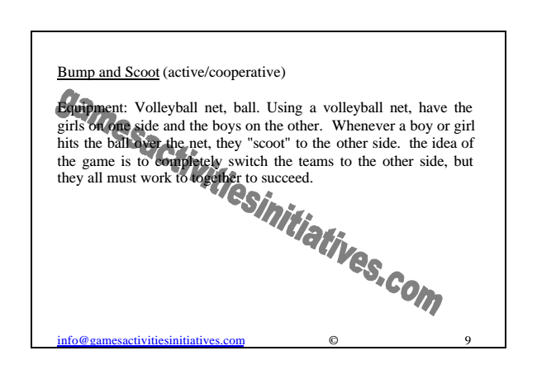
Bump and Scoot (active/cooperative)
Equipment: Volleyball net, ball. Using a volleyball net, have the girls on one side and the boys on the other. Whenever a boy or girl hits the ball over the net, they "scoot" to the other side. the idea of the game is to completely switch the teams to the other side, but they all must work to together to succeed.
info@gamesactivitiesinitiatives.com © 9

