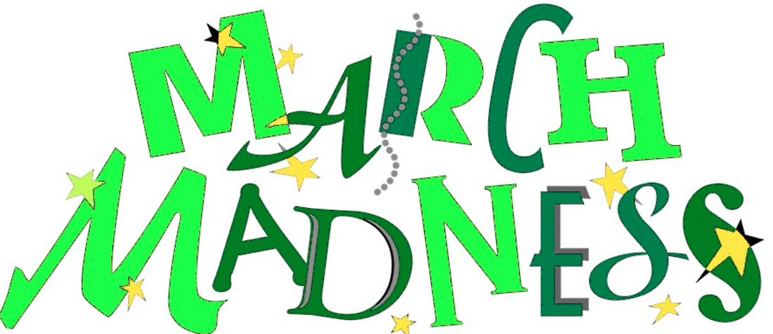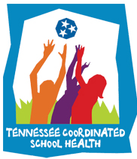

**8 Components of Coordinated School Health**

Coordinated School Health is based on the Centers for Disease Control 8 component approach to healthier schools: (1) Nutrition Services, (2) Physical Education/ Physical Activity, (3) Healthy School Environment, (4) Health Education, (5) Counseling and Psychological Services, (6) Health Promotion for Staff, (7) Parent/ Community Involvement, and (8) Health Services.

The purpose of a healthy school team is to utilize faculty and staff in each school building who are considered experts in each component so that we are able to capture a more comprehensive look at the school. After assessing the needs of your school, as a team, the school will develop a plan to not only address the weaknesses, but also highlight its strengths. We want to promote healthy schools and encourage healthy behaviors, for students, faculty and families.

**November Health Observances**

[National Nutrition Month](http://www.eatright.org/resources/national-nutrition-month)® is a nutrition education and information campaign created annually in March by the Academy of Nutrition and Dietetics. The campaign focuses attention on the importance of making informed food choices and developing sound eating and physical activity habits. Additional resources may be found [(here)](http://fnsweb01.edc.usda.gov/NNM.html) and ([here](https://www.tn.gov/education/topic/school-nutrition)).

[American Diabetes Month](http://healthfinder.gov/nho/NovemberToolkit.aspx)

**Sleep Awareness Month**

National Sleep Awareness Week is March 2-9. Learn how sleep affects brain function, how much sleep we need, and more ([here](https://sleepfoundation.org/)).

**GMSD Teacher & Staff Fitness Discounts:**

[**http://www.gmsdk12.org/Downloads/GMSD%20Fitness%20Discounts.pdf**](http://www.gmsdk12.org/Downloads/GMSD%20Fitness%20Discounts.pdf)

**Healthy School Team Update**

**March 2016**

[GMSDschoolhealth.com](http://www.gmsdschoolhealth.com/)

**IMPORTANT DATES:**

March -18th 3rd Quarter CSH Meeting Notes

March - 18th PA/PE Quarter 3 Report Due

May – 6th Pacer Data Report Due

April – 30th All Student Health Screening Data Due To Be Imported Into Power School

**Save Your Vision Month**

Save Your Vision Month is AOA's national observance in March to promote the importance of regular, comprehensive eye care from an optometrist.

The 2016 Save Your Vision Month campaign focuses on healthy eyesight and vision in the 21st century. Educate your staff and students about the importance of regular eye care for a lifetime of healthy vision with resources found ([here](http://www.aoa.org/patients-and-public?sso=y)) and ([here](http://vision.about.com/od/eyeexaminations/qt/Diet_Eyes.htm)).

**National School Breakfast Week**

Use the 2016 [National School Breakfast Week](https://schoolnutrition.org/nsbw/) theme to spread the message to administrators, parents, and students that a healthy school breakfast brings a sunny start to the day for students. At the link above, you may download School Nutrition Association’s resources and celebration tips to get started today.

**Brain Injury Awareness Month**

Whether the victim is an adult, a child, or an infant, TBIs can have a major impact on individuals and their families. To raise awareness of traumatic brain injury, the Brain Injury Association of America recognizes National Brain Injury Awareness Month every March. You may learn more about brain injury at the links below:

* [Project BRAIN](http://www.tndisability.org/brain)
* [Brain Awareness Week](http://www.dana.org/BAW/)
* [Brain Injury Association of America](http://www.whathealth.com/organizations/b/braininjuryass-us.html)
* [CDC Traumatic Brain Injury and Concussion Resources](http://www.cdc.gov/traumaticbraininjury/pubs/index.html)
* [CDC Heads Up](http://www.cdc.gov/headsup/)**B**
* [U Got Brains?](http://www.ugotbrains.com/)