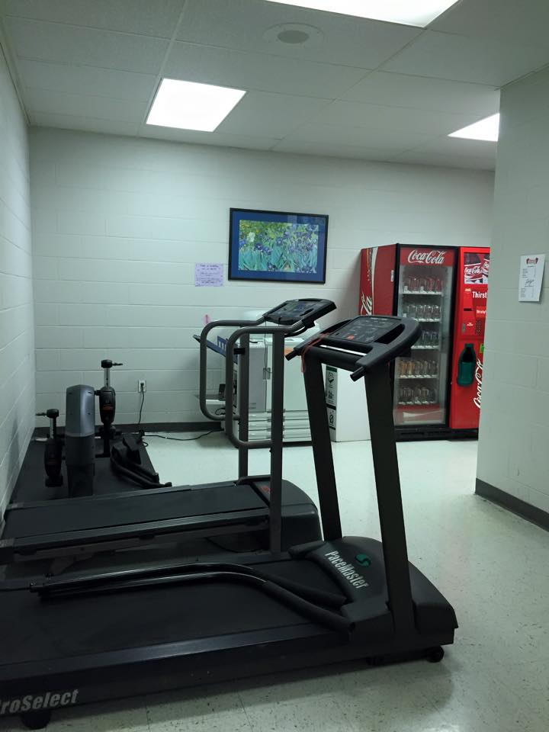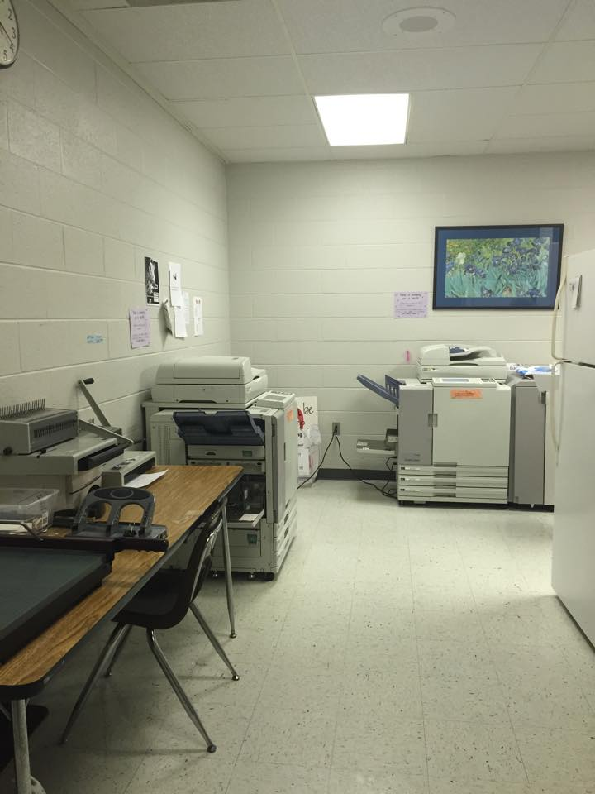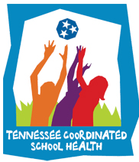

**Get-Up & Move!!**

“Get- Up and Move” announcements are to inform GMSD employees, students, & families about Getting Fit In February! The following will give suggestions for success and successful programs in GMSD

**WOW! See What HMS Is Doing!!**

“HMS is getting a make over!” Says Brandy Thompson, School Counselor. “We are moving the copy machines to the mailroom and turning the workroom into a "work-out room.” Faculty and staff will be able to use the machines before or after school. Teachers who log the most time on the machines will receive a weekly incentive such as a jeans day or a smoothie. “Exercise is the greatest stress buster! Let's get Healthy, Houston!”

**Healthy School Team Improtant Dates:**

March 13 – PA/PE 3 Due

March 13 – Healthy School Team

Meeting Minutes #3

**Next, Ways Being Active Helps Your Heart**

Sure, you know that living an active life is good for your ticker. But do you really know why exercise is such a powerful heart-disease protector? Be active, and see all that you’ll reap:

**Better blood-sugar control**. People with diabetes have a significantly higher risk of heart problems, so anything that keeps that disease in check protects the heart, too.

**Lower blood pressure.** Being active helps reduce the risk of developing high-blood pressure, and it helps control it if it sets in.

**Healthier cholesterol levels**. Physical activity increases HDL (good) cholesterol, decreases LDL (bad) cholesterol and decreases triglycerides.

**Reduced stress.** Exercise triggers biochemical changes in your brain that temper feelings of anxiety and depression, a condition that has been linked to heart disease.

**Weight loss**. Sweating it out forces the body to burn more calories, which means there are fewer available that can be stored as fat.

**Sounder sleep.** Living actively can help improve the quality of your sleep as well as help you fall asleep faster. And that’s good new for your heart: Research has linked chronic sleep deprivation to heart disease.

**Appetite control**. Working it may help curb your appetite, which can make it easier to lose and control your weight.

**Lastly, Lets See What We Should:** Help keep your heart healthy with recipes that are low in fat, cholesterol and sodium but high in flavor and nutrition. [Click here for great recipes and more…](http://www.heart.org/HEARTORG/GettingHealthy/NutritionCenter/Recipes/Heart-Healthy-Recipes_UCM_465114_RecipeLanding.jsp)

|  |  |  |
| --- | --- | --- |
|  |  |  |
|  |  |  |

In this months newsletter we will focus on the *HEART.* We will highlight safe and effective ways to strengthen the heart.

**Lets Start With Exercise Myths**

**Myth – Muscle burn is a good indicator of exercise intensity.** Muscle burn is NOT a good indicator of intensity. For an aerobic workout the proper intensity is 50% to 85% of your maximum heart rate, this is known as a Target Heart Rate Range. Your heart rate is not related to the presence of muscle “burn”. The use of Target Heart Rate Range or Rating of Perceived Exertion is a good indicator of exercise intensity.

**Myth – I should stretch both before and after exercise.** Stretching before exercise may not be very beneficial. Stretching should be completed after the muscles are warm. A warm-up consisting of dynamic movements will prepare you for activity more properly than doing static stretches. Static stretching should be completed after activity to increase and maintain range of motion and flexibility.

**Myth – I can reduce the size of one area of my body.** Spot training to decrease your size doesn’t happen. The body loses fat in layers over its entirety. You cannot lose fat over only one area, no matter how many crunches you do.

**Myth – I can outrun my genetics.**You know exercise is great for you and that it can alter body composition and body shape, but there are limits. Not every person will look like a runway model or body-builder, no matter how hard they work out. Your body type is determined by your DNA and not by the amount of time you are on that treadmill.

Coordinated School Health

Newsletter