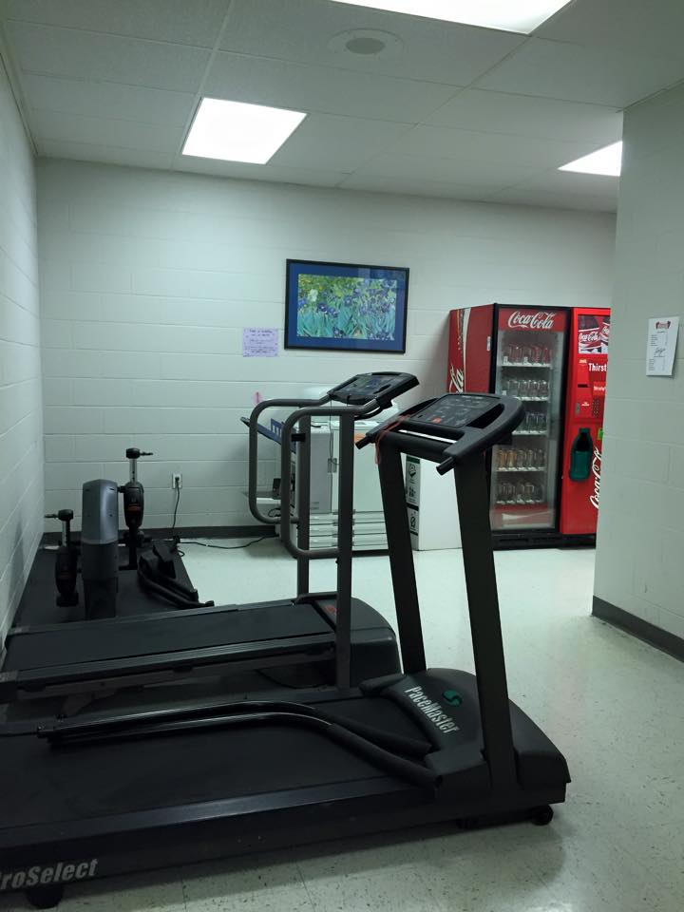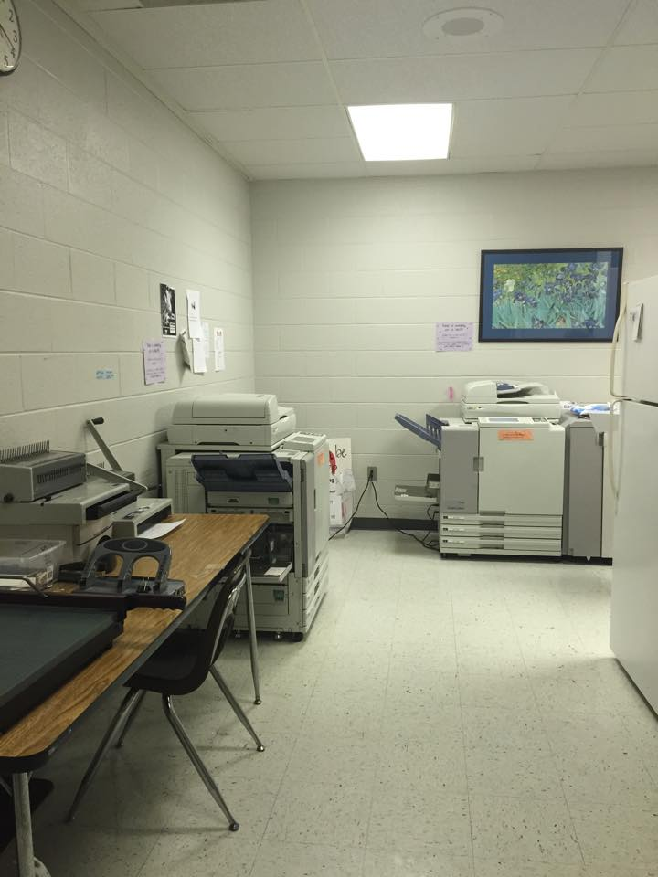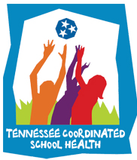

**What Is Coordinated School Health?**

Coordinated School Health encourages healthy lifestyles, provides needed supports to at-risk students and helps to reduce the prevalence of health problems that impair academic success.

Coordinated School Health is an effective approach designed to connect health (physical, emotional and social) with learning. CSH improves children’s health and their capacity to learn through the support of families, communities and the schools working together.

The involvement of parents, families and community is the glue that binds the CSH. Full involvement of these entities as partners in the educational process provides valuable input, increases the commitment of all partners and ensures positive educational and health outcomes.

**April Health Observances**

April is a busy month for health observances and promoting awareness. In the month of April the nation celebrates:

World Health Day – April 7th National Volunteer week – April 12th-18th Earth Day – April 22nd National Youth Violence Prevention Week – April 23rd-27th

**Mental, Physical, Emotional, and Nutritional Benefits of Gardening**

Nature has long been known for its relaxing qualities, as a place for humans to find tranquility and healing.

Gardening in particular is associated with mental clarity and feelings of reward, and it has many physical benefits as well. Food gardening can particularly be gratifying and an excellent source of fresh produce. From soil preparation to the joy of harvesting, there is always a task, big or small, during the growing season! If you have ever spent a summer gardening, you know that these tasks can serve as great exercise. [Read more..](http://www.nextavenue.org/article/2012-01/gardenings-surprising-health-benefits)

**Houston High Student’s “Nutritious Cupcake War”**

Houston High School student were at war, but in the traditional since. They were competing for the best “nutritious cupcake recipes”. Ms. Penn’s classes were given the task of researching and cooking a healthy, cost efficient cupcake. Ms. Penn

|  |  |  |
| --- | --- | --- |
|  |  |  |
|  |  |  |

**Coordinated School Health**

**Newsletter**

**Get-Up & Move!!**

“Get- Up and Move” announcements are to inform GMSD employees, students, & families about Getting Fit In February! The following will give suggestions for success and successful programs in GMSD

**WOW! See What HMS Is Doing!!**

“HMS is getting a make over!” Says Brandy Thompson, School Counselor. “We are moving the copy machines to the mailroom and turning the workroom into a "work-out room.” Faculty and staff will be able to use the machines before or after school. Teachers who log the most time on the machines will receive a weekly incentive such as a jeans day or a smoothie. “Exercise is the greatest stress buster! Let's get Healthy, Houston!”

**Healthy School Team Improtant Dates:**

March 13 – PA/PE 3 Due

March 13 – Healthy School Team

Meeting Minutes #3