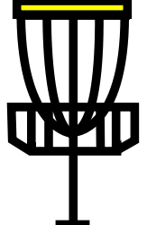
Putting
1. Putt from 10 feet away
2. Throw 10 putts
3. Write down how many putts you made out of 10.

4. If time, see how far you can make a putt from. Write your name down and move the cone to that spot.
Catching

1. Find a partner
2. Pick which set of cones you would like to throw from.
3. Write down the most successful, consecutive catches you and your partner complete.
Driving for Distance
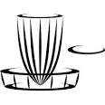
(Backhand)

1. Tee off from the start cone using the backhand throw.
2. If your throw is the furthest mark your lie with your gender’s cone.
3. Write your name on the card.
4. Try again.
Driving for Distance
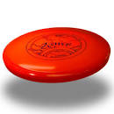
(Sidearm)
1. Tee off from the start cone using the sidearm throw.
2. If your throw is the furthest mark your lie with your gender’s cone.
3. Write your name on the card.
4. Try again.

