**ATHLETE**

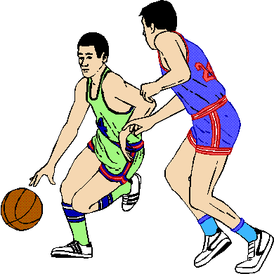

**FACTS:**

* **Paid to play in a professional sports league.**
* **Trained hard to master the skills of their sport.**

**ACTIVITY:**

* **COMPETITION ROUND… COMPLETE THE 1-10-1 STACK AND TIME YOURSELF!**

**NOVELIST**



**FACTS:**

* **Writes books and articles.**
* **Must be good at writing complete and grammatically correct sentences.**

**ACTIVITY:**

* **COMPETITION ROUND… COMPLETE THE 3-6-3 STACK AND TIME YOURSELF!**

**FIREFIGHTER**

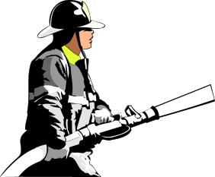

**FACTS:**

* **Fights fires to make sure that people stay safe.**
* **Rescue people from burning buildings.**
* **Responds to vehicle wrecks to help police.**

**ACTIVITY:**

* **FREESTYLE…YOU CHOOSE WHICH TYPE OF STACK TO DO!**

**POLITICIAN**

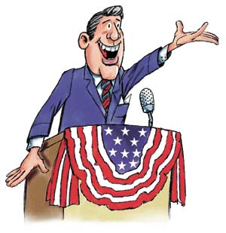

**FACTS:**

* **Helps to come up with laws and pass them.**
* **People vote on these people to have them lead as senators, congressmen, governors, and presidents.**

**ACTIVITY:**

* **COMPLETE THE 1-10-1 STACK**

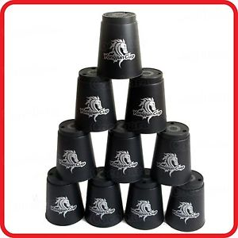

**DOCTOR**



**FACTS:**

* **Studies medicine to help others that are sick or injured.**
* **Works at a hospital.**
* **Saves the lives of others.**

**ACTIVITY:**

* **COMPLETE THE 1-10 STACK**



**LAWYER**



**FACTS:**

* **Represents clients in court.**
* **Works with a judge to uphold laws.**
* **Studies law to help people in court.**

**ACTIVITY:**

* **COMPLETE THE 10 STACK**



**CHEF**



**FACTS:**

* **Cooks and prepares meals at restaurants.**
* **Makes sure food is cooked safely.**

**ACTIVITY:**

* **COMPLETE THE 6-6 STACK**

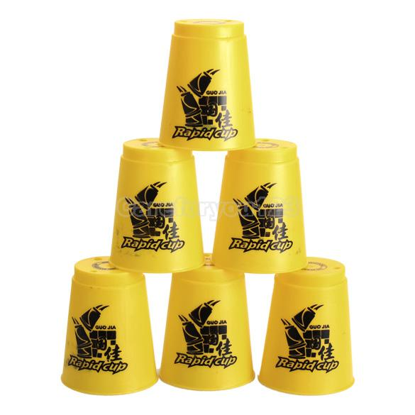

**BOAT CAPTAIN**

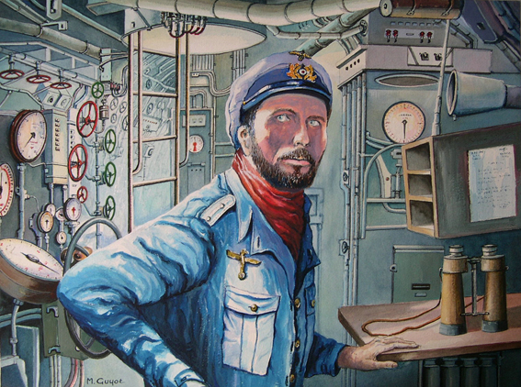

**FACTS:**

* **Operates a boat to transport goods, passengers, and other objects across large bodies of water.**

**ACTIVITY:**

* **COMPLETE THE 3-6-3 STACK**



**MILITARY OFFICER**

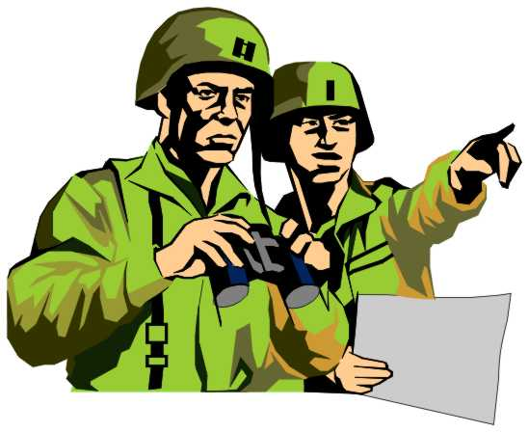

**ACTIVITY:**

* **COMPLETE THE 3-6 STACK**



**FACTS:**

* **Serve our country to keep all of our citizens safe.**
* **Perform missions to recue others.**
* **Travel around the world to keep peace.**

**AIRLINES PILOT**

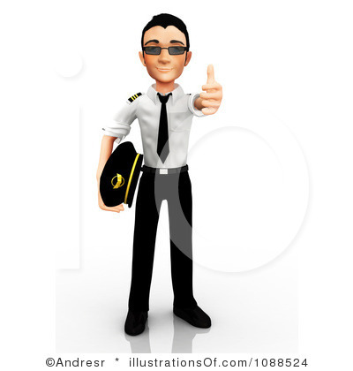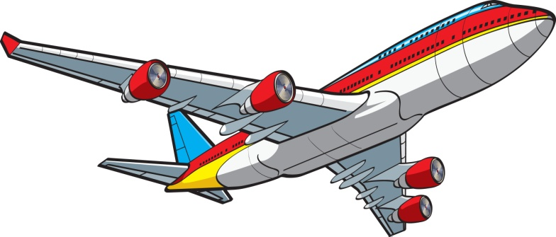

**FACTS:**

* **Transports passengers from one location to another through the air.**

**ACTIVITY:**

* **COMPLETE THE 6 STACK**



**PERSONAL TRAINER**

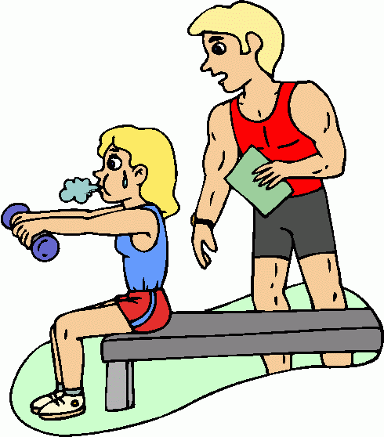

**FACTS:**

* **Provide fitness information to others.**
* **Help clients exercise properly.**
* **Help patients recover from injuries.**

**ACTIVITY:**

* **COMPLETE THE 3-3-3-3 STACK**



**CONSTRUCTION WORKER**

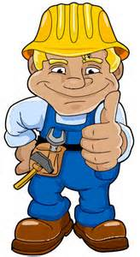

**FACTS:**

* **Build buildings, roads, and houses.**
* **Work with their hands and tools.**
* **Use math to help measure.**

**ACTIVITY:**

* **COMPLETE THE 3-3-3 STACK**



**POLICE OFFICER**

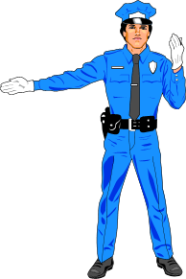

**FACTS:**

* **Protect citizens from dangers.**
* **Enforce laws and arrest criminals.**
* **Help with traffic and keeping drivers safe.**

**ACTIVITY:**

* **COMPLETE THE 3-3 STACK**



**SCHOOL TEACHER**

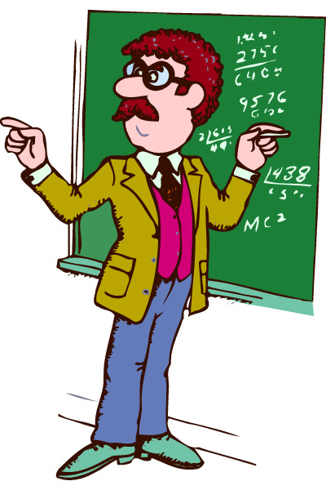

**ACTIVITY:**

* **Complete the 3 Stack**



**FACTS:**

* **Plan daily lessons to teach children important academics.**
* **Test student’s knowledge to ensure they are learning important skills.**