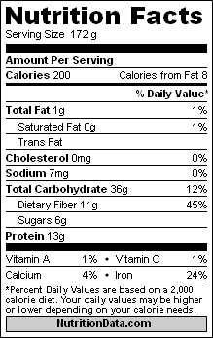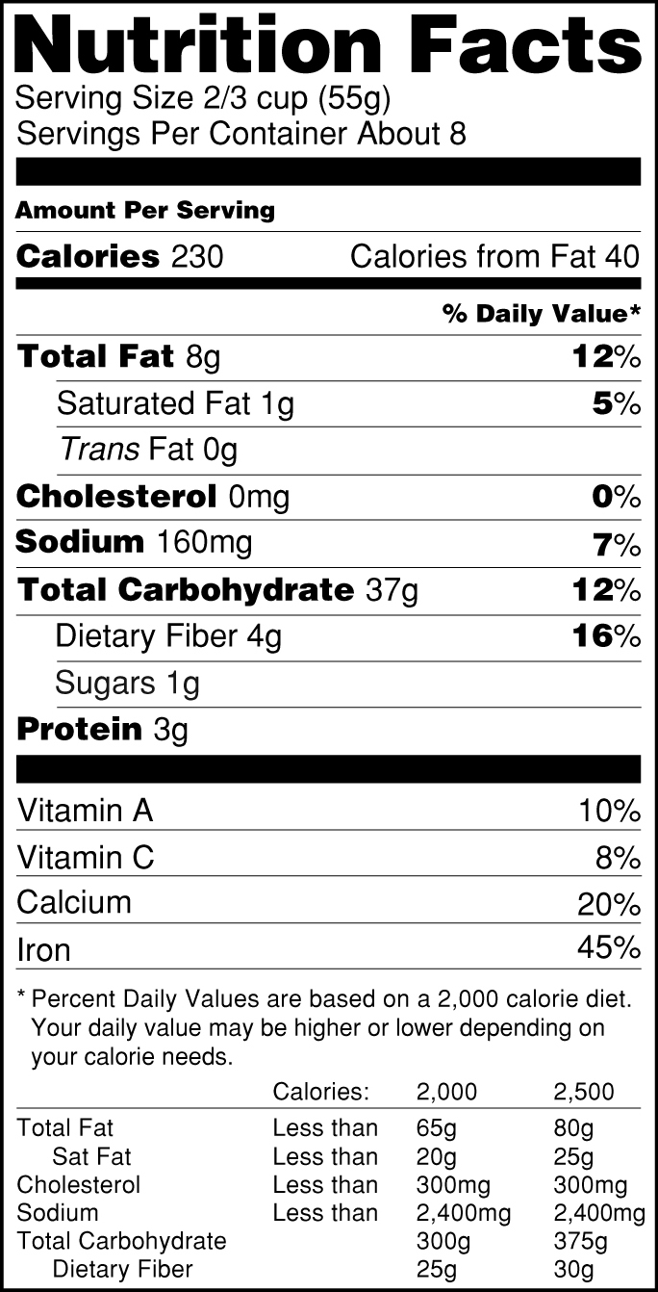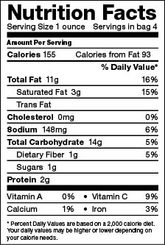
Carbohydrates: | Carbohydrates: | Carbohydrates:
Protein: | Protein: | Protein:
Lipids (fat): | Lipids (fat): | Lipids (fat):
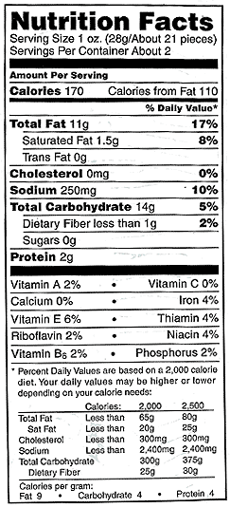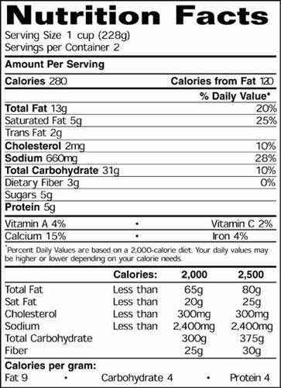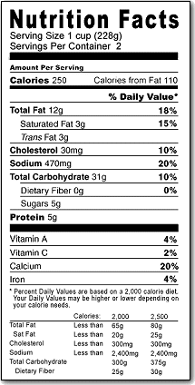
Carbohydrates: | Carbohydrates: | Carbohydrates:
Protein: | Protein: | Protein:
Lipids (fat): | Lipids (fat): | Lipids (fat):
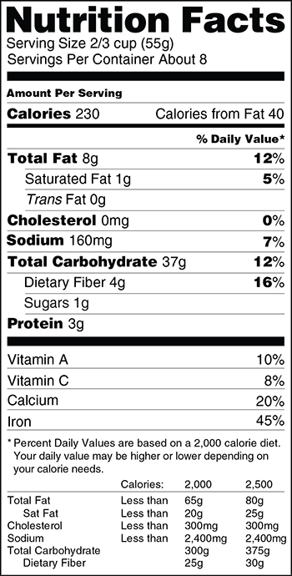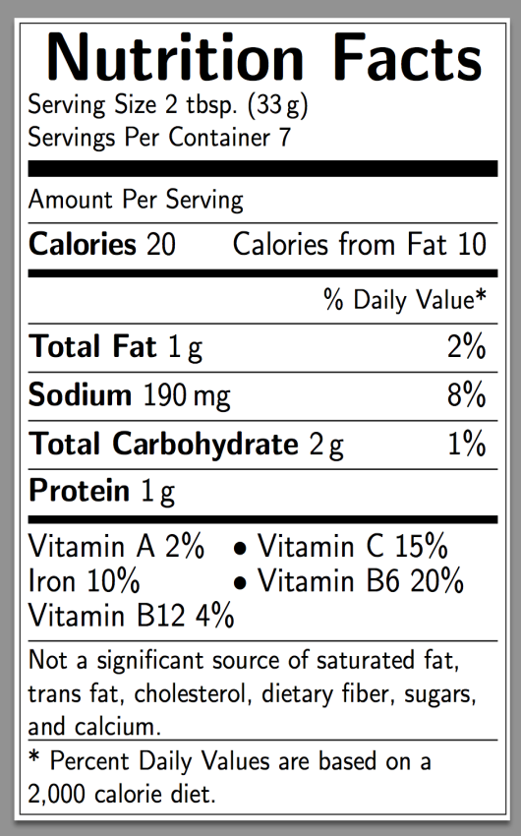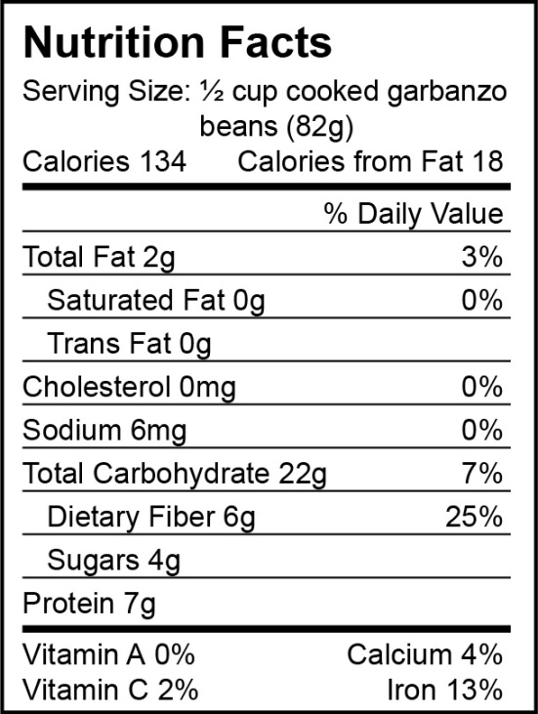
Carbohydrates: | Carbohydrates: | Carbohydrates:
Protein: | Protein: | Protein:
Lipids (fat): | Lipids (fat): | Lipids (fat):
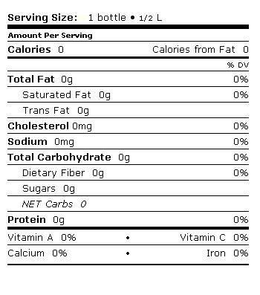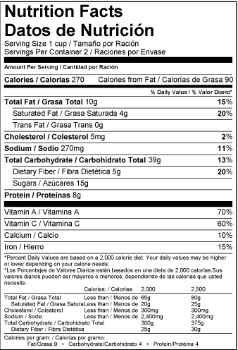
Carbohydrates: | Carbohydrates:
Protein: | Protein:
Lipids (fat): | Lipids (fat):
Calories per gram: Carbohydrates (4) Protein (4) Lipids (9)

