Build A Rainbow

Grade level: 1st & 2nd

Time: 40 minute class period

Equipment: buckets or cones (I use 36), laminated shamrocks with colors (4 sets of each color/ 2 sets of each activity) or activities on them (red, orange, yellow, blue, green, violet, indigo plus hop, skip, balance, run in place..etc.. each on their own shamrock), white board/poster with simple directions, 6-8 cones for teams’ home base.

Standards:
S1:E1 Locomotor Skills
*More S1 could be added depending on the skill activities you add to shamrocks

S3:E2 Engages in physical activity

S4 Exhibits responsible personal and social behavior that respects self and others during physical activity.

Overview: A fun fitness and March holiday themed relay. Teams search for shamrocks to complete a rainbow, and also find activity cards along the way. First team to have all the colors wins the round.

Set up:
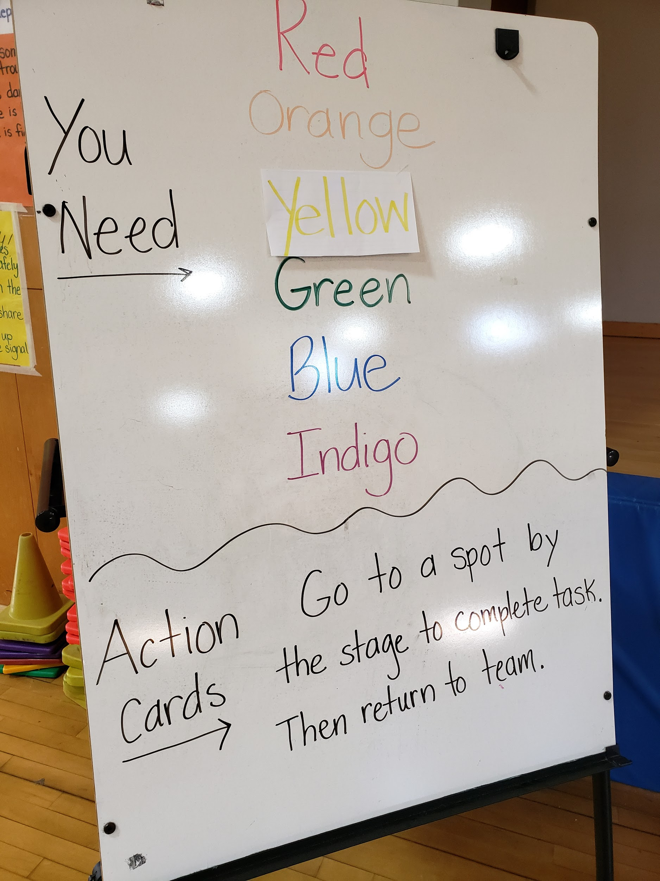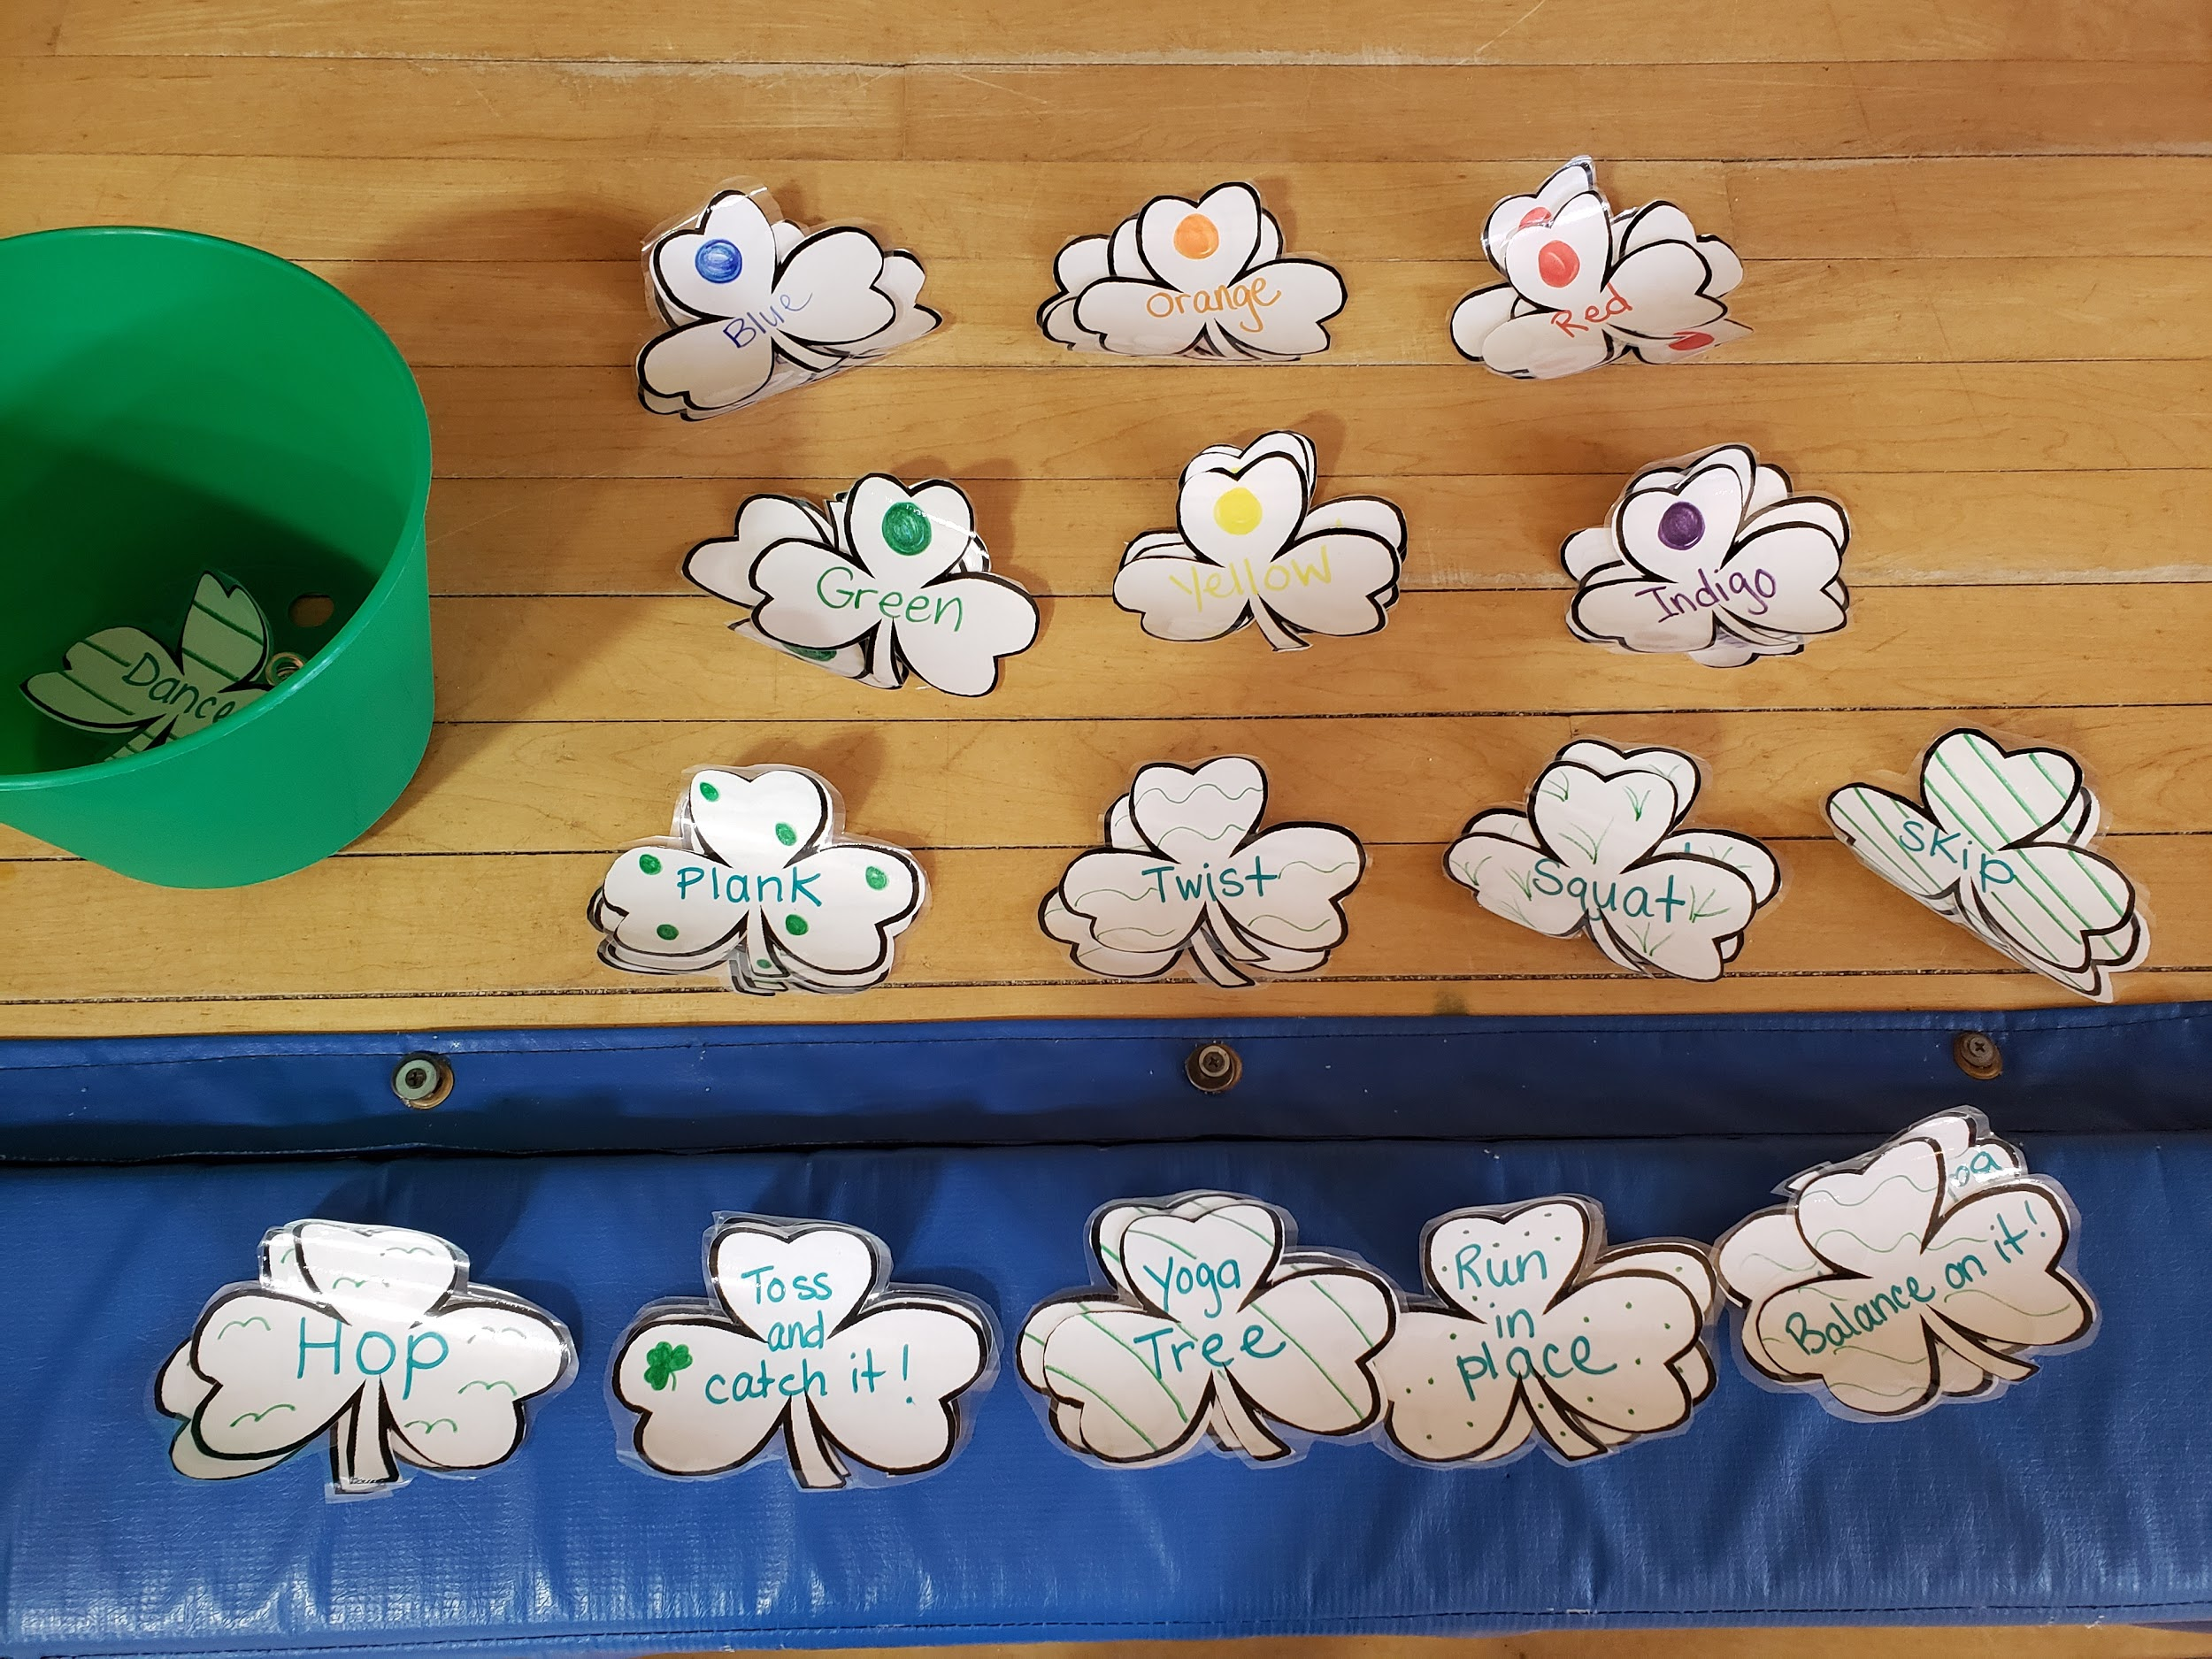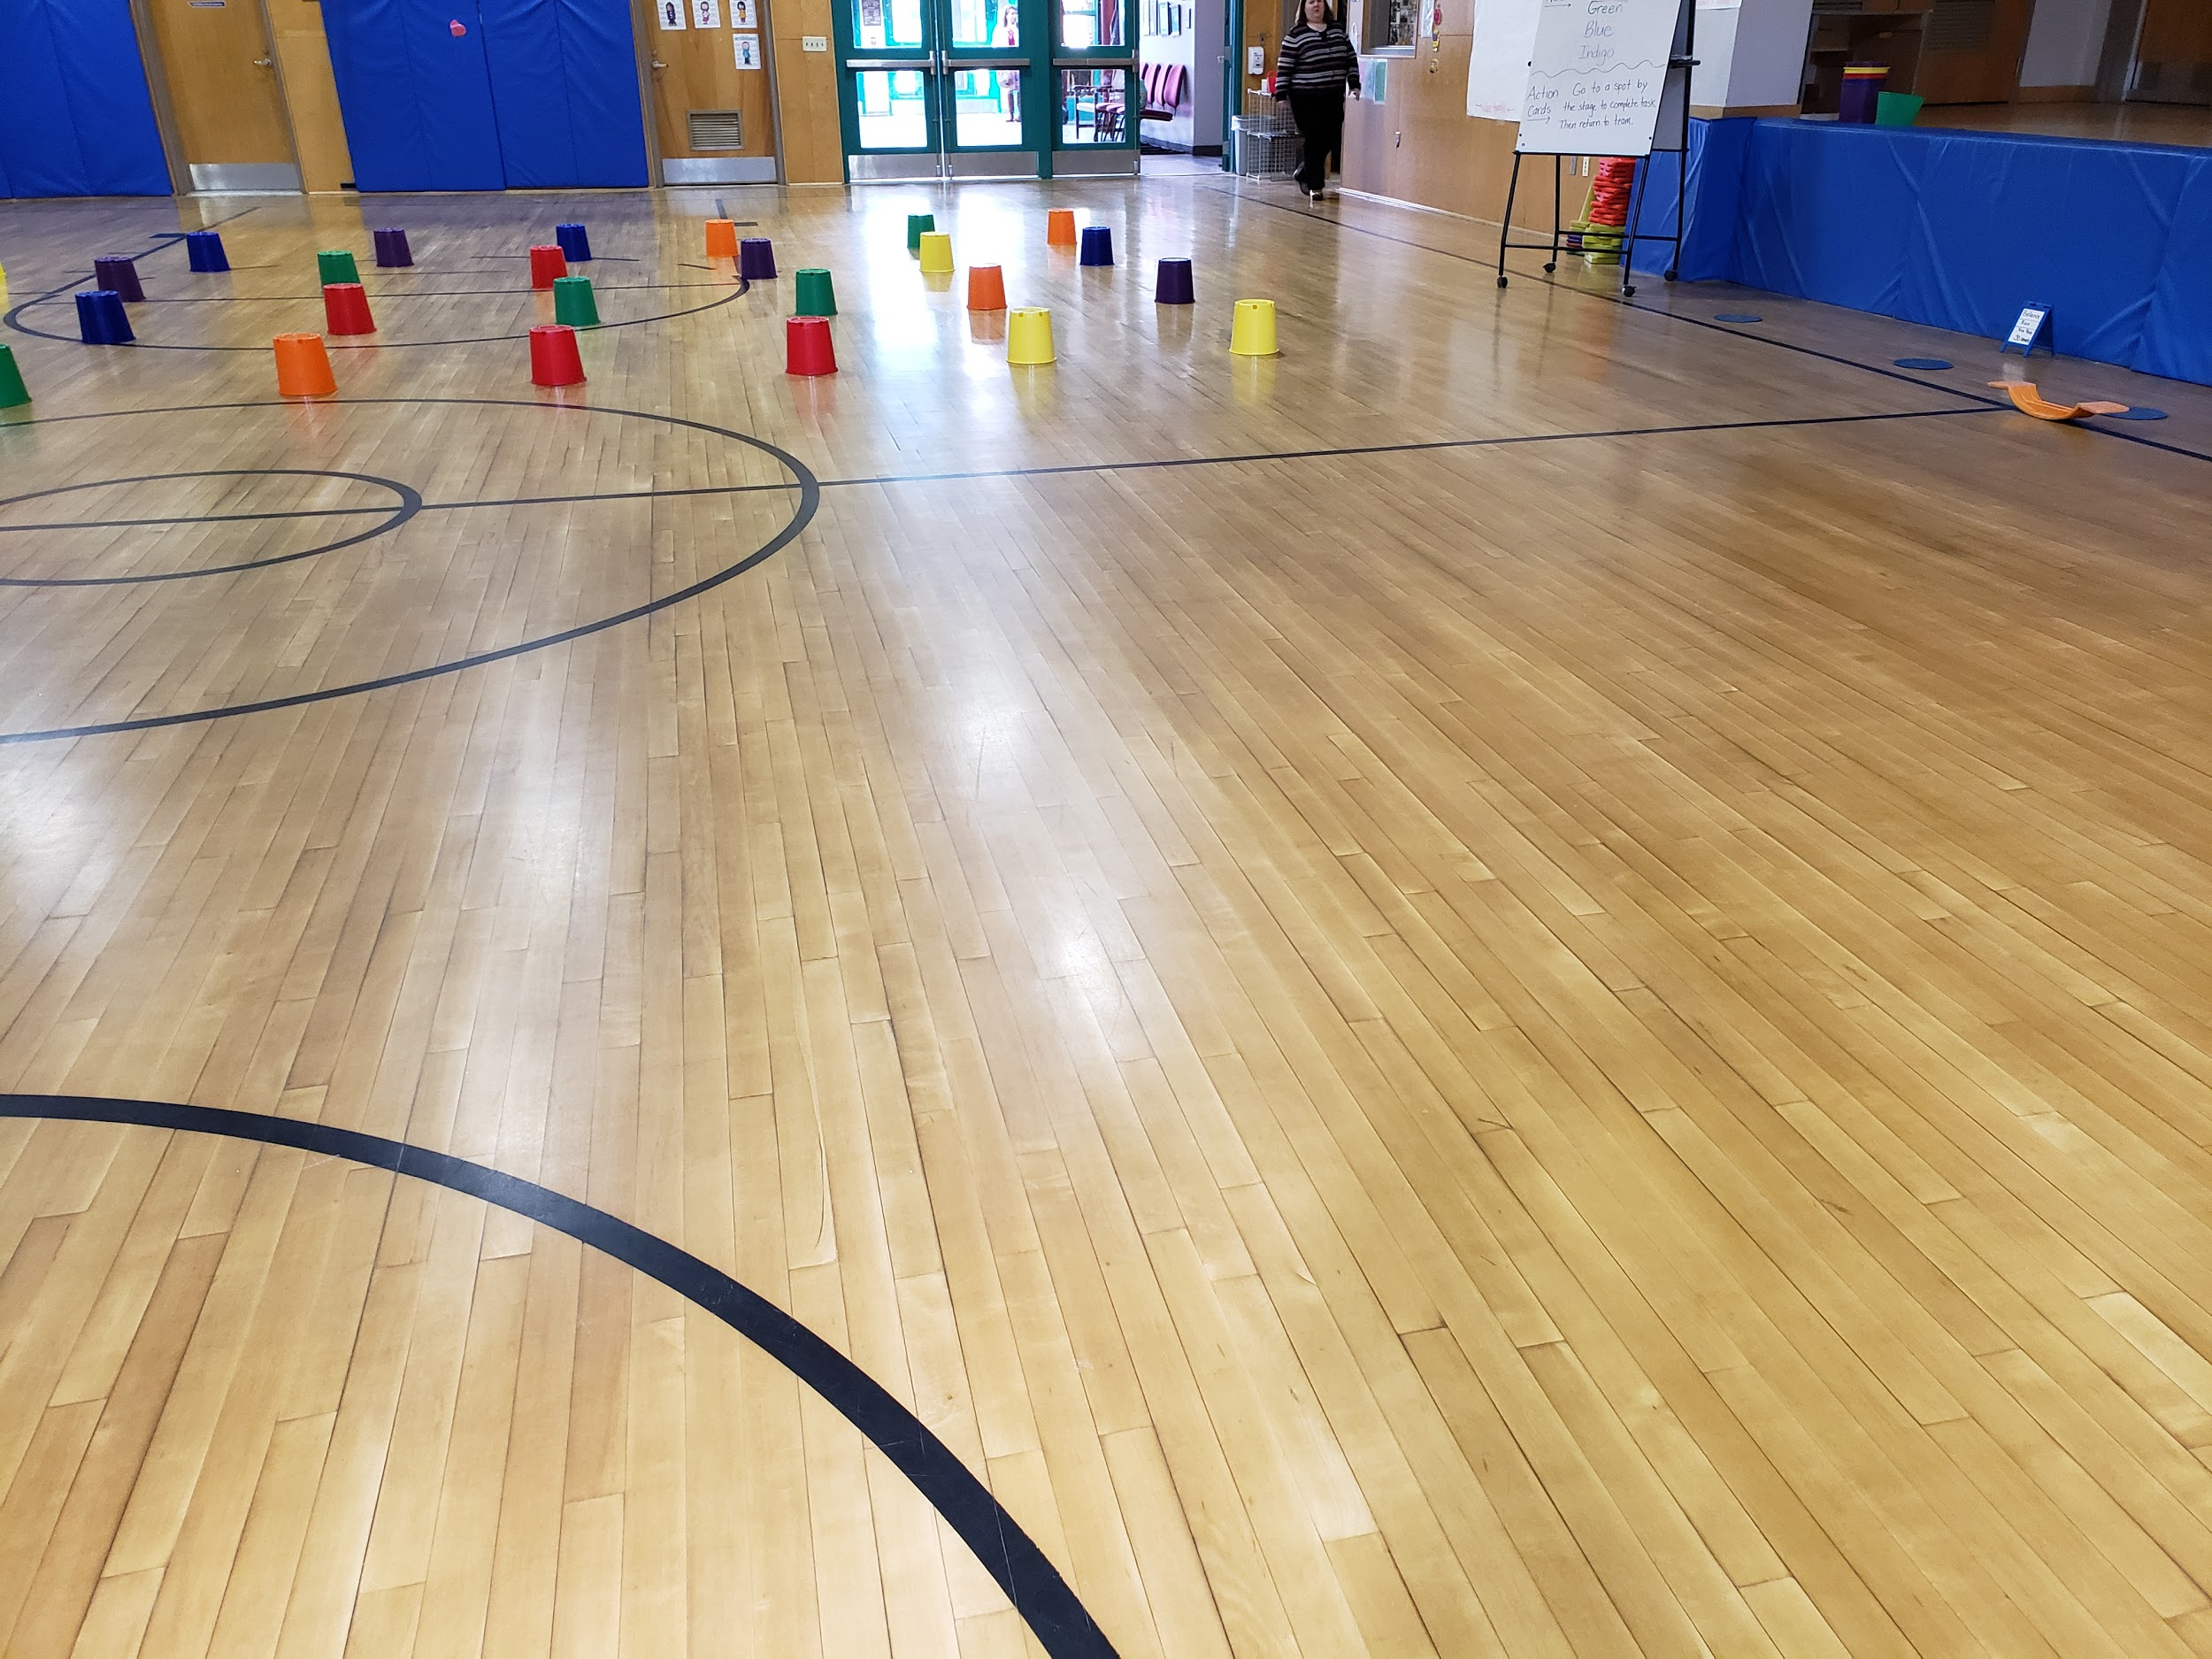

How to play:
1 -Create relay teams.
2- On GO, one player from each team begins the relay...run out, look under ONE bucket & take color if team needs it, leave color under bucket if not needed & also leave fitness shamrocks under bucket (just look at it & complete the fitness activity before returning to group).
3- When a bucket is emptied, players flip it over (saves time when re-hiding shamrocks)
4- If a player gets an activity shamrock, they go to the side, complete the activity & returns to team.
5- When a team has 1 of each color shamrock, they shout “RAINBOW!” and we set up for a new round.

Variations:
1- change locomotor skills each round
2- if an activity card is uncovered, have the whole team complete it, not just the 1 who got the card

