Station #1
Sliding with a bean bag
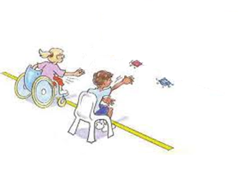
Task: Take turns sliding the bean bag and aim for the cone. The person who comes closest to the cone gets 5 points.
Station #2
Back and Forth Bowling

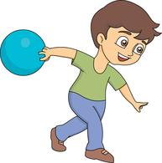

Task: Working with your partner, practice rolling a ball back and forth. Try using different types of balls, increase/decrease your distance, and explore different levels of force.
Station # 3
Bowling w/ Pins
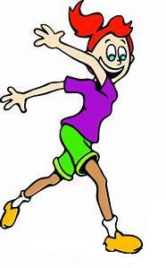
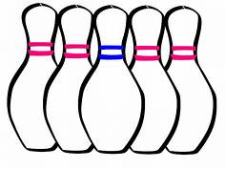

Task: Take turns rolling the ball at the set of pins and try to knock them all down. Your partner will be responsible for resetting the pins.
Station #4
Peer Assessment Bowling
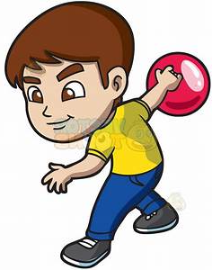

Task: In groups of three, practice rolling the ball and knocking down all the pins, while one partner resets the pins and the other partner uses the check list to assess how you are rolling the ball.
Station #5
Go Bowling! Using pins & score cards

Task: In groups of three, practice rolling the ball and knocking down as many of the pins as you can, while your partner keeps score and continues to help you with your technique.

