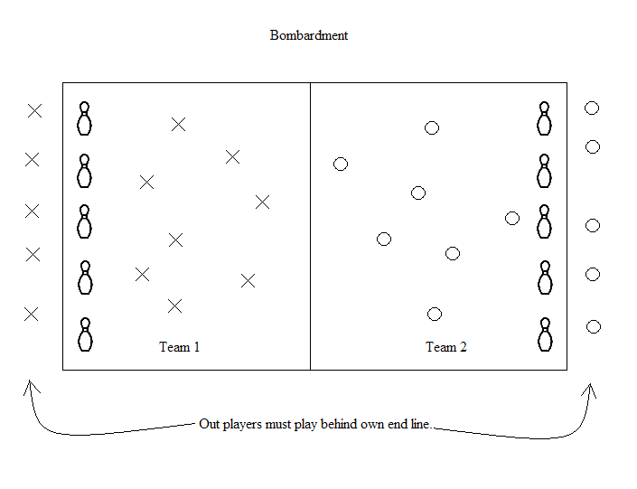
Grades: 1-5
Equipment: 20 – 30 small gator balls, 10 bowling pins, score board.
Object of the game: To knock down the other team’s bowling pins by rolling the ball.
Rules: Students must roll, no throwing. Students can get players out by rolling the ball into the opponent’s legs & feet. Students may dodge the ball or stop it by catching it or by hitting it away. Students may stand guard in front of the pins. If anyone get hit in the legs or feet by the ball rolled by the opposite team, they must play from behind the end line. Once out and behind the end line, out players may still receive a ball that rolls to them and roll it back to try to knock down the opponents pins or get opposing players out.
Once all pins are down, winning team gets a point. Have students reset the pins and get ready to start the next round.
No sliding or diving for a ball.
Students should share the balls, no ball hoarding.

