**U.S.S. TENNESSEE**

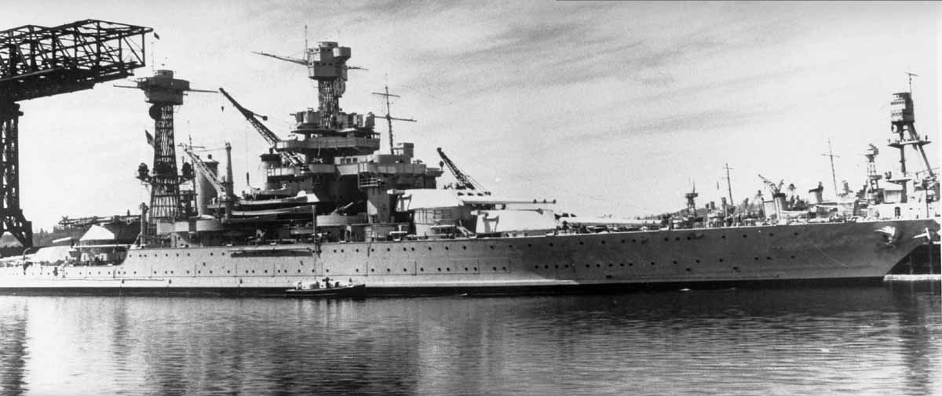

**FACTS:**

* **USS *Tennessee* (BB-43), the** [**lead ship**](http://en.wikipedia.org/wiki/Lead_ship) **of** [**her class**](http://en.wikipedia.org/wiki/Tennessee-class_battleship) **of** [**battleship**](http://en.wikipedia.org/wiki/Battleship)**, was the third ship of the** [**United States Navy**](http://en.wikipedia.org/wiki/United_States_Navy) **named in honor of** [**the 16th US state**](http://en.wikipedia.org/wiki/Tennessee)**.**[**[5]**](http://en.wikipedia.org/wiki/USS_Tennessee_(BB-43)#cite_note-USNHC-Tennessee-5) **During** [**World War II**](http://en.wikipedia.org/wiki/World_War_II) **in the** [**Pacific Theater**](http://en.wikipedia.org/wiki/Pacific_War)**, she was damaged during the** [**attack on Pearl Harbor**](http://en.wikipedia.org/wiki/Attack_on_Pearl_Harbor) **in December 1941 but was repaired and modernized.**
* **She was also involved in the** [**Battle of Surigao Strait**](http://en.wikipedia.org/wiki/Battle_of_Surigao_Strait)**, the final battleship vs. battleship conflict ever.**
* **After the end of** [**World War II**](http://en.wikipedia.org/wiki/World_War_II)**, the *Tennessee* was placed on reserve in the "mothball fleet" for nearly 15 years before finally being scrapped in 1959.**

**U.S.S. ALABAMA**

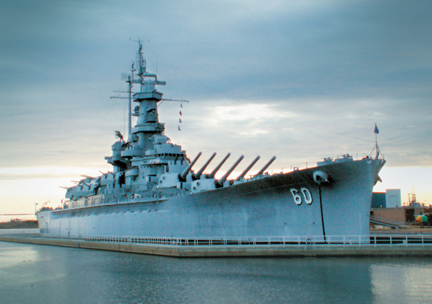

**FACTS:**

* **USS *Alabama* (BB-60), a** [***South Dakota*-class**](http://en.wikipedia.org/wiki/South_Dakota-class_battleship_(1939))[**battleship**](http://en.wikipedia.org/wiki/Battleship)**, was the sixth ship of the** [**United States Navy**](http://en.wikipedia.org/wiki/United_States_Navy) **named after the US state of** [**Alabama**](http://en.wikipedia.org/wiki/Alabama)**.**[**[A]**](http://en.wikipedia.org/wiki/USS_Alabama_(BB-60)#cite_note-1) ***Alabama* was commissioned in 1942 and served in World War II in the Atlantic and Pacific theaters.**
* **In 1964, *Alabama* was taken to Mobile Bay and opened as a museum ship the following year. The ship was added to the** [**National Historic Landmark**](http://en.wikipedia.org/wiki/National_Historic_Landmark) **registry in 1986.**

**U.S.S. ARIZONA**

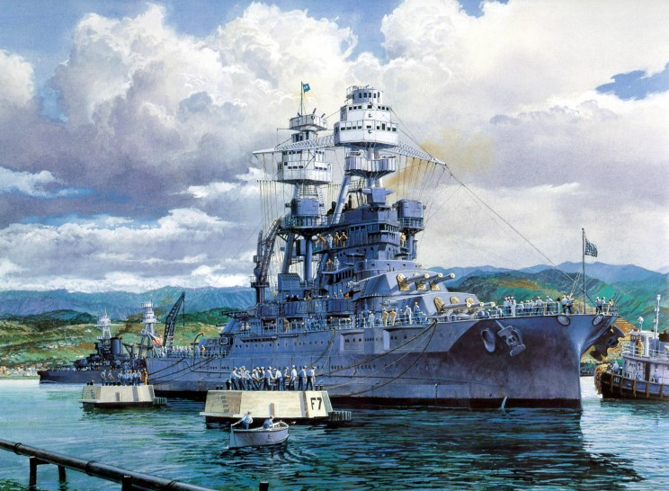

**FACTS:**

* **USS *Arizona* was a** [***Pennsylvania*-class**](http://en.wikipedia.org/wiki/Pennsylvania-class_battleship)[**battleship**](http://en.wikipedia.org/wiki/Battleship) **built for and by the** [**United States Navy**](http://en.wikipedia.org/wiki/United_States_Navy) **in the mid-1910s. Named in honor of the** [**48th state's**](http://en.wikipedia.org/wiki/Arizona) **recent admission into the union, the ship was the second and last of the *Pennsylvania*-class of "**[**super-dreadnought**](http://en.wikipedia.org/wiki/Super-dreadnought)**" battleships.**
* **During the** [**Japanese attack on Pearl Harbor**](http://en.wikipedia.org/wiki/Attack_on_Pearl_Harbor) **on 7 December 1941, *Arizona* was bombed. She exploded and sank, killing 1,177 officers and crewmen. Unlike many of the other ships sunk or damaged that day, *Arizona* could not be fully salvaged, though the navy removed parts of the ship for reuse. The** [**wreck**](http://en.wikipedia.org/wiki/Shipwreck) **still lies at the bottom of Pearl Harbor and the** [**USS *Arizona* Memorial**](http://en.wikipedia.org/wiki/USS_Arizona_Memorial)**, dedicated on 30 May 1962 to all those who died during the attack, straddles the ship's** [**hull**](http://en.wikipedia.org/wiki/Hull_(watercraft))**.**

**U.S.S. MISSOURI**

**[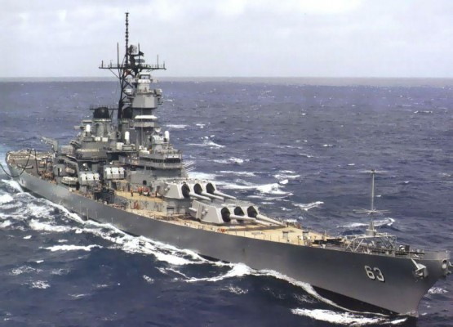](http://www.toptenz.net/top-10-most-famous-ships-in-history.php/battleship-u-s-s-missouri)**

**FACTS:**

* **The “Mighty ‘Mo”, as she became known to her crew, had the distinction of being the vessel upon which the surrender documents that ended World War Two were signed in Tokyo Bay on September 2, 1945.**
* **World War Two wasn’t the only action the massive 45,000 ton battleship was to sea in her lifetime; decommissioned after the war, she was reactivated and sent to fight during the Korean War, and again in 1984, when she became part of Ronald Reagan’s 600-ship fleet plan.**