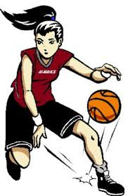
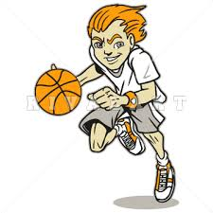
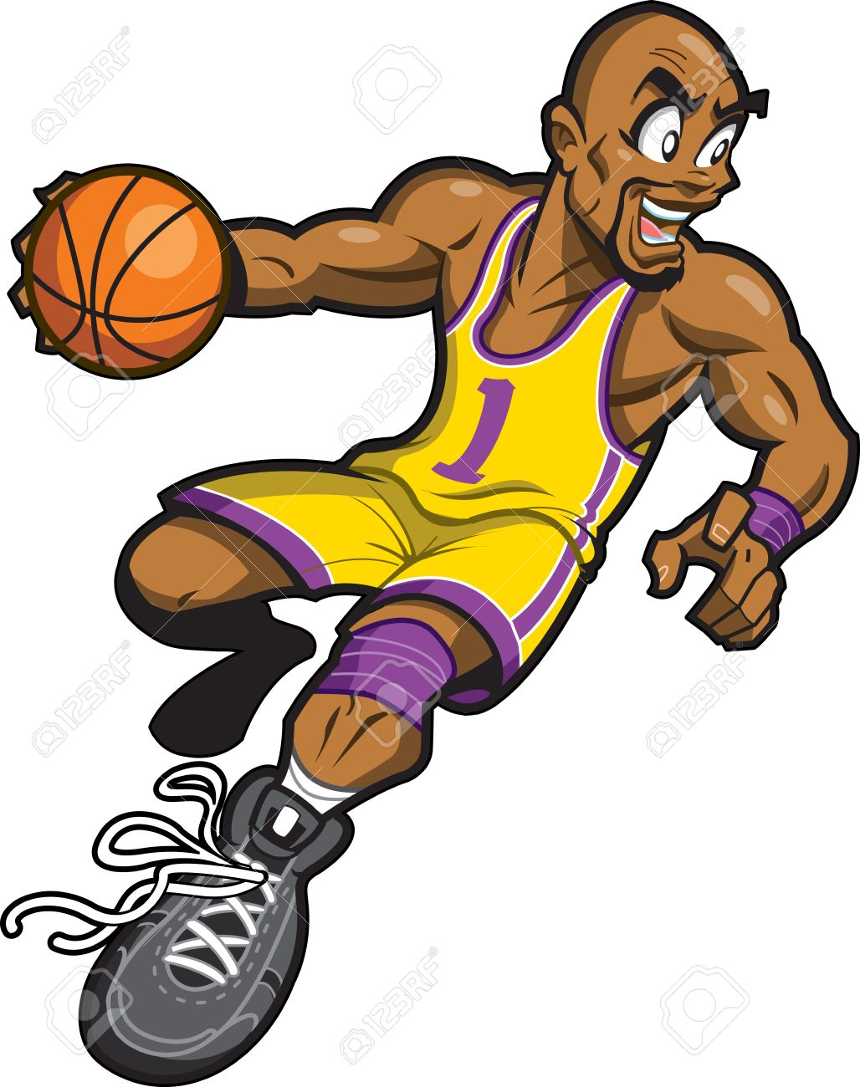
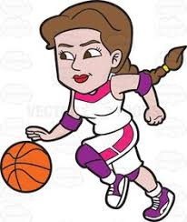
DRIBBLING KNOCKOUT
TRY TO KNOCK THE OTHER PLAYER’S BALL OUT OF THE SQUARE.
YOU MUST COMPLET 10 JUMPING JACKS BEFORE RETURNING TO THE GAME.
1 VS. 1
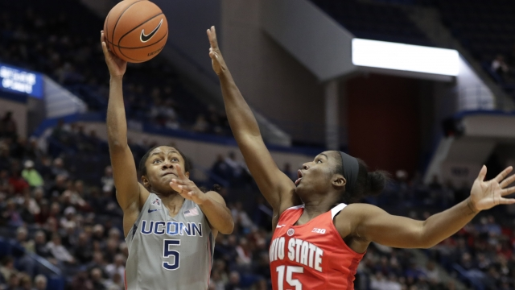
PLAY A 1 VS 1 GAME OF BASKETBALL
RULES:
- NO FOULING
- NO TRAVELING
- NO DOUBE DRIBBLES
- NO BAD SPORTSMANSHIP

CONE DRIBBLING
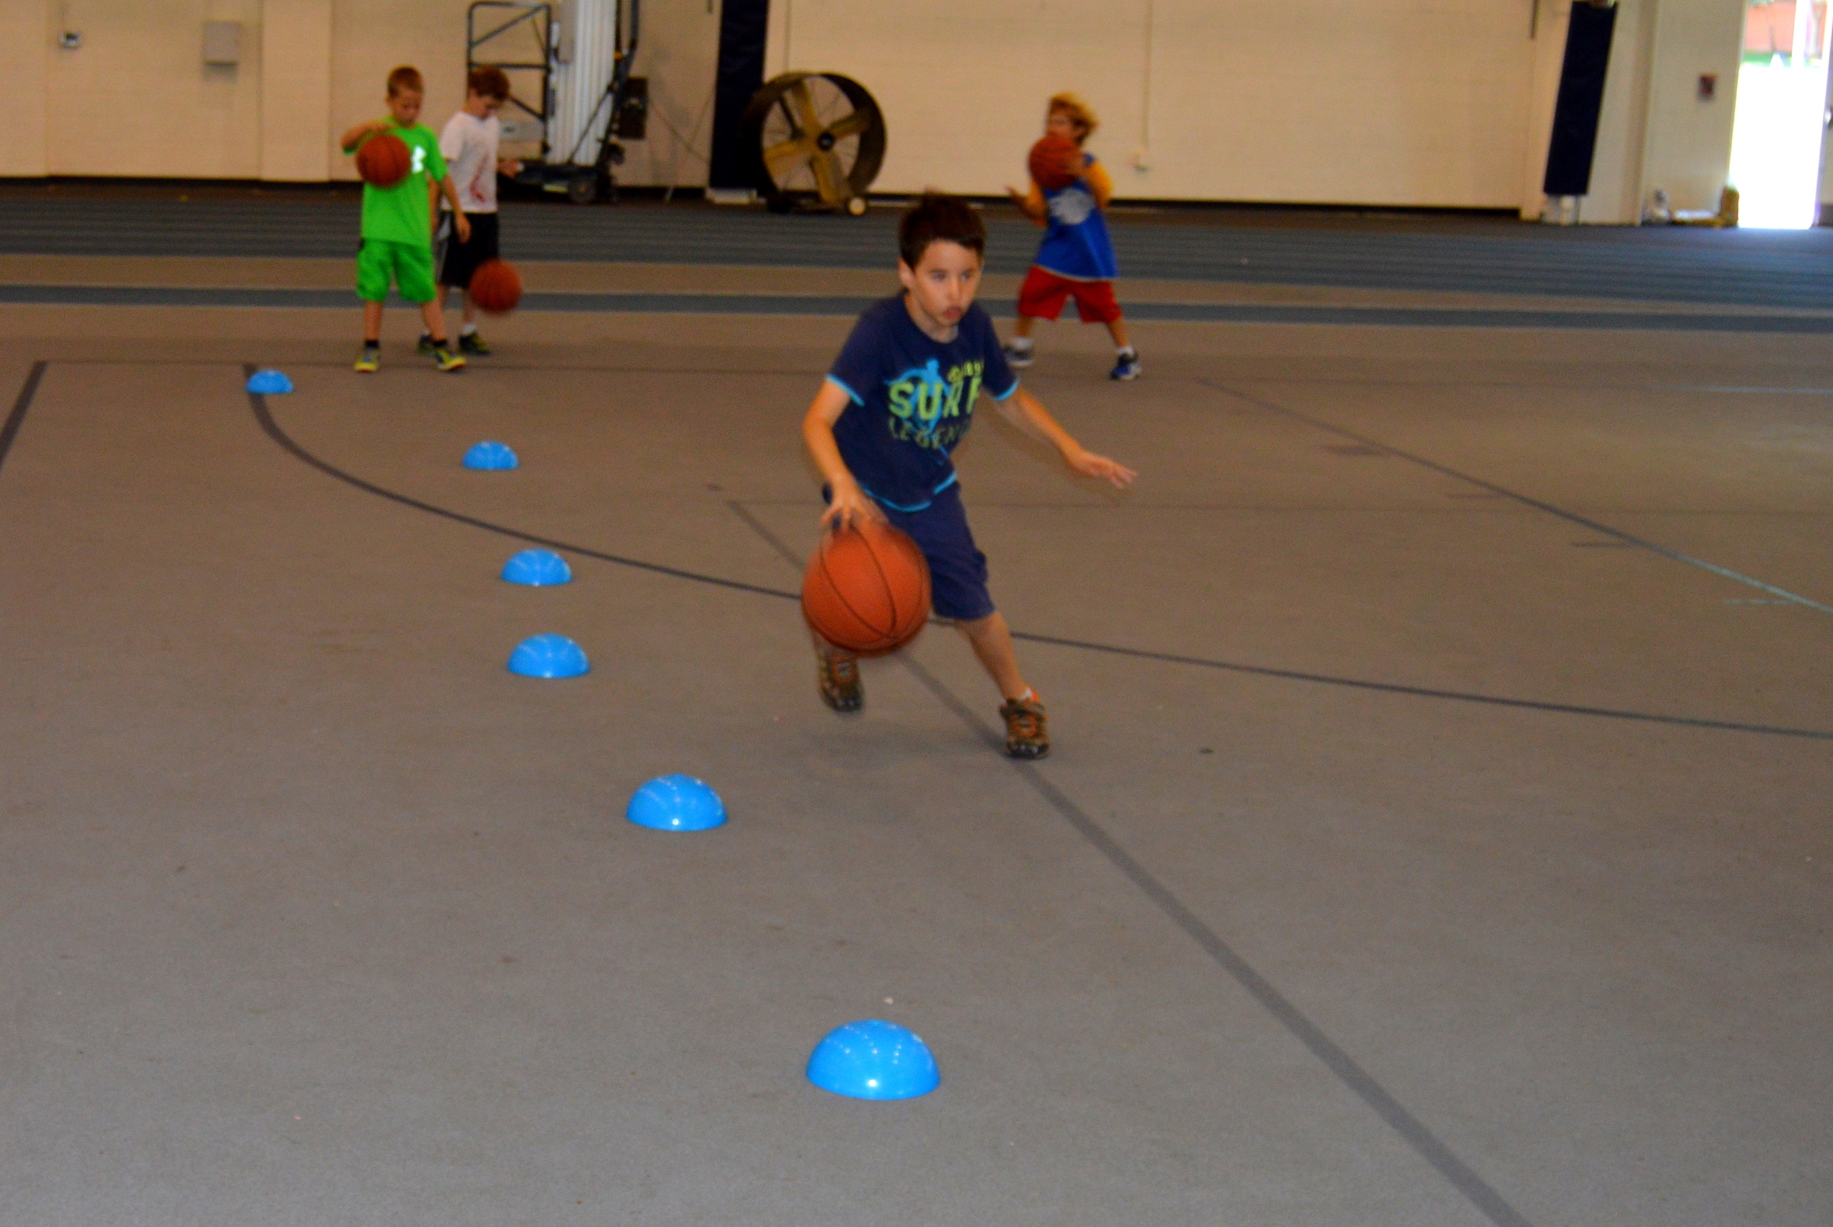
DRIBBLE THROUGH THE CONES IN A ZIG-ZAG PATTERN ON WAY DOWN AND BACK.

