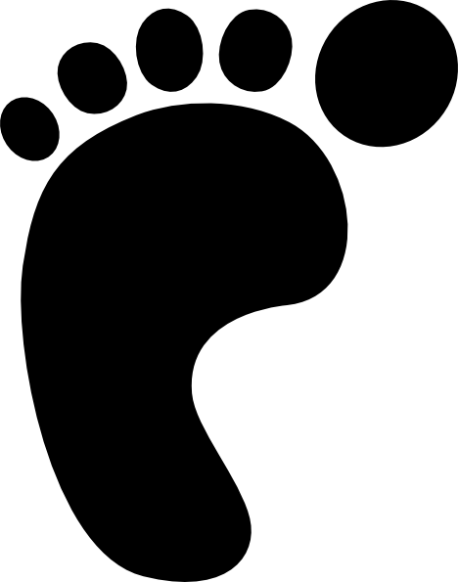

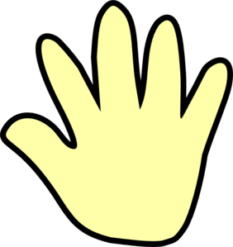

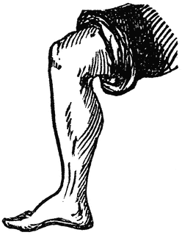

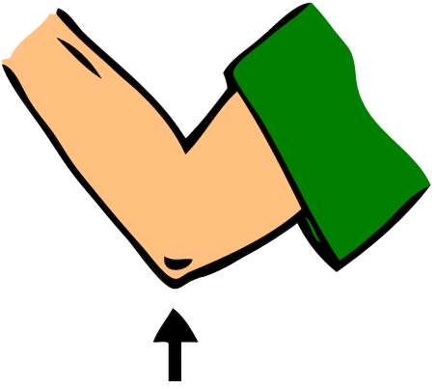

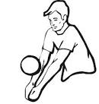

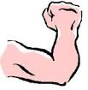

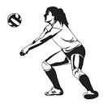

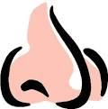

Balloon Activities for P.E.
(Lesson may be divided into 2-4 separate lessons)
Some ideas taken from “Dynamic Phiysical Education for Elementary Students by Robert Pangrazi

Instructional Procedures:
a. catch and control with the fingertips
b. keep your eyes on the object
c. move your body in the path of the oncoming object
d. reach, catch and move the object to the body (giving)

Notes: When teacher gives the signal to stop (whistle or pausing music), students catch their balloon, hold it with two hands, and look at the teacher for the next instruction.

1. Free Exploration - allow 2 minutes for children to play under control with their balloon

2. Direct class to hit their balloon with different body parts: This is a great time to hold up the pictures of different body parts (above). Example, teacher holds up the FOOT picture and all the students practice hitting their balloon with their foot. Hold up a different picture every minute or so.
Body parts to use to hit balloon: Foot, hand, fingers, thumb, forearm, knee, shoulder, elbow, head, nose, etc.

3. Hit the balloon using a pattern: hand-foot, hand-foot, etc. or hand-knee, hand-knee, etc. foot-hand-head, foot-hand-head. (AB patterns, ABB patterns, ABC patterns, etc).

4. Sit and hit balloon, lay and hit, kneel and hit or jump and hit it high. Talk about hitting it at different levels (low, medium, high)

5. Restrict movement - keep one foot in place. Keep one or both feet in hula hoop, etc.

6. Hit back and forth with a partner.

7. Hit it like a volleyball. (bump, set, spike)

8. Hit balloon with a lollipop paddle or noodle pieces.

9. Have 4-6 students seated on the floor in a small circle. Each circle gets two balloons to be kept in the air. Student’s seats are “glued” to the floor. Once a balloon hits the floor, it is out of play. Play for a specific time (30-60 seconds). Increase the challenge using beach balls.

