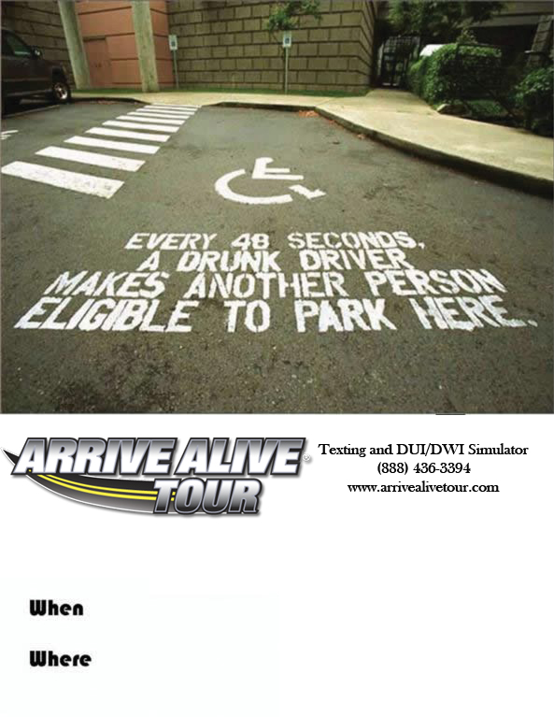

Parking Lot

(Near football stadium)

May 3rd & May 4th

8:00 am – 2:00 pm

