ARCHERY WORKSHEET 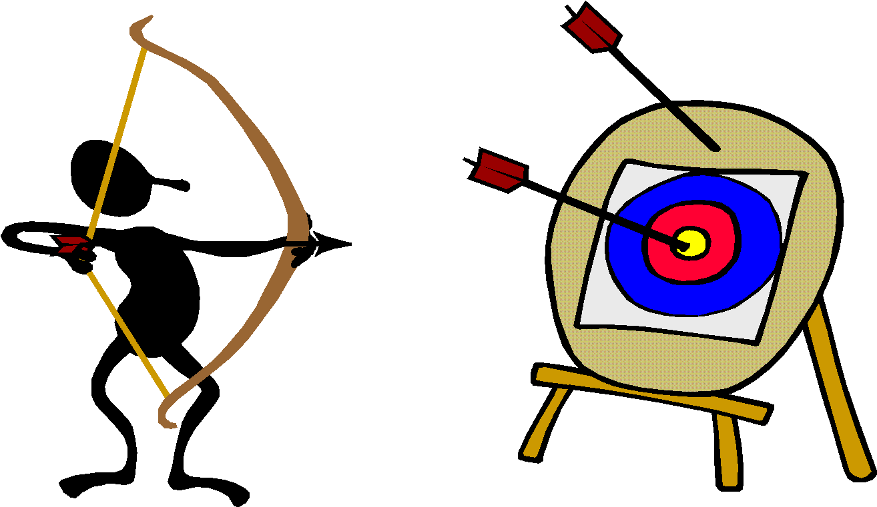
- What are some physical benefits of archery?

- What protocol is MOST important in archery?

- Describe how to nock an arrow.

- Define the four whistle commands:

- Describe proper stance on the firing line.

- Where is the proper anchor point?

- How do you aim?

- What is the proper process for arrow retrieval from the target?

- Describe the point values on a target.

- What is it called if you hit the innermost circle on the target face?

- What happens if you drop an arrow on the floor while on the shooting line?

- Describe “shot setup

- What is a quiver?

- What is the index fletching?

